Phenolic profile of several fruit industry byproducts determined by HPLC-DAD-MS/MS
Letricia Barbosa-Pereiraª, Ana Rodriguez-Bernaldo de Quirósª, Ana Sanches-Silva^{b} and Raquel Sendónª
ª Department of Analytical Chemistry, Nutrition and Food Science, Faculty of Pharmacy, University of Santiago de Compostela (Spain), Santiago de Compostela, Spain
^{b} National Institute for Agricultural and Veterinary Research (INIAV), I.P., Rua dos Lagidos, Lugar da Madalena, 4485-655, Vairão, Vila do Conde, Portugal

Abstract (300 word limit)
Fruit sector produces large amounts of wastes during juice extraction by pressing. These by-products are an important source of high amounts of dietary polyphenols recognized by their antioxidant properties and so their potential health benefits. Therefore, the bioconversion of fruit by-products into new functional and clean label ingredients/additives represents a sustainable approach with great potential of application for food, pharmaceutical and cosmetic sectors.
The aim of this work was the exhaustive characterization of different extracts yielded from three fruit by-products by the identification and quantification of the polyphenols using liquid chromatography.
Ethanolic extracts yielded from apple, lemon and orange by-products containing polyphenols were analyzed by liquid chromatography coupled to mass spectrometry (LC-MS/MS) operated in negative ESI (Electrospray System Ionization) mode. Separation was performed on a Kinetex® EVO C18 100 Å (150 x 3mm, 5µm size of particle) column using water and acetonitrile acidified with 0.1% formic acid as mobile phase. High resolution liquid chromatography with diode detector (HPLC-DAD) was used for the quantification of the main phenolic compounds.
More than 30 compounds were tentatively identified with different distribution among the extracts. Orange by-product was that with high number of polyphenols, while lemon extract was that with high concentrations of these molecules. The main compounds present in orange by-product were Naringenin-7-O-rutinoside, Hesperetin-7-O-rutinoside, Isosakuranetin-7-O-rutinoside. Lemon extract was characterized by the presence of Naringenin-7-O-rutinoside, Eriodyctiol-O-rutinoside, Hesperetin-7-O-rutinoside. On the other hand, apple by-product showed a different phenolic profile (e.g. Phlorizin, Naringenin-7-O-glucoside and Rosmarinic acid) compared to the citric extracts and also in lower concentrations. The results highlight that the origin of the extract affects its composition and therefore the characterization of these profiles is mandatory for food application. These fruits by-products may be a low-cost source of polyphenols that can be used as food ingredients/additives minimizing their environmental impact.

Image
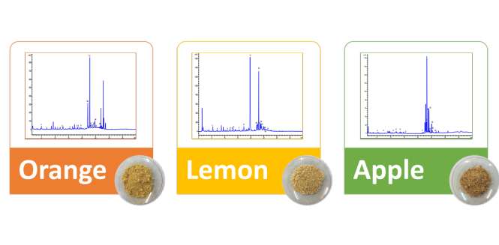
Fig.1. HPLC-DAD chromatograms of each fruit by-products characterized monitored at 278 nm.
Recent Publications (minimum 5)
- Gómez-Mejía, E., Rosales-Conrado, N., León-González, M. E., & Madrid, Y. (2019). Citrus peels waste as a source of value-added compounds: Extraction and quantification of bioactive polyphenols. Food chemistry, 295, 289-299.
- Zhang, Z., Poojary, M. M., Choudhary, A., Rai, D. K., & Tiwari, B. K. (2018). Comparison of selected clean and green extraction technologies for biomolecules from apple pomace. Electrophoresis, 39(15), 1934-1945.
- Molina-Calle, M., Priego-Capote, F., & de Castro, M. D. L. (2015). Development and application of a quantitative method for determination of flavonoids in orange peel: Influence of sample pretreatment on composition. Talanta, 144, 349-355.
- Mcharek, N., & Hanchi, B. (2017). Maturational effects on phenolic constituents, antioxidant activities and LC-MS/MS profiles of lemon (Citrus limon) peels. J Appl Bot Food Qual, 90, 1-9.

Acknowledgements:
This work was financially supported by the VIPACFood project (selected by ERA-NET ARIMNet2 call 2016 (Coordination of Agricultural Research In the Mediterranean) of the European Union through the 7th Framework Programme and funding by the Spanish National Institute for Agricultural and Food Research and Technology (INIA) ref. APCIN2016-0006-00-00. L. Barbosa-Pereira is grateful to the Spanish Ministry of Science, Innovation and Universities for her “Juan de la Cierva – Incorporación” Grant (Agreement No. IJCI-2017-31665).

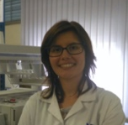 Biography (150 word limit)
Letricia Barbosa-Pereira is a Postdoctoral researcher at the Department of Analytical Chemistry Nutrition and Food Science of the Faculty of Pharmacy of the University of Santiago de Compostela. Her expertise is focused in new approaches for the recovery, characterization and application of plant- based bioactive compounds as food ingredients/additives, development of new healthier food products using low-cost functional ingredients, development of functional foods with health benefits to provide the consumers healthy food choices and find new applications of bioactive in the health sector as nutraceuticals.
Email: letricia.barbosa.pereira@usc.es
Notes/Comments

