Quantification of bisphenol related compounds in canned food by HPLC-FLD
Antía Lestido Cardama*, Ana Rodríguez Bernaldo de Quirós*, Juana Bustos**, Mª Isabel Santillana**, Perfecto Paseiro Losada*, Raquel Sendón*
*Department of Analytical Chemistry, Nutrition and Food Science, Faculty of Pharmacy, University of Santiago de Compostela, Spain
**National Food Center, Spanish Agency for Food Safety and Nutrition, Spain

Abstract (300 word limit)
Major types of interior can coatings are made from synthetic polymers known as epoxy-based resins. These resins usually contain among their components bisphenol related compounds, which can be released as well as oligomers and/or derivatives (hydrolysed or chlorinated) and reach the food. There is no specific European legislation for can coatings, but there are specific migration limits (SML) for some of them that are known to migrate. Several investigations have suggested bisphenol A (BPA) as an endocrine disruptive chemical, and for this reason other analogues have been developed to replace BPA in the manufacture of these resins.
In this work, canned food including fish (tuna, sardines), vegetables (corn, olives, asparagus, tomato), seafood (clams, mussels) and fruit (peach) were taken as study samples. Determination of the pH of each sample was carried out. The simultaneous identification and quantification of thirteen compounds including bisphenols (BPA, BPB, BPC, BPE, BPF, BPG) and BADGEs (BADGE, BADGE.H₂O, BADGE.2H₂O, BADGE.HCl, BADGE.2HCl, BADGE.H₂O.HCl, cyclo-di-BADGE) was performed using an analytical method based on high performance liquid chromatography (HPLC) with fluorescence detection, after extraction using heptane and acetonitrile as extraction solvents. In addition, a liquid chromatography coupled to tandem mass spectrometry (LC-MS/MS) method was optimized for confirmation purposes.
The HPLC-FLD method developed to determine the migrants in the food samples showed an adequate linearity (R2 > 0.9994), low detection levels (LOD = 5ppb), good repeatability (RSD % < 12) and acceptable recoveries (>70 %).
The study was financially supported by the Ministerio de Ciencia, Innovación y Universidades, by Fondo Europeo de Desarrollo Regional (FEDER), and by Agencia Estatal de Investigación Ref.No. PGC2018-094518-B-I00 “MIGRACOATING” (MINECO/FEDER, UE). Antía Lestido is grateful for her grant “Programa de axudas á etapa predoutoral” da Xunta de Galicia (Consellería de Cultura, Educación e Ordenación Universitaria).

Image
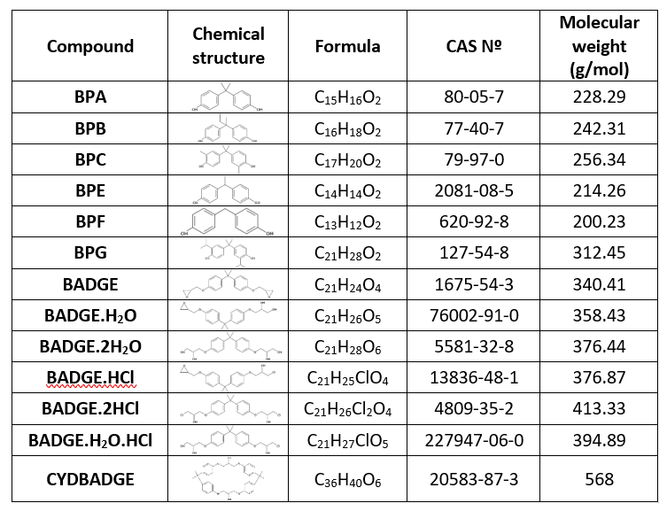
Table 1: Formules and chemical structures of the anlytes studied.
Recent Publications (minimum 5)
- Xiong L, Yan P, Chu M, Gao Y Q, Li W H, Yang X L (2018). A rapid and simple HPLC–FLD screening method with QuEChERS as the sample treatment for the simultaneous monitoring of nine bisphenols in milk. Food chemistry, 244, 371-377.
- Cardama A L, Rodríguez Bernaldo de Quirós A, Sendón R (2017). Analysis of bisphenol A in beverages and food packaging by high- performance liquid chromatography. Food & Nutrition Journal, 2017(5), 1-4.
- Alabi A, Caballero-Casero N, Rubio S (2014). Quick and simple sample treatment for multiresidue analysis of bisphenols, bisphenol diglycidyl ethers and their derivatives in canned food prior to liquid chromatography and fluorescence detection. Journal of Chromatography A, 1336, 23-33.
- Gallart-Ayala H, Moyano E, Galceran M T (2011). Fast liquid chromatography–tandem mass spectrometry for the analysis of bisphenol A-diglycidyl ether, bisphenol F-diglycidyl ether and their derivatives in canned food and beverages. Journal of Chromatography A, 1218(12), 1603-1610.
- Sendón Garcı́a R, Paseiro Losada P (2004). Determination of bisphenol A diglycidyl ether and its hydrolysis and chlorohydroxy derivatives by liquid chromatography–mass spectrometry. Journal of Chromatography A, 1032(1-2), 37-43.

Biography (150 word limit)
Antía Lestido is a PhD student in the Department of Analytical chemistry, Nutrition and Food Science in the Faculty of Pharmacy, University of Santiago de Compostela (Spain). Her studies are based on the estimation of the exposition to different chemical migrants present in food packaging using methodologies based on gas chromatography (GC) and liquid chromatography (LC).
Email: antia.lestido@usc.es

Notes/Comments:

