Identification of potential migrants present in polymeric coatings in food cans
Antía Lestido Cardama*, Raquel Sendón*, Juana Bustos**, Mª Isabel Santillana**, Perfecto Paseiro Losada*, Ana Rodríguez Bernaldo de Quirós*
*Department of Analytical Chemistry, Nutrition and Food Science, Faculty of Pharmacy, University of Santiago de Compostela, Spain
**National Food Center, Spanish Agency for Food Safety and Nutrition, Spain

Abstract (300 word limit)
Polymeric coatings are commonly used in metal food cans to protect food from corrosion. However, there is a risk that coatings used in cans release complex chemical mixture into foodstuff including monomers, oligomers, additives, impurities, reaction products, etc. It is important to develop analytical tools for the identification of these potential migrants in the food packaging with the ultimate objective of ensure the consumer safety. A total of twelve food cans that cover several types of food (fish, vegetables, fruit, etc.) were selected as study samples.
In a first step, after an extraction with acetonitrile, a non-targeted screening by gas chromatography coupled to mass spectrometry (GC-MS) was performed for migrant identification. Then, in the second part, a targeted analysis was carried out for the simultaneous determination of thirteen compounds including bisphenols (BPA, BPB, BPC, BPE, BPF, BPG) and BADGEs (BADGE, BADGE.H₂O, BADGE.2H₂O, BADGE.HCl, BADEGE.2HCl, BADGE.H₂O.HCl, cyclo-di-BADGE) by liquid chromatography coupled to tandem mass spectrometry (LC-MS/MS) with atmospheric pressure chemical ionisation (APCI) source. The separation of the analytes was achieved on a Phenosphere 80A ODS (150 * 3.2 mm, 3 µm) column and using a gradient of water and acetonitrile:methanol (50:50) as mobile phase.
The screening reveals the presence of a great variety of compounds including plasticizers, photoinitiators, antioxidants, lubricants, etc. The developed method by LC-MS/MS turned out to be an excellent analytical tool for the confirmation of the presence of bisphenol related compounds in the can extracts being cyclo-di-BADGE the predominant compound detected.
The study was financially supported by the Ministerio de Ciencia, Innovación y Universidades, by Fondo Europeo de Desarrollo Regional (FEDER), and by Agencia Estatal de Investigación Ref.No. PGC2018-094518-B-I00 “MIGRACOATING” (MINECO/FEDER, UE). Antía Lestido is grateful for her grant “Programa de axudas á etapa predoutoral” da Xunta de Galicia (Consellería de Cultura, Educación e Ordenación Universitaria).

Image
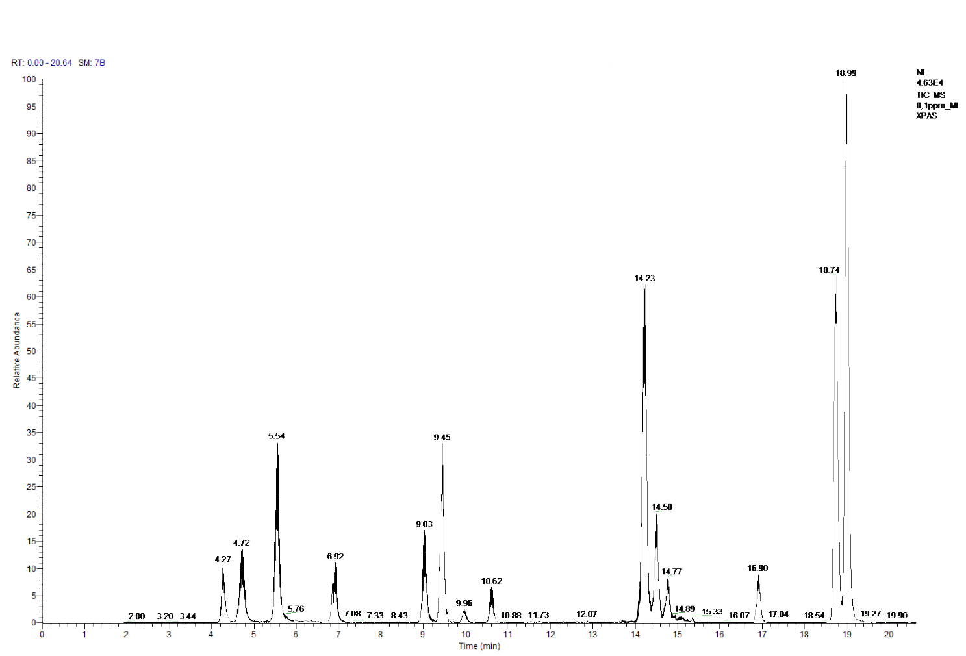
Figure 1: A LC-MS/MS chromatogram corresponding to a mix working solution
Recent Publications (minimum 5)
- Ibarra V G, Rodríguez Bernaldo de Quirós A, Paseiro Losada P, Sendón, R (2019). Non-target analysis of intentionally and non intentionally added substances from plastic packaging materials and their migration into food simulants. Food Packaging and Shelf Life, 21, 100325.
- Galmán Graíño S, Sendón R, López Hernández J, Rodríguez Bernaldo de Quirós A (2018). GC-MS screening analysis for the Identification of potential migrants in plastic and paper-based candy wrappers. Polymers 10(7), 802.
- García Ibarra V, Rodríguez Bernaldo de Quirós A, Paseiro Losada P, Sendón R (2018). Identification of intentionally and non-intentionally added substances in plastic packaging materials and their migration into food products. Analytical and Bioanalytical Chemistry, 410(16), 3789-3803.
- Gallart-Ayala H, Moyano E, Galceran M T (2011). Fast liquid chromatography–tandem mass spectrometry for the analysis of bisphenol A-diglycidyl ether, bisphenol F-diglycidyl ether and their derivatives in canned food and beverages. Journal of Chromatography A, 1218(12), 1603-1610.
- Sendón Garcı́a R, Paseiro Losada P (2004). Determination of bisphenol A diglycidyl ether and its hydrolysis and chlorohydroxy derivatives by liquid chromatography–mass spectrometry. Journal of Chromatography A, 1032(1-2), 37-43.

Biography (150 word limit)
Antía Lestido is a PhD student in the Department of Analytical chemistry, Nutrition and Food Science in the Faculty of Pharmacy, University of Santiago de Compostela (Spain). Her studies are based on the estimation of the exposition to different chemical migrants present in food packaging using methodologies based on gas chromatography (GC) and liquid choromatography (LC).
Email: antia.lestido@usc.es

Notes/Comments:

