Surface Supported Metal Organic Thin Film Materials Based Heterojunctions for Triplet Triplet Annihilation Upconversion

Shargeel Ahmad¹, Jinxuan Liu¹, and Licheng Sun^{1,2}
¹ State Key Laboratory of Fine Chemicals, Institute of Artificial Photosynthesis, Dalian University of Technology, Dalian 116024, China.
² Department of Chemistry, School of Chemical Science and Engineering, KTH Royal Institute of Technology, 10044 Stockholm, Sweden
* Correspondence: shargeel@mail.dlut.edu.cn
Abstract
The surface supported metal organic framework thin film hybrid material has been grown by using highly crystalline and orderly arranged MOF thin film heterojunction. The heterojunctions which has been fabricated with metallo-porphyrin photosensitizer (Zn (II) tetraphenylpophyrin) and photoemitter (3,9-perylenedicarboxylic acid) for triplet triplet annihilation upconversion to enhance the energy. The hybrid MOF thin film materials can be effectively utilized to transform the low energy green light into high energy blue light by overcoming the Shockley–Queisser limit. The obtained data indicate that the hybrid material can be used as one of vibrant sources of TTA UC based enhanced energy conversion materials.

Introduction
It’s very important to find the new materials for solar energy conversion technologies which would help us to save energy for future generation. Harnessing the idea of triplet triplet annihilation upconversion (TTA UC) requires a smart hybrid material overcoming required distance for smooth and efficient triplet energy transfer(TEnT)^{[1-3]}. However, the TTA UC process is the one of the best wavelength shift methodology in which the two low energy photons (hu₁) having high wavelength are absorbed and transformed into one high energy photons (hu₂) with low wavelength via Dexter type energy transfer mechanism^{[3, 4]}. In our previous demonstration we have reported the triplet energy transfer between PtOEP (PtOEP = Pt(II) octaethylporphine) as sensitizer and Zn-perylene SURMOF as acceptor in acetonitrile solution^{[5]} by making solid liquid interface and surface modifications. Here we will put a novel idea of suing solid-solid interface by making SURMOF-SURMOF heterojunction to study TTA UC
The TTA UC has been studied using variety of materials to enhance the contemporary demands of solar energy ^{[1, 6, 7]}. Moreover, notable efforts has been made to utilize the modern surface-anchored metal-organic frameworks (SURMOFs) materials in gas separation,electronics, CO₂ reduction, water splitting, photovoltaic, and most recently in TTA-UC system^{[3, 5]} due to its controlled growth orientation, tunable pore size and highest crystallinity.Moreover, previous studies showed that the random orientation of photosensitizer which was dissolved in the solution could also hinder the transfer of triplet energy in the photoelectrochemical cell^{[5]}.
It has been reported that the Zn (II) tetraphenylpophyrin molecules have s and p bond between N atom and Zn⁺² transition metal. The Zn⁺² and N atom have p coordination due to d electrons which strengthens the (T₁ ← S₁) transition.As a matter of fact the Zn (II) tetraphenylpophyrin photosensitizer can also effectively utilize the long-lived S₂ state (1.5 and 2.4 ps) with strong transition ( S2 ← S0 ) followed by hopping process with S₂ excitation energy which needs the
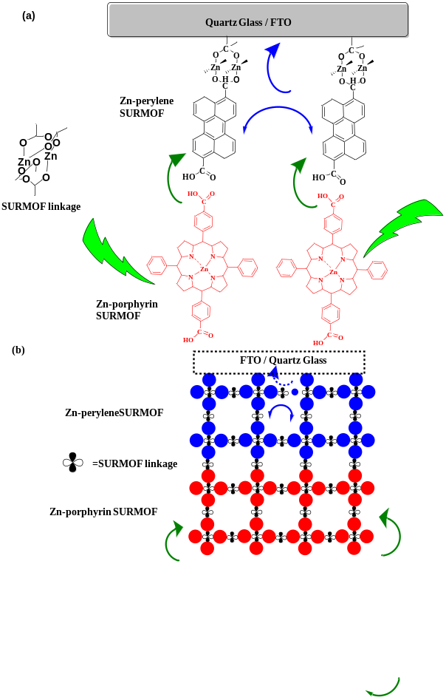
Figure 1: Schematic Illustration (A) is The SURMOF-SURMOF Heterostructure on Top of Coarse Glass / FTO (B) The Controlled Growth of SURMOF-SURMOF Heterostructure Which Favors the Conversion of Green Light into Blue Light via TTA UC. Pophyrin: Zn (II) Tetraphenylpophyrindicarboxylic Acid.

emitter of higher energy level^{[8, 9]}.
Moreover, the blue emitter-perylene molecule has lower energy level which favors the triplet energy transfer (TEnT) followed by triplet triplet annihilation mechanism from sensitizer and the exchange of triplet energy with acceptor annihilating the triplets for the formation of singlets to generating the blue light with high energy. In this work we will introduce the formation of heterojunction with Zn (II) tetraphenylpophyrin molecules as sensitizer and 3,9-perpylenedicarboxylic acids as acceptor which will be used for triplet triplet annihilation upconversion (TTA UC) shown in Figure 1.

Experimental Strategies

Preparation of substrates
The quartz glass / FTO glass (SOLARONIX, Switzerland) substrates were cleaned in acetone for approximately ten minutes in an ultrasonic bath then these are treated with plasma under O₂ for nearly thirty minutes to generate a surface with -OH (hydroxyl groups).These cleaned substrates were used instantaneously to grow SURMOF.

Preparation of Zn-perylene SURMOF
Liquid phase epitaxy technique is used for the preparation of the Zn-Perylene SURMOFs on top of FTO /Quartz Glass substrates. We prepared a concentration zinc acetate ethanolic solution (1 mM). On top of cleaned FTO we sprayed it for 5s. After 30s wait, 3,9 perylene dicarboxylic acid ethanolic solution was sprayed ( concentration:20μΜ-40μM; spray time: 20 s, waiting time: 30 s). This alternate spray process of Zn-acetate as metal linker and 3,9 perylene dicarboxylic acid as organic linker supported the formation of highly crystalline metal organic framework thin film and more detail can be found somewhere in the literature^{[10]} .

Preparation of Zn-porphyrin SURMOF and Its Heterojunction
SURMOF of Zn (II) metalloporphyrin were fabricated using well established highly throughput automated spray system Briefly, a concentration of 20 mM Zn(II)metalloporphyrins in ethanol (spray time: 25 s, waiting time: 35 s) and a concentration of 1 mM zinc acetate in ethanol (spray time: 15 s, waiting time: 35 s) were one by one sprayed onto the FTO / Quartz Glass substrates in a layer-by-layer fashion using N₂ as a carrier gas (0.2 mbar). In between, pure ethanol was used for rinsing to get rid of the unreacted species from the surface (rinsing time: 5 s). The thickness of the sample was controlled by the number of deposition cycles. Moreover, the SURMOF-SURMOF heterojunction was formed by firstly growing the 20 cycles of Zn-perylene SURMOF and on top of it 20 more cycles of Zn (II) metalloporphyrin SURMOF was added to make heterojunctions. Moreover, the formation of heterojunction which is described in the literature ^{[4]}.

Triplet-triplet annihilation upconversion (TTA UC) setup
First of all, 40 mg/ml PMMA (poly methyl (methacrylate) was prepared in the acetonitrile solution. Then as prepared MOF thin film material consisting of FTO/Quartz Glass-Zn-perylene SURMOF+Zn-porphyrin SURMOF were immersed into the well mixed acetonitrile solution of PMMA which was degassed with N₂ for half an hour. The heterostructure was characterized for triplet triplet annihilation upconversion using laser light source.

XRD Characterizations
The SURMOF SURMOF heterojunction has been characterized which showed (001) and (002) preferred orientation Figure 2.These results were compared with the reported studies ^{[4]}.

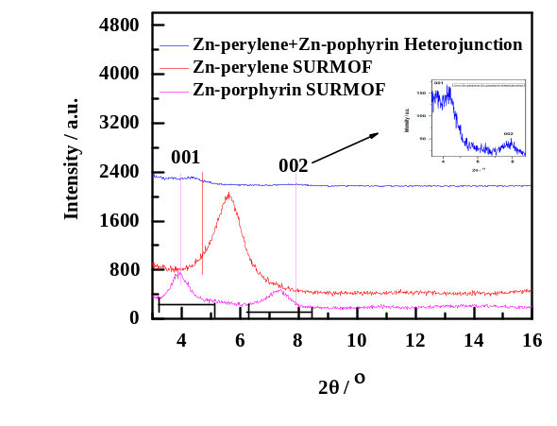
Figure 2: XRD of Zn-porphyrin (red);Zn-perylene (red) and Zn-perylene+Zn-porphyrin Heterostructure.

Results and Discussions
Comparative analysis of the ultraviolet-visible (UV-vis) spectrum of Zn-perylene SURMOF, Zn-porphysin SURMOF and Zn-perylene-Zn-porphyrin heterojunction is being shown in Figure 3. The UV-vis spectrum of Zn-perylene alone SURMOF range from 358 nm to 470nm (in brown) which is also compared with the solution of free perylene dicarboxylic^{[11]} acids indicating a blue shift in MOF thin film sample. The UV-vis of Zn-porphyrin shows a Sorret Band at ~ 440nm and two Q bands between 530 nm to 614 nm. The Zn (II) tetraphenylpophyrin molecule shows two Q bands which are different from free base porphyrin generating four Q bands because Zinc⁺² ion coordination with porphyrin molecule changes the symmetry of the former molecule The combined UV vis of Zn-perylene SURMOF and Zn-porphyrin SURMOF heterostructure overlaps with all the bands of both MOF thin films shown in figure 3(red).The merging of all the bands in SURMOF heterostructure is very important for efficient absorption of green light and its conversion into blue light shown in Figure 3.

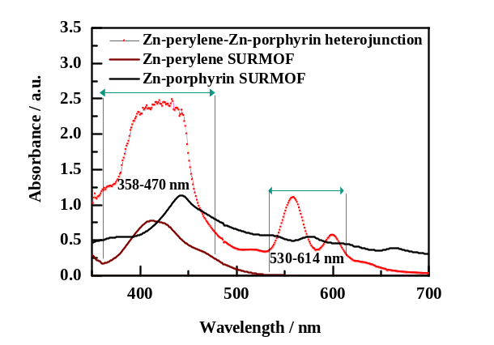
Figure 3: UV-vis Spectra of Zn-perylene SURMOF(Brown)-Zn-porphyrin SURMOF (Black) and Zn-perylene SURMOF-Zn-porphyrin SURMOF Heterojunctions (Red).
The SEM characterization of SURMOF-SURMOF heterojunction shows that the first 20 cycles of highly crystalline Zn-perylene MOF thin film have grown the ~200nm thick film Moreover, the addition of Zn-porphyrin SURMOF Zn-perylene SURMOF could grow more ~200 nm thick shown in Figure 4.



Figure 4: Scanning electron microscope showing the thickness of SURMOF-SURMOF heterostructure.

The phenomenon of TTA UC has been studied with SURMOF-SURMOF heterojunction which showed enhanced energy shown in Figure 5 (a,b).This give us the idea that MOF thin film based highly crystalline and versatile materials is very useful for energy conversion devices.
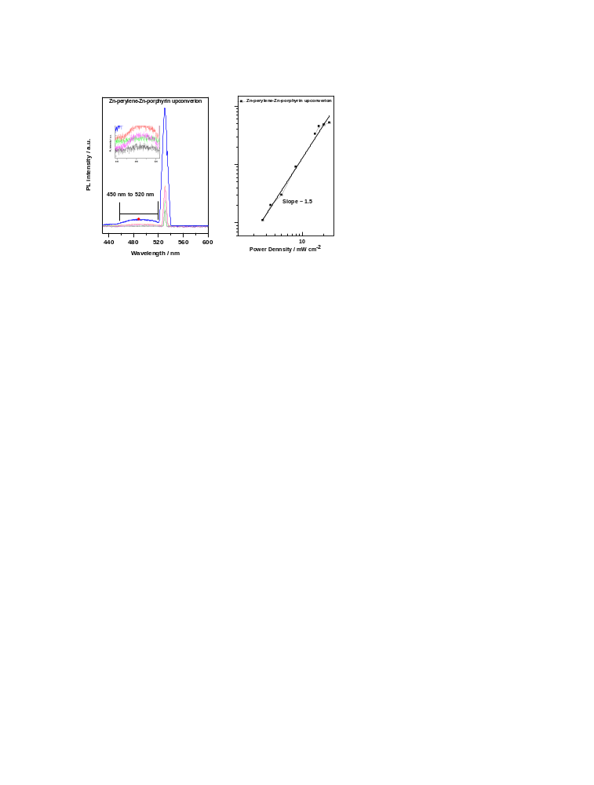
Figure 5: (a) Demonstration of TTA UC with SURMOF-SURMOF heterojunctions. (b) The SURMOF-SURMOF Based Intensity Dependent Behavior under 532 nm Green Light Irradiation.
The obtained quantum yield efficiency of Zn-perylene SURMOF+Zn-porphyrin SURMOF heterostructure is 0.182%. Following the same method of calculation mention in the reported literature, we found that the calculated value is consistent with the literature values ^{[12].} However, it is highly recommended to use the heterojunction for future dye sensitized solar cell devices.
Conclusion & Significance: The MOF thin film based smart and hybrid materials can be used for enhanced energy conversion triplet triplet annihilation upconversion. The studied hybrid material can be used for the future energy conversion devices. The point of view is that a prototype dye sensitized solar cell device can be fabricated with highly crystalline MOF thin film. Moreover, it has been demonstrated that the photocurrent can be significantly enhanced by overcoming the longer distance which finally may overcome Shockley–Queisser limit. Further efforts in such direction may open the new avenues for exploring more MOF thin film materials for solar energy conversion devices.

Publications
[1] Hill S P, Dilbeck T, Baduell E, et al. Integrated Photon Upconversion Solar Cell via Molecular Self-Assembled Bilayers [J]. ACS Energy Letters, 2016, 1(1): 3-8.
[2] Monguzzi A, Tubino R, Hoseinkhani S, et al. Low power, non-coherent sensitized photon up-conversion: modelling and perspectives [J]. Physical Chemistry Chemical Physics, 2012, 14(13): 4322-4332.
[3] Simon Y C, Weder C. Low-power photon upconversion through triplet-triplet annihilation in polymers [J]. J Mater Chem 2012, 22(39): 20817-20830.
[4] Oldenburg M, Turshatov A, Busko D, et al. Photon Upconversion at Crystalline Organic-Organic Heterojunctions [J]. Advanced Materials, 2016, 28(38): 8477-8482.
[5] Ahmad S, Liu J, Gong C, et al. Photon Up-Conversion via Epitaxial Surface-Supported Metal–Organic Framework Thin Films with Enhanced Photocurrent [J]. ACS Applied Energy Mater, 2018, 1(2): 249-253.
[6] Hill S P, Banerjee T, Dilbeck T, et al. Photon Upconversion and Photocurrent Generation via Self-Assembly at Organic-Inorganic Interfaces [J]. Journal of Physical Chemistry Letters, 2015, 6(22): 4510-4517.
[7] Simpson C, Clarke T M, Macqueen R W, et al. An intermediate band dye-sensitised solar cell using triplet–triplet annihilation [J]. Phys Chem Chem Phys, 2015, 17(38): 24826-24830.
[8] Sugunan S K, Tripathy U, Brunet S M, et al. Mechanisms of Low-Power Noncoherent Photon Upconversion in Metalloporphyrin− Organic Blue Emitter Systems in Solution [J]. The Journal of Physical Chemistry A, 2009, 113(30): 8548-8556.
[9] Duvanel G, Grilj J, Vauthey E. Ultrafast Long-Distance Excitation Energy Transport in Donor–Bridge–Acceptor Systems [J]. The Journal of Physical Chemistry A, 2013, 117(5): 918-928.
[10] Ahmad S, Liu J, Ji W, et al. Metal–Organic Framework Thin Film-Based Dye Sensitized Solar Cells with Enhanced Photocurrent [J]. Materials, 2018, 11(10): 1868.
[11] Joblin C, Salama F, Allamandola L. Absorption and emission spectroscopy of perylene (C₂₀H₁₂) isolated in Ne, Ar, and N₂ matrices [J]. Journal of Chemical Physics, 1999, 110(15): 7287-7297.
[12] Liu J X, Zhou W C, Liu J X, et al. Photoinduced Charge-Carrier Generation in Epitaxial MOF Thin Films: High Efficiency as a Result of an Indirect Electronic Band Gap? [J]. Angew Chem Int Ed, 2015, 54(25): 7441-7445.

 Biography
Shargeel Ahmad has is completing his PhD from Dalian University of Technology, China His research is focusing on exploration of enhanced photocurrent by overcoming the Schokley Queisser Limitations. During his research work, he has used highly crystalline surface supported metal organic framework this film as energy conversion materials. He is currently research scholar in DUT and has published 4 articles of international reputation.
Email: shargeel@mail.dlut.edu.cn

