A magnetic porous molecularly imprinted polymers combined with HPLC method for efficient and selective detection of aristolochic acids from rat urine
Yan-Hui Ge, Hua Shu, Rui-Lin Liu, Chun Chang, Qiang Fu *

PhD, School of Pharmacy, Xi'an Jiaotong University, China

Abstract

Aristolochic acids (AAs) are the forms of nephrotoxins and mutagens in Aristolochia and related plants [1]. However, there is still lack of a fast and specific method for monitoring AAs in biological samples. It is well known that the low-cost molecularly imprinted polymers (MIPs) have an outstanding mechanical robustness, especially its high selectivity for binding and trapping target molecule, which received lots of attention in recent years [2]. Herein, we synthesized a hybrid magnetic mesoporous carbon-molecularly imprinted polymers (MMC@MIPs) based on pericarpium granati, and then used as a novel magnetic solid-phase extraction (MSPE) adsorbent for selective recognition of aristolochic acid I and II in rat urine, The choline chloride/glycol-based deep eutectic solvent was used as the eluent and indomethacin as dummy template molecule accordingly. The optimum conditions of the MMC@MIPs-MSPE procedure were also optimized well combined with high performance liquid chromatography (HPLC). Results showed that the proposed method had a relatively satisfactory recovery (86.7 – 94.3%), with low standard deviation (< 4.85%) and acceptable correlation coefficients (0.991-0.996). Overall, this work not only provides an inexpensive and eco-friendly method to fabricate MMC@MIPs, but also develops a highly promising approach for the detection of aristolochic acid I and II in biological samples.
Keywords: Aristolochic acids; Magnetic mesoporous carbon; Molecularly imprinted polymers; Magnetic solid-phase extraction 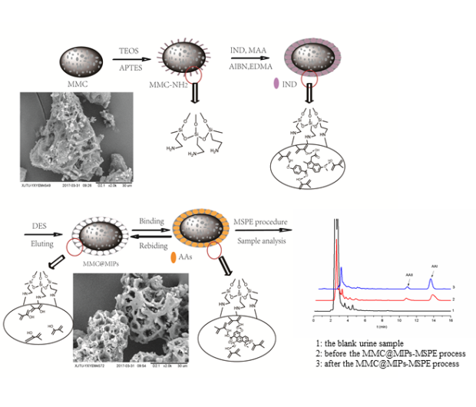
Figure 1 The preparation and application scheme of MMC@MIPs
Reference
[1] A.W.T. Ng, S.L. Poon, M.N. Huang, J.Q. Lim, A. Boot, W. Yu, Y. Suzuki, S. Thangaraju, C.C.Y. Ng, P. Tan, S.T. Pang, H.Y. Huang, M.C. Yu, P.H. Lee, S.Y. Hsieh, A.Y. Chang, B.T. Teh, S.G. Rozen (2017), Science Translation Medicine. https://doi.org/10.1126/ scitranslmed. aan6446
[2]Y. Ge, P. Guo, X. Xu, G. Chen, X, Zhang, H Shu, B. Zhang, Z. Luo, C. Chang, Q. Fu (2017). Journal of Separation Science. 17, 2791–2799

Biography
Yanhui Ge has her expertise in pharmaceutical analysis in traditional Chinese medicine. Her open and contextual evaluation model was based on selective molecularly imprinted polymers. She has studied this field after years of experience in research and evaluation in university.
Phone: +86 029 82655382

Email: geyanhui@stu.xjtu.edu.cn
Abstract type: Poster presentation
Session name/Track: HPLC

