CASE STUDY: Using Orofacial Myofunctional Therapy as an Adjunct Treatment Approach to Obstructive Sleep Apnea (OSA)
Dana Hockenbury, MA, CCC-SLP, COM
PURPOSE: The purpose of this case study was to demonstrate improved nighttime breathing using Orofacial Myofunctional Therapy (OMT) as an adjunct treatment approach with patients who have been diagnosed with Obstructive Sleep Apnea (OSA).
BACKGROUND: The field of OMT, evaluating and treating Orofacial Myofunctional Disorders (OMDs), historically focused on achieving appropriate diurnal and nocturnal tongue and lip resting postures. Re-patterning a tongue thrust swallow with saliva, liquid and solid boluses and eliminating noxious oral habit are addressed when necessary. This important conditioning work stabilizes the oral complex, avoiding orthodontic relapse in children through adults^{3,4,5,7}
The field of orofacial myology has expanded into the assessment and referral of SDB regarding soft tissue concerns^{3,10} such as hypertrophied tonsils, adenoids or ankyloglossia. When the ability to breathe through the nose is interrupted or compromised due to these various soft tissue concerns, mouth breathing is encouraged; a sequela of related health issues will ensue^{3,6,10}. Once these required surgical interventions related to SDB are conducted, traditional OMT can begin.
Current research has demonstrated when oropharyngeal exercises are prescribed to patients diagnosed with mild to moderate OSA, severity and symptoms are significantly reduced ¹. Specifically, the research found a decrease in snoring frequency and intensity, daytime sleepiness and OSA severity (AHI)⁸. An increase in overall sleep quality score was observed; sleepiness decreased as oxygen saturation rates increased ⁹. Therefore, orofacial myofunctional therapy should be a part of a treatment approach to wellness for patients with OSA ^{1,8,9,10}.
SUBJECT: A 60 year old white male was diagnosed with moderate OSA during a nocturnal polysomnography in a sleep lab. A treatment plan was developed to include the use of a night time oral appliance (SomnoMed) to advance his jaw forward to encourage improved breathing while sleeping. A second sleep study was conducted with the prescribed oral appliance in place. Night time breathing with snoring did not improve; AHI was recorded as 22.8 per hour, sleep architecture was fragmented and lowest desaturation was 89%. As a result, a Continuous Positive Airway Pressure (CPAP) machine was recommended, tried, but couldn’t be tolerated. A previous ENT evaluation was unremarkable.
The patient was then referred for an orofacial myofunctional examination; case history was taken and an evaluation was conducted. The Epworth Sleepiness Scale, Berlin Questionnaire and the Pittsburg Sleep Quality Index were completed to obtain a subjective baseline. Pre-therapy intra-oral pictures were taken to establish Mallampati Grade and Friedman’s Tongue Position. Oropharyngeal exercises¹ were taught and prescribed twice daily.
RESULTS: The patient attended all 8 scheduled monthly therapy sessions. He was highly compliant, executing the exercises as prescribed and instructed. Intra-oral photos were taken at each session and shared with patient. At the conclusion of treatment, the Epworth Sleepiness Scale, Berlin Questionnaire and the Pittsburgh Sleep Quality Index were once again completed for comparative purposes.
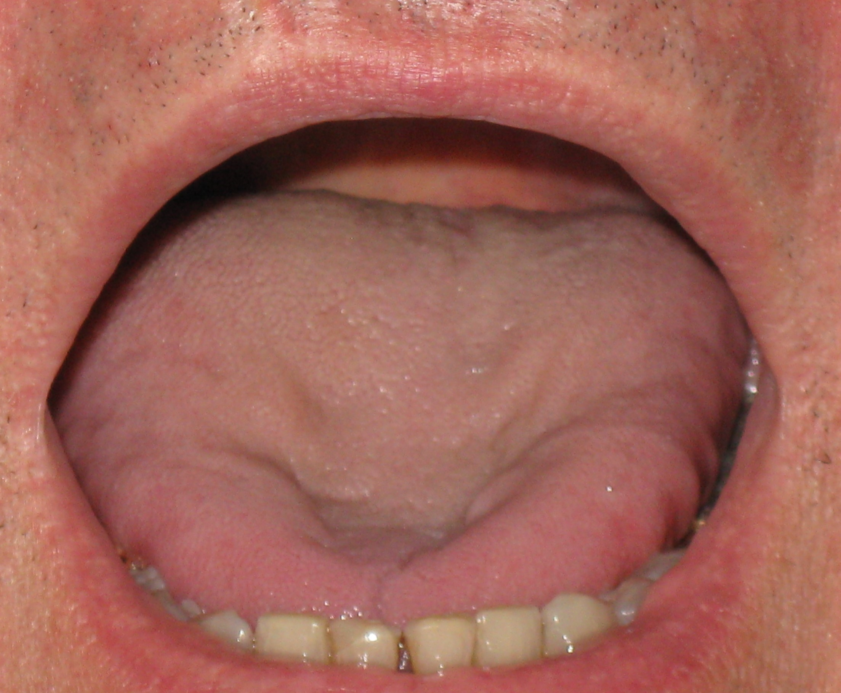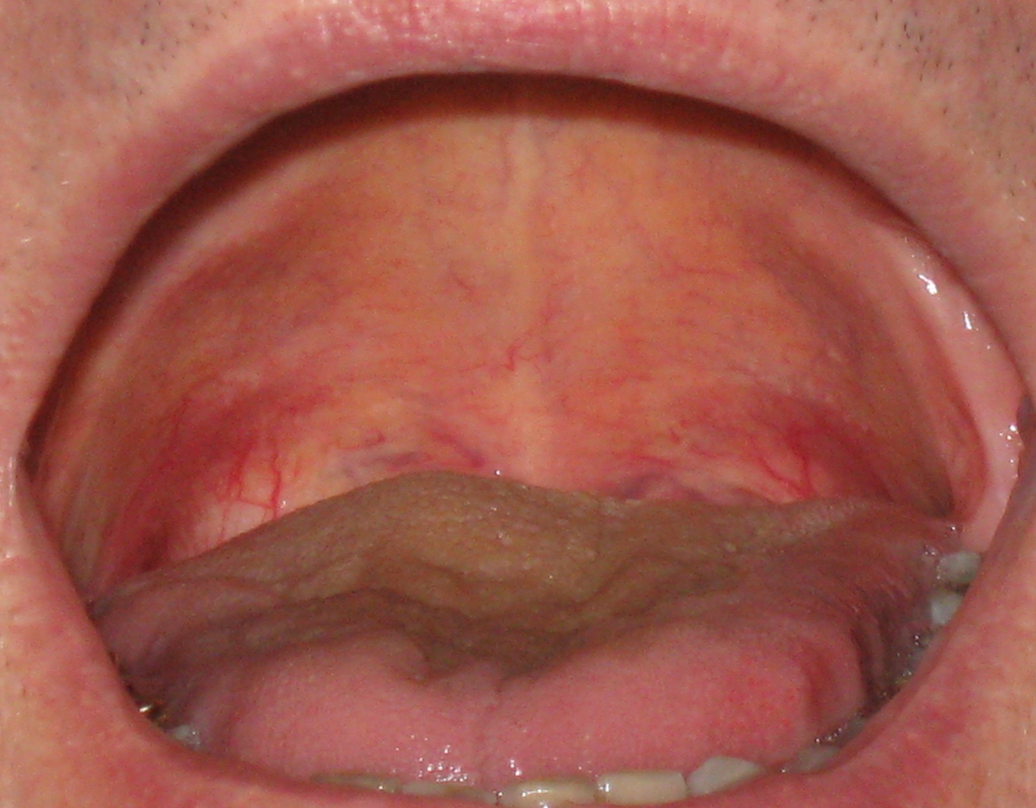
Post –Therapy November
Pre-Therapy April

A follow-up home sleep study using the Watch-Pat device was then conducted. The same SomnoMed oral appliance was worn during the sleep study. The clinical findings of this test were negative for OSA; the patient had an AHI of 4.4 events per hour (normal <5, mild 5-14, moderate 15-30, severe >30). The mean SaO2 was 96%. Snoring did not occur.
Comparison of pre- and post-therapy pictures revealed Friedman’s Tongue Position changed from Position IV to Position I. The Mallampati score, which could not be observed or determined during the initial evaluation, was presented as Grade III post-therapy.
Comparing the pre- and post-therapy subjective questionnaires indicated significant changes in reported sleep quality. The Epworth Sleepiness Scale indicated chances of dozing decreased from ‘2-3’ to ‘0-1’ a day. On the Berlin Questionnaire, ‘no snoring was reported, patient noted he ‘quit breathing nearly nightly’ to ‘never’ and feeling fatigued decreased from ‘daily’ to ‘3-4 times a week’. The Pittsburgh Sleep Quality Index reported the ability to ‘fall asleep faster’, ‘greater ability to breathe comfortably’ with overall sleep quality rating improved from ‘fairly badly’ to ‘fairly good’. The need for sleep medicine (Melatonin) from ‘>3/week’ to ‘<once a week’ was reported.
The patient was then discharged; recommendation was made to execute the exercises 3x weekly.
CONCLUSION: Since significant objective and subjective changes were demonstrated, Orofacial Myofunctional Therapy as an adjunct therapy has extreme value. Formal incorporation of assessment and treatment of sleep-disordered breathing into the practice of Orofacial Myofunctional Therapy must become standardized. Given the importance of this conclusion, an Orofacial Myofunctional Therapist be recognized as a valued member of the dental team whose task is to comprehensively co-manage patients with sleep-disordered breathing.
REFERENCES:
- Guimaraes, Drager, Genta, Marcondes, Lorenzi-Filho Effects of oropharyngeal exercises on patients with moderate obstructive sleep apnea syndrome American Journal of Respiratory and Critical Care Medicine 2009, vol 179 962-966
- Camacho, Certal, Abdullatif, Zaghi, Ruoff, Capasso, Kushida Myofunctional therapy to treat obstructive sleep apnea: a systematic review and meta-analysis Sleep, 2015 38(5): 669-675
- Guilleminault & Sullivan, Towards Restoration of Continuous Nasal Breathing as the Ultimate Treatment Goal in Pediatric Obstructive Sleep Apnea Enliven: Pediatrics and Neonatal Biology, 2014, V1 (1):1-5
- Hanson, M., Mason, R., Orofacial Myology: International Perspectives Charles C. Thomas, Publisher, Springfield Illinois, Second Edition
- Smithpeter & Covell Relapse of anterior open bites treated with orthodontic appliance with and without orofacial myofunctional therapy AJODO 2010 605-614
- Mahony & Williams The effects of enlarged tonsils and adenoids on a developing malocclusion Journal of the American Orthodontic Society 2007 24-33
- Paskay OMD Orofacial Myofunctional Disorders; Assessment, Prevention and Treatment JAOS 2012 April: 34-40
- Guilleminault, Huang, Monteyrol, Sato, Quo, Lin Critical role of myofascial reeducation in pediatric sleep disordered breathing Sleep Med 2013: 14(6):518-25
- de Castro Correa & Berretin-Felix Myofunctional therapy applied to upper airway resistance syndrome: a case report CoDas 2015 vol 27(6)
- Frey, Green, Fabbie, Hockenbury, Foran, Elder The essential role of the COM in the management of sleep-disordered breathing: a literature review and discussion IJOM 2015
- Homem, M., Vieira-Andrade, R., Falci, S., Ramos-Jorge, M., and Marques, L. (2014). Effectiveness of orofacial myofunctional therapy in orthodontic patients: A systematic review. Dental Press J Orthod. Jul-Aug; 19(4): 94–99.

CASE STUDY: Using Orofacial Myofunctional Therapy as an Adjunct Treatment Approach to Obstructive Sleep Apnea (OSA)
Dana Hockenbury, MA, CCC-SLP, COM

250-word or less abstract:
The purpose of this case study was to demonstrate improved sleep disordered breathing (SDB) with patients diagnosed with Obstructive Sleep Apnea (OSA) using Orofacial Myofunctional Therapy (OMT) as an adjunct treatment approach. Because of the significant improvement in night time breathing, orofacial myologists should be a member of a dental / sleep team when treating patients diagnosed with OSA.

500-word or less summary for the poster committee to review which should include clearly labeled “Learning Objectives” (max 3):
Learning Objective 1: Describe significant changes in Sleep Disordered Breathing (SDB) of those diagnosed with Obstructive Sleep Apnea (OSA) using oropharyngeal exercises
Learning Objective 2: Describe a treatment program created for patients with OSA
Learning Objective 3: Promote the importance of working as a team member to comprehensively co-manage the patient with SDB

Biosketch:
Dana Hockenbury, M.A., CCC-SLP, COM, retired from the NYC public schools as a speech pathologist after +25 years. Her full time private practice is dedicated to evaluating and treating Orofacial Myofunctional Disorders in children through adults. She founded the Tri-State Orofacial Myology Study Club. Dana and a college launched TRES OM, a complete website for orofacial myologists. She is an active member of the IAOM and currently serves as the Education Committee Chair.


2017 Annual IAOM Convention
Holiday Inn San Diego Bayside, San Diego, CA
Call for Posters Application

The following must accompany this completed form:
- 250-word or less abstract
- 500-word or less summary for the poster committee to review which should include clearly labeled “Learning Objectives” (max 3)
- 50 word or less Biosketch on ALL presenters
- If submitting a Research Brief:
In a Word Document, please provide the following information
    - Background of the problem
    - Purpose and Objectives of the Study
    - Methodology/Preliminary Results
Important Dates:
- Submission Deadline for requested documentation is April 7, 2017.
- You will be notified by May 1, 2017 if your submission has been accepted.
Presenter(s): (With professional titles as they should appear on the program)
Dana K. Hockenbury, MA, CCC-SLP, COM
Primary Presenter’s Contact Information:
Address: 565 West 169th Street Apartment 6G, NY, NY 10032
Work #: 646-334-1713 Cell #: 646-334-1713 Fax #: none
Email Address: dkhnyc@aol.com
Poster Title CASE STUDY: Using Orofacial Myofunctional Therapy as an Adjunct Treatment Approach to Obstructive Sleep Apnea (OSA)
Submission Track: X Clinical Techniques/Treatment □General □Research
X Professional Education □Other___________________

2017 POSTERS AUTHORS AGREEMENT FORM
By submitting a poster for the IAOM Convention, you agree to the following:
- Unless specifically designated and pre-approved, IAOM programs are noncommercial forums. The inclusion of products, services, and materials used for practice and research is encouraged when efficacy is supported by evidence. However, the poster platform is not intended as a forum for sales or marketing activity.
- All authors must disclose to participants, prior to the presentation, any proprietary interest in any product instrument, device, service, or materials discussed in a presentation as well as the source of compensation related to the presentation. Please review and sign the provided disclosure forms.
- All poster authors are expected to follow accepted procedures to protect human subjects and confidentiality.
- All presenters will follow the guidelines for crediting authorship for research presentations as outlined in the Publication Manual of the American Psychological Association.
Signatures of Presenters: Date:
Dana Hockenbury June 1, 2017

IAOM Financial Relationship Disclosure Form
Copy this page as many times as you need in order for us to have complete information regarding each of your relevant financial relationships. The Poster/Paper author/presenter has a relevant financial relationship that could influence the information presented in the poster/paper and could be perceived as a conflict of interest to the learners/viewers.
Poster Author’s Name: Dana K. Hockenbury date: June 1, 2016
Financial relationship with (name of the Company/Organization): NONE
What was received? (Check all that apply) ☐Salary ☐Consulting Fee ☐Gift ☐Grants ☐Intellectual property rights ☐Royalty ☐Honoraria ☐In kind ☐Speaking Fee ☐Hold patent on equipment ☐Ownership interest (e.g. stocks, stock options or other ownership interests excluding diversified mutual funds) ☐Other financial benefit Please explain: ______________________________________________________________________
For what role? (Check all that apply) ☐Employment ☐Management position ☐Consulting ☐Teaching/speaking ☐Board membership ☐Ownership ☐Membership on advisory committee or review panels ☐Independent contractor (including contracted research) ☐Other (Please describe): ______________________________________________________________________
IAOM Non-Financial Relationship Disclosure Form
Copy this page as many times as you need in order for us to have complete information regarding each of your relevant non- financial relationships. The poster/paper author/ presenter has a relevant non-financial relationship that could influence the information presented in the poster/paper and could be perceived as a conflict of interest to the learners/viewers.
Poster Author’s/Presenter’s Name: Dana K. Hockenbury date: June 1, 2017
Non-financial relationship with (name of the Organization): NONE
What is the nature of the non-financial relationship? (Check all that apply) ☐Personal ☐Professional ☐Political ☐Institutional ☐Personal interest ☐Bias ☐Other relationship
Please describe: ______________________________________________________________________
For what role? (Check all that apply) ☐Volunteer Employment ☐Volunteer teaching/speaking ☐Volunteer consulting ☐Board membership ☐Volunteer membership on advisory committee or review panels ☐Other volunteer activities (Please describe)______________________________________________________________
I attest that the information in this disclosure is accurate at the time of completion. I agree to notify the IAOM of any changes to this information between now and the presentation.
Signature: Dana Hockenbury Date: June 1, 2017

