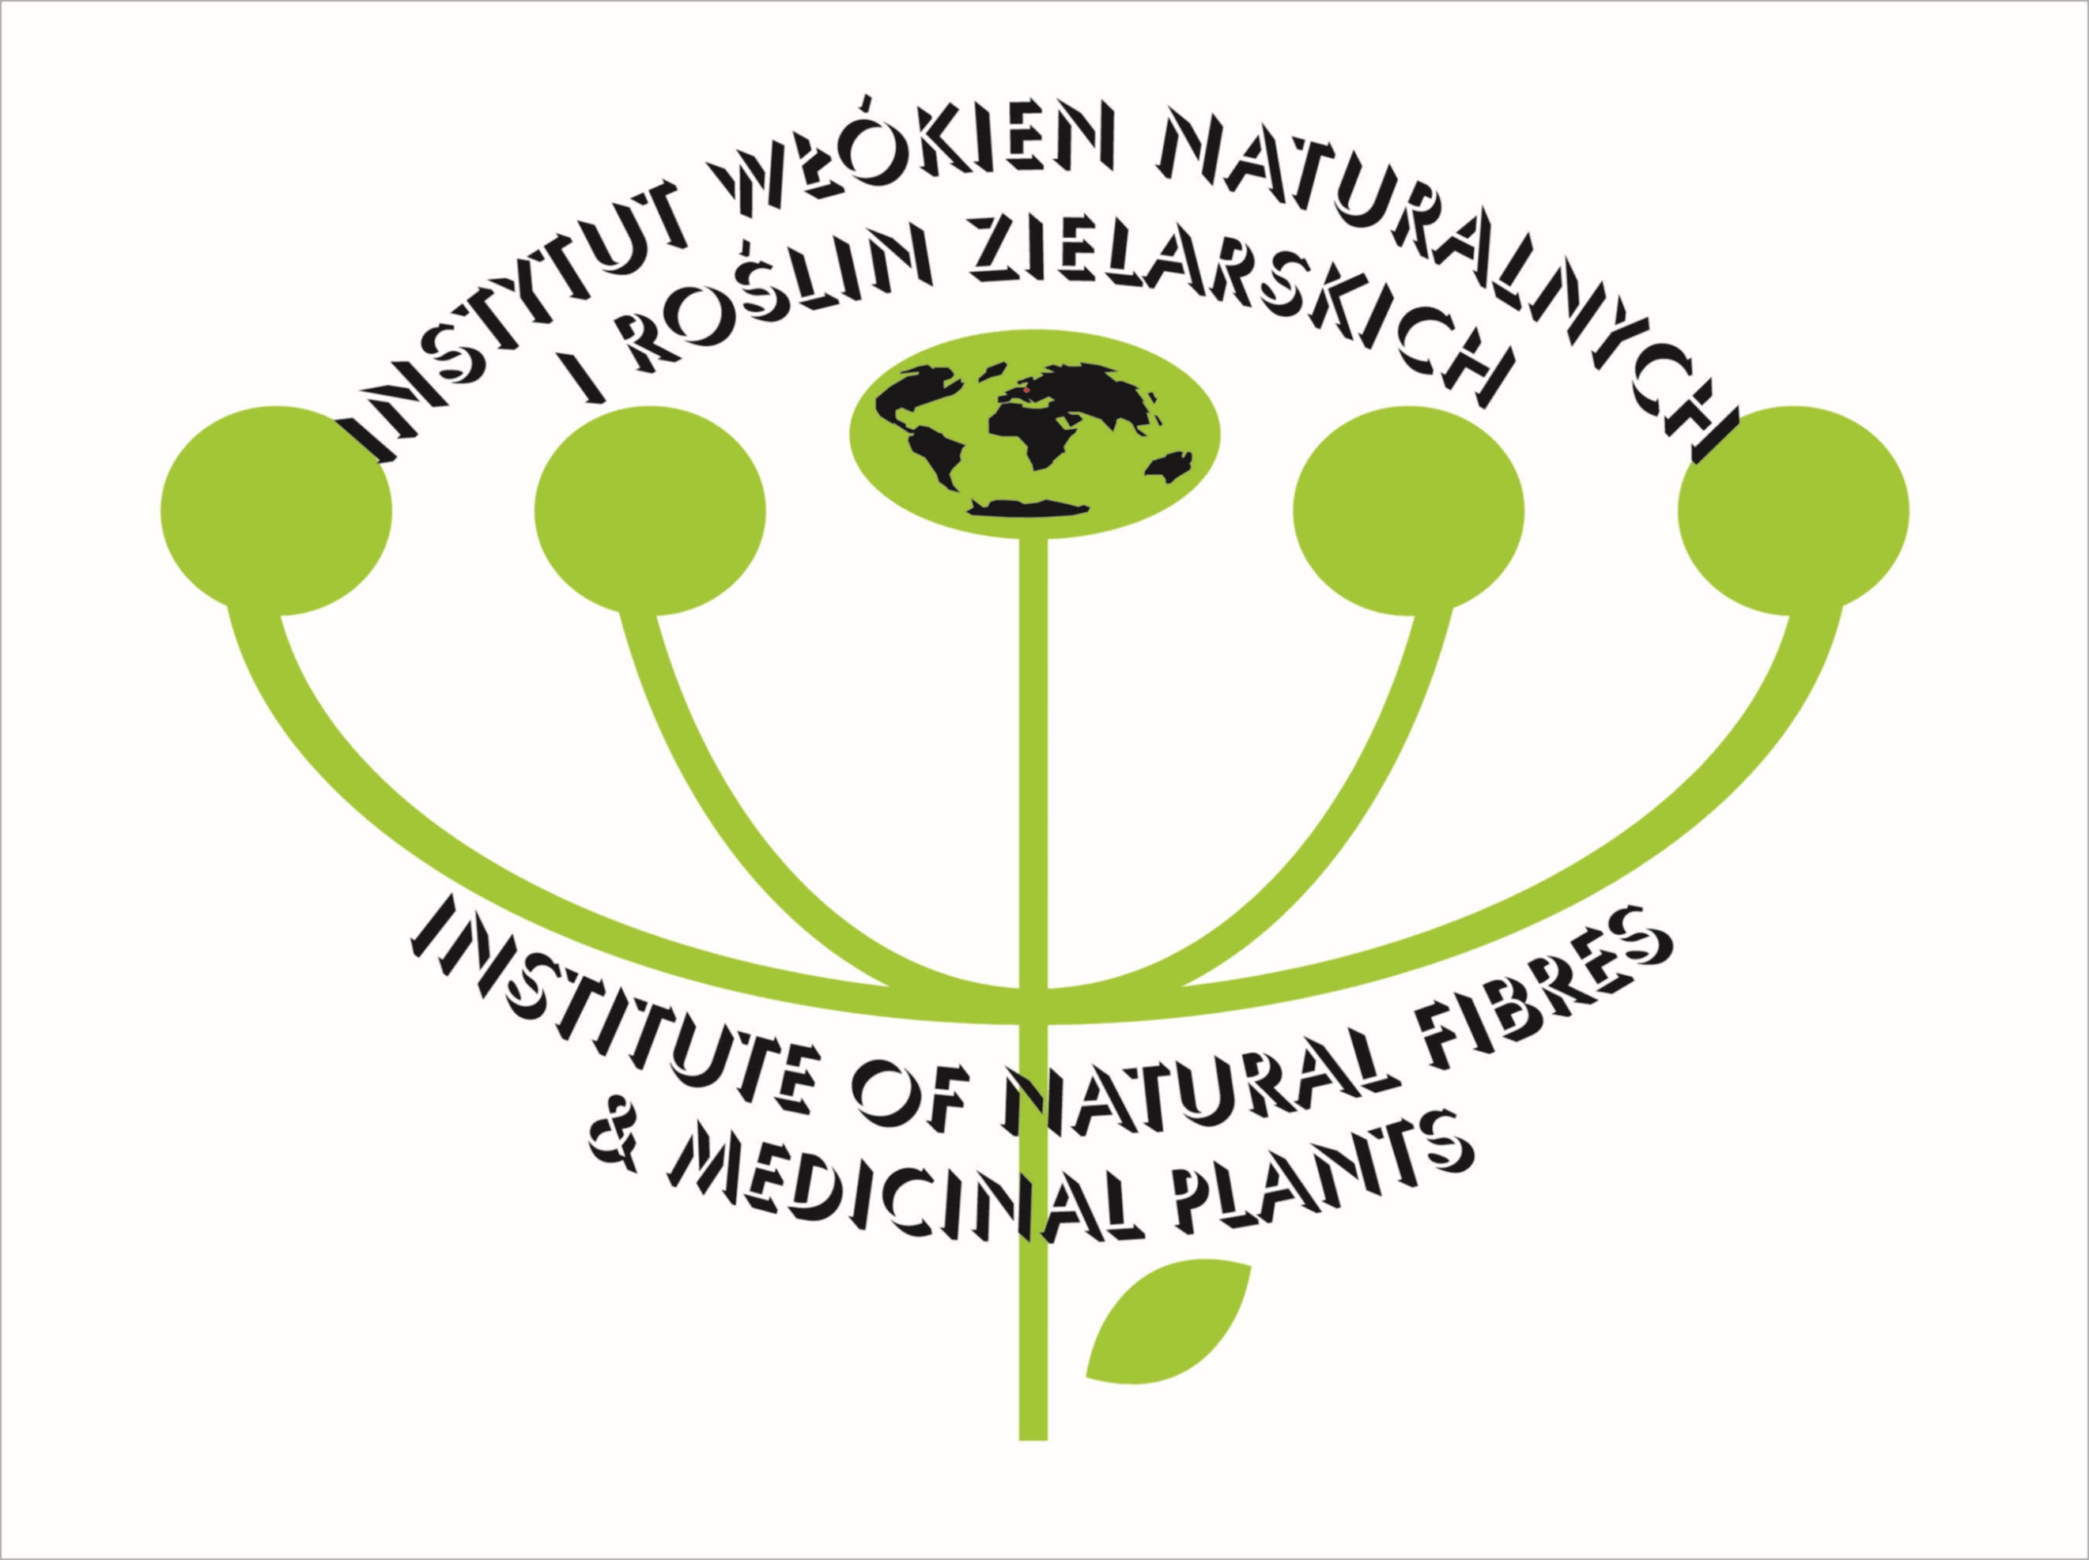

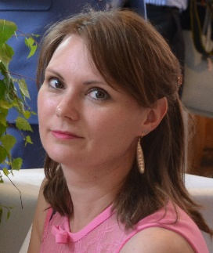

Title: New perspectives in sericulture
Name: Małgorzata Łochyńska

Institute of Natural Fibres and Medicinal Plants, Wojska Polskiego 71B, 60630 Poznan, Poland

Numerous new applications of the mulberry silkworm (Bombyx mori L.) and the white mulberry (Morus alba L.) significantly increase the value of sericulture. Due to the bioactive substances contained in the leaves and silk, farmers are increasingly interested in the production of leaves as herbal raw material and silk cocoons. Additionally, products and by-products obtained from sericulture may be used in agriculture, medicine and industry. Beyond the commonly known sericulture attributes, silk proteins - fibroin and sericin – and almost 300 hemolymph are uncommon bioactive. The aim of this lecture is to present fascinating insect and its host and all possibilities to use them in human life.

Biography

Małgorzata Łochyńska has completed his PhD at the age of 26 years from Adam Mickiewicz University in Poznan. She is the head of Department of Silkworms Breeding and Mulberry Cultivation INF&MP in Poznan. She has published more than 70 papers in international journals and attended in 93 research conferences.

