
Microfluidic double emulsion and particle for a controlled release of therapeutic peptide.
Marine Truchet
ESPCI, 75005 Paris, France

Encapsulation of peptide therapeutics have a growing significance in pharmaceutical and biotech industry to controlled the release over weeks or months. If the capsules is made from biodegradable polymer, it will degrade slowly and release the drug progressivel. To fabricate the particle, people often uses the double emulsion/solvent removal method[1]. A double emulsion of water in oil in water (W/O/W) is formed. The active ingredient is within the inner water droplet. The middle phase composed of the solvent and the biodegradable polymer is then solidified. The emulsification process is mostly performed with mechanical stirring or ultrasonication, a process that enables the creation of large volumes of emulsions but results in very bad monodispersity and low encapsulation yield[2].
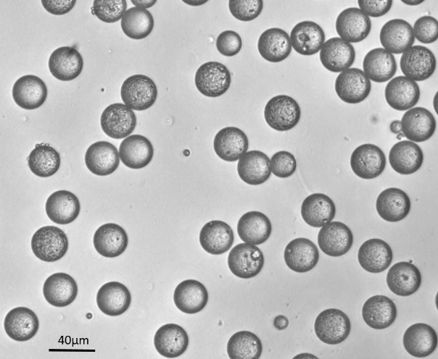
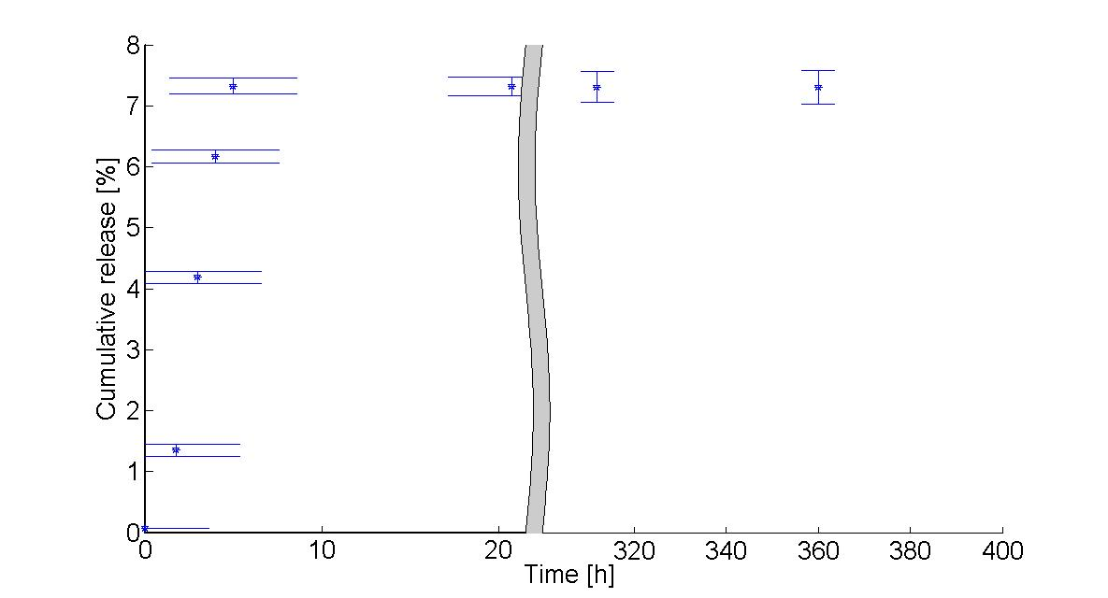
The production of monodispersed (W/O/W) double emulsions using different microfluidics technologies has been demonstrated ([3], [4], [5]). However, no one can be used as is to prepare microparticles with desired properties compatible with control delivery of APIs. Each technique having one or several limitations: compatibility of chips with solvents, low throughput, droplet size … In this study, we solved those problems by combining traditional tehcnologies with microfluidics. Our three-step hybrid process allow the formation of very well controlled size, morphology and drug loading particles. We managed, for the first time, to obtain micro-particles with desired particle size, whose structure is controlled and adapted to the delivery challenge we address. We are now able to study precisely the mechanism of release and the influence of each parameter on the drug release.
Figure 2 Cumulative release of active ingredient in PLGA particles
Figure 1 Polymeric particles made with a process combining traditional methods and microfluidics

[1] Vrancken, M. N. and Claeys, D. A., US Patent 3, 523, 906, (1970).
[2] Microspheres for protein delivery prepared from amphiphilic multiblock copolymers. Bezemer, J. M et al. (2000). Journal of Controlled Release, 67, 233–248.
[3] Controlled Production of Monodisperse Double Emulsions by Two-Step Droplet Breakup in Microfluidic Devices, S.Okushima et al, Langmuir, 20, 9905 (2004).
[4] Monodisperse Double Emulsions Generated from a Microcapillary Device, Utada et al, D.A. Science 308, 537 (2005).
[5] Microfluidics-assisted engineering of polymeric microcapsules with high encapsulation efficiency for protein drug delivery, J. Pessi et al, International Journal of Pharmaceutics 472 (2014) 82-87

Biography

Marine Truchet is a third year PhD student from ESPCI in Paris. Before starting is PhD, Marine obtained an engineer diploma, in one of the best Engineering School in France, Centrale Nates. She realized then an 8-month internship in a biotechnological start-up, Twist Bioscience. This experiment permit her to discover microfluidic and to aquire strong knowledge in biotechnology. This PhD project is a collaboration with the Gulliver laboratory in ESPCI and the pharmaceutical company SANOFI.

Presenting author details
Full name: Truchet Marine
Contact number: +331 40 79 59 68
Twitter account:
Linked In account: https://www.linkedin.com/in/marine-truchet-8728494a/
Session name/ number: Health & Pharmaceutical Biotechnology /session 1
Category: Oral presentation

