Title: A systems pharmacology approach to higher order drug combinations in prostate cancer

Dr. H. Alexander Ebhardt, Systems Biology Ireland, University College Dublin, Ireland.

Abstract (300 word limit)

Introduction

Healthy aging in men coincides with regular screening of their prostate as malignancies may develop at any time. Malignancies in prostate start as local disease but aggressive tumour development might lead to a non-localized metastatic disease state (mPCa). The unmet clinical need remains: eradicate mPCa and return men to health.

Methods

We used evolutionary modelling to estimate the number of drugs necessary to eradicate mPCa. Then we carried out a perturbation study in which we treated mPCa models with six drugs in single and all double drug combinations. Changes to the proteome were quantified using targeted proteomics and reverse protein arrays. This analysis identified a number of proteins and signal transduction pathways to be targeted in a triple drug combination. Commercially available inhibitors had uncertain binding specificity against the target and we used structure-based drug design to assess their specificity. Following our analysis, triple drug combinations were tested in a mPCa model.

Results

Due to the tumour burden and heterogeneity in mPCa, more than two drugs are required to obtain a reduction in tumour mass. Most likely triple combination therapy will be necessary to overcome the emergence of drug resistance and return men to health. Identifying ways in which tumours block the action of 2 drugs is a way of prioritizing drug targets for triple combinations.

Conclusions

The combined approach of in silico modelling and systems pharmacology resulted in a promising new drug combination to treat mPCa.
Image

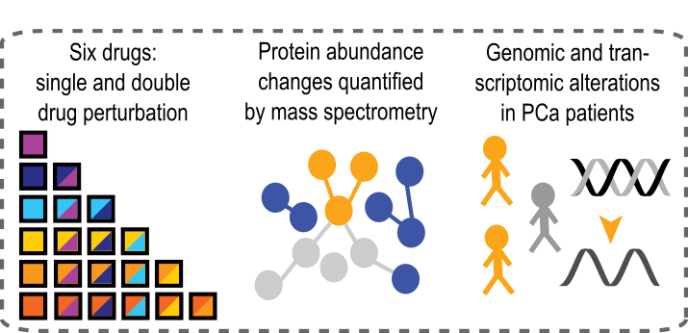
Recent Publications (minimum 5)
- A. Root, H. A. Ebhardt, A two-drug combination simulation study for metastatic castrate resistant prostate cancer. The Prostate, (2018).
- H. A. Ebhardt, A. Root, Y. Liu, N. P. Gauthier, C. Sander, R. Aebersold, Systems pharmacology using mass spectrometry identifies critical response nodes in prostate cancer. NPJ Syst Biol Appl 4, 26 (2018).
- A. Root, A. Beizaei, H. A. Ebhardt, Structure-based Assessment and Network Analysis of Targeting 14-3-3 Proteins in Prostate Cancer. MOLC-D-18-00730R1

Biography (150 word limit)
H. Alexander Ebhardt obtained his PhD in Molecular Biology and Biochemistry from Simon Fraser University, B.C., Canada investigating endogenous and exogenous small RNAs in a virally infected system (PNAS 2005). Besides RNA proteins play a vital role in the life cycle of biological systems. Hence, he expanded his expertise to include quantitative mass spectrometry. At ETH Zurich, Switzerland, he applied his new gained analytical expertise to prostate cancer. Using a systems pharmacology approach his research aimed at identifying new protein targeted for higher order drug combination therapy for metastatic castrate resistant prostate cancer. Now Junior Group Leader at Systems Biology Ireland, his research continues in the area of prostate cancer which will be presented during this conference.
Email: h.a.ebhardt@ucd.ie

Notes/Comments:

Adv.Bioinformatics 2018

