High Altitude and Preeclampsia: Adaptation or Protection.

Sarah I Y Ahmed
Institute of Endemic Diseases, University of Khartoum

Abstract
Background: Adaptive genes of high altitudes in the Chinese Tibet, African Ethiopian plateau, and the Andeas of America can also be protective in diseases like preeclampsia, hypertension, and diabetes mellitus, Alzheimer, Parkinson Disease and Cancer, which may result from deregulation of hypoxia pathway. Recently, “acclimatized” sea level Sojourners on ascent were found to acquire similar genotypic and allelic frequencies of certain adaptive genetic variants as in “adapted” high altitude natives, and this enables them to overcome the oxygen deprivation through integrated physiological processes while the high altitude natives are adapted to the prevailing hypoxic condition through natural selection. Objective: To study the genetic variants of high altitude adaptive genes in the samples of preeclampsia in compare to normal pregnancy controls as signs of acclimatization and adaptation. Methods: Using computational tools, a total of 36 RNA-seq samples from the amniotic fluid, were retrieved from NCBI; 19 pre-eclamptic samples and 17 full-term birth samples. Variant calling pipeline was performed for the raw RNA-seq reads. FASTQ files were downloaded from the database and were aligned to the human genome build GRCh37/hg19 using STAR-based aligner ‘Hisat2’ to identify both known and novel SNPs and indels. Samples were further processed by marking duplicates and sorting, trimming, realigning indels and recalibrating sequences, according to the recommended workflow from the Broad Institute. All the samples have passed quality control assessment using FASTQC. Filtered variants were evaluated by variant annotation using snpEff, and were further annotated using Ensemble Variant Effect Predictor. All the variants in the variant calling file (VCF) were considered and were compared between cases and controls. Results: Adaptive variants of genes that were found predominately in highlanders and in acclimatized individuals on ascent, were also found both in normal hypoxia of pregnancy (N=52.9%) and in pathological condition of preeclampsia(N=42.1%), with no significant difference. Interestingly, higher adaptive alleles frequency (AF) were found in normal controls of pregnancy(AF= 0.103) compared to cases of Pre_eclampsia (AF=0.065) with p value = 0.003. The mean homozygous genotype frequency (GF) for adaptive variants were even much higher in controls (GF = 0.074) than in cases (GF = 0.027) with P value = 0.0001. Interpretation: The high homozygous genotype frequency of adaptive alleles in the controls, indicates the higher ability of controls to retain beneficial variants, which can ultimately drives the natural selection of variants towards fitness, while the heterozygosity of cases reflects the higher genetic variability that is associate with slow fixation rate for the adaptive alleles, which results in insufficient adaptation of spiral arterioles and shallow trophoblastic invasion, resulting in reduced uteroplacental blood flow leading to placental hypoxia, which is believed to be the underlying cause of Pre_eclampsia. Conclusion: Understanding the mechanisms of acclimatization and adaptation in acclimatized individuals and ancient indigenous populations of high altitude in comparison to other hypoxia-related disorders can pave the way to new treatment strategies that can help the body to earn some genetic tricks in the roadway of evolution and adaptation.

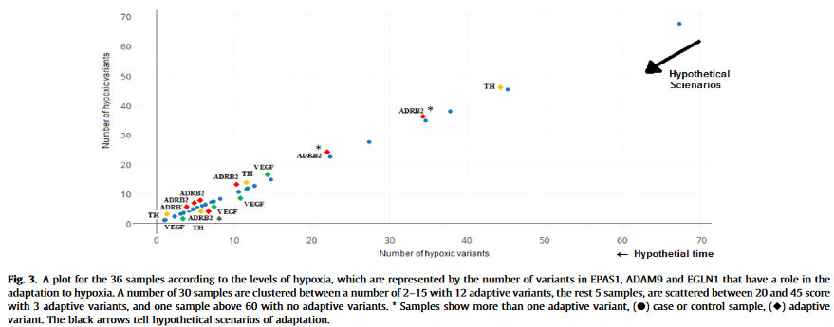
1. Tomar A, Malhotra S, Sarkar S. Polymorphism profiling of nine high altitude relevant candidate gene loci in acclimatized sojourners and adapted natives. BMC Genet BMC Genetics 2015;16:112.
2. Tal R. The role of hypoxia and hypoxia-inducible factor-1 alpha in preeclampsia pathogenesis. Biol Reproduct 2012;87(6):134. 1–8.
3. Rath G, Aggarwal R, Jawanjal P, Tripathi R, Batra A. HIF-1 alpha and placental growth factor in pregnancies complicated with preeclampsia: A qualitative and quantitative analysis. J Clin Lab Anal 2016;30:75–83.
4. Cui SF, Wang C, Yin X, Tian D, Lu QJ, Zhang CY, et al. Similar responses of circulating MicroRNAs to acute high-intensity interval exercise and vigorous-intensity continuous exercise. Front Physiol 2016;7:102.
5. Weiss M, Brandenburg L, Burchardt M, Stope MB. MicroRNA-1 properties in cancer regulatory networks and tumor biology. Crit Rev Oncol Hematol.2016;104:71–7

Biography

Sarah I Y Ahmed has completed her MSc in Molecular Medicine from Institute of Endemic Diseases, University of Khartoum, Khartoum, Sudan. BSc on Medical Laboratory Science from University of Khartoum. She is intrigued by the concept of evolutionary adaptation, and she believed that developing computational tools and methods to exploit high-throughput genomics data is an important step towards understanding the mechanisms of evolutionary processes.

The scientific paper is published by the British journal “Medical Hypotheses” in 2017.

