Title: Predictions of the structure of Bacillus subtilis GerA germination receptor complex in the membrane model.
Authors: Inga Jamrozek^{1,2}, Pawel Przygocki², Rajmund Kazmierkiewicz², Michal Obuchowski¹
Affiliations: ¹ Intercollegiate Faculty of Biotechnology University of Gdansk and Medical University of Gdansk, Laboratory of Molecular Bacteriology, Gdansk, Poland; ² Intercollegiate Faculty of Biotechnology University of Gdansk and Medical University of Gdansk Laboratory of Biomolecular Systems Simulations, Gdansk, Poland;

Abstract (300 word limit)
Statement of the problem: Spores of Bacillus subtilis are extremely resistant to harsh environmental factors and can survive for years in their dormant state. However when the favorable conditions arise spores can rapidly lose their dormancy and resistance in the process of spore germination. Germination can be triggered by germinants – nutrients, that bind to a specific germination receptor (GR). One of such receptors, and the main interest of this study is GerA GR, which is composed of three subunits: GerAA, GerAB and GerAC, and is located in the spore inner membrane. Subunits A and B are predicted to be integral membrane proteins and responsible for germinants binding. Hoverer, up to now there is no definitive knowledge describing the 3D structure of this receptors.
Methodology: Models of GerA subunits were predicted using homology modeling approach, using Modeller program. Due to lack of close structural homolog GerAA and GerAB models were predicted using multitemplate modeling approach. Based on protein-protein interaction sites prediction, on biological assembly of templates used in homology modeling and on the similarity in the Grs clustering process to chemotaxis receptors clustering, we proposed that GerA subunits may form homodimers or homotrimers. Homocomplexes were predicted using protein-protein and symmetrical docking methods; using SAM program, ClusPro, ROSIE and GrammX servers. Proposed models of GerA receptor were built based on the protein-protein interaction sites prediction and using two approaches: molecular dynamics simulation in AMBER package and a spontaneous proteins aggregation simulations. Models of GerA receptor were embedded into biological membrane model and optimized using the MARTINI force field.
Findings and significance: We were able to propose models of GerA germination receptor complex embedded into membrane model. Determination of GerA receptor structure and topology is an important step in study on the relationship of structure and function and on the mechanism of action of GerA receptor.

Image
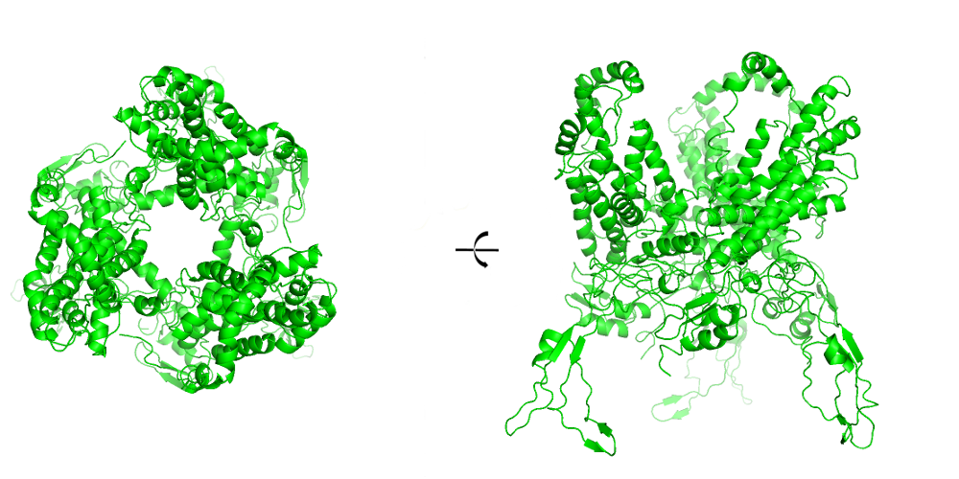
Fig. 1: Homotrimer of GerAA subunit model.
Recent Publications (minimum 5)
- Korza G, Setlow P (2013) Topology and Accessibility of Germination Proteins in the Bacillus subtilis Spore Inner Membrane; Journal of Bacteriology 195:1484-1491
- Griffiths K et al.(2011) Germination proteins in the inner membrane of dormant Bacillus subtilis spores colocalize in a discrete cluster; Molecular Microbiology 81:1061-1077.
- Hsu Pin-Chia, et al. (2017)CHARMM_GUI Martini Maker for Modeling and Simulation of Coplex Bacterial Membranes with Lipopolysaccharides; Journal of Computational Chemistry 38:2354-2363.
- Li Y, Setlow B, Setlow P, Hao B (2010) Crystal Structure of the GerBC Component of a Bacillus subtilis Spore Germinant Receptor; J. Mol. Biol 402:8-16
5. Setlow P, (2014) Germination of Spores of Bacillus Species: What We Know and Do Not Know; Journal of Bacteriology 196:1297-1305

Biography (150 word limit)
Inga Jamrozek received her BA degree in Bioinformatics and MA degree in Biotechnology from University of Gdansk, Poland. She is a third year PhD student in the Intercollegiate Faculty of Biotechnology of University of Gdansk and Medical University of Gdansk. Her major research interests in developing a model of GerA receptor and molecular mechanism of its function. This study is an interdisciplinary research conducted with Laboratory of Molecular Bacteriology, Intercollegiate Faculty of Biotechnology of UG and MUG.
Email: inga.jamrozek@biotech.ug.edu.pl

Notes/Comments:

Bioinformatics Congress 2018

