Virtual Screening, Docking and ADMET studies of Novel Hybrid NSAIDs to Exploring Multiple Targeted Cancer Therapy
Ashish P Shah¹*, Chhagan N Patel²
¹Department of Pharmacy, Sumandeep Vidyapeeth, Vadodara, Gujarat, India
²Department of Chemistry, Shree Sarvajanik Pharmacy College, Mehsana, Gujarat, India

Abstract:
The traditional anticancer approaches, targets cancer cell proliferation interfering with non-specific targets (e.g. DNA), have been replaced, in the last few decades, by more specific target oriented therapy. However, single-target approaches have not always led to optimal outcomes because, for its complexity, cancer needs to be tackled at various levels by modulation of several targets. In-silico methods are useful tool for the search and design of selective multi-target agents. In silico studies are expected to reduce the risk of late-stage attrition of drug development and to optimize screening and testing by looking at only the promising compounds. The chemopreventive effect of non steroidal anti-inflammatory drugs (NSAIDs) is novel approach for cancer prevention. Benzothiazole and thiadiazole posses wide range of biological activity including anticancer. Both heterocyclic nucleuses were reported as inhibitors of receptor tyrosine kinase which have crucial role in oncogenesis. Importantly, they kill the cancer cells in target specific manner. Herewith we are reporting design of some new Hybrid NSAIDs by linking main structural unit of NSAIDs with benzothiazole and thiadiazole nucleus which may reduce inflammation of cancer site as well as kills tumor cells. Preliminary investigation done by performing docking study for inflammatory receptor COX-II, TNF-alpha and receptor tyrosine kinase to check their binding affinity using glide function of Schrödinger small molecule drug discovery suite. Many of the ligands show very good binding affinity against targeted proteins. All the designed ligands were validated for ADMET properties to find out drug likeliness. The bioactivity prediction of designed compounds shows good score in enzyme inhibition. Good docking score (binding affinity), bioactivity prediction score and drug likeliness of designed compounds suggest that Hybrid NSAIDs can be further explored multi-targeted anticancer therapy. Detail investigation of these results will be presented.


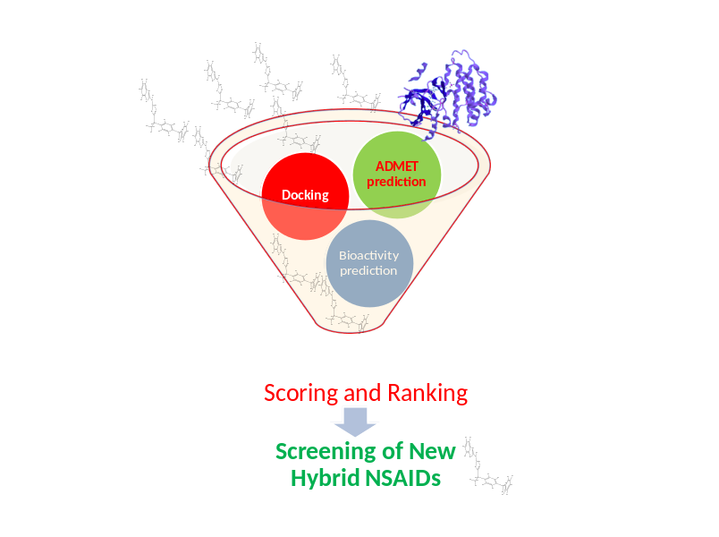 Fig: 1 Workflow of Virtual Screening
Recent Publications:
- Shah AP, Patel CN, Sureja DK, Sanghavi KP. A review on DNA repair inhibition by PARP inhibitors in cancer therapy. Folia Med (Plovdiv) 2018; 60(1):39-47. doi: 10.1515/folmed-2017-0067
- Panchal I, Sen DJ, Shah A, Patel A, Bhavsar V. Molecular Docking and Synthesis of Some Substituted Sulphonylurea/Pyrrolidine -Based Derivatives as Hypoglycemic Agents. Journal of Chemical and Pharmaceutical Research, 2017; 9(8):164-172.
- Shah AP, Patel CN. A Review on Some Proposed Targets and its Effective Molecules in Cancer Disease. International Journal of Pharma Research & Review, June 2016;5(6):37-50
- Ramani V, Sureja D, PatelM, Sanghavi K, Shah A, Sailor G, Seth AK, Synthesis, Characterisation and Antimicrobial activity of 2,3-disubstituted thiazolidin-4-one derivatives, Journal of Chemical and Pharmaceutical Research, 2016; 8(8):868-873.
- Shah A, Patel H. Synthesis and antifungal activity of imidazole and thiazole derivatives. Inventi Impact: Med Chem, 2015; 2015(4):23-26.

Mr. Ashish Shah is working in the area of insilico drug designing and synthetic medicinal chemistry since last five years. He is pursuing research in the field of new molecule development for cancer disease since last three years. He has also published review as well as research article relevant to his expertise. He has also presented poster on insilico drug design in various national and international conferences.
Email: ashishshah.dop@sumandeepvidyapeethdu.edu.in

