Title: Recovery & Redemption (21 Days to Renew the “Mindset”)
CJ HORNES, CACI, CAMF, USA

Statement of the Problem: Ex-Offenders that are reentering their communities have five common issues that stand to be addressed: mental health, substance abuse, housing, and homelessness, education and employment, and children and families. Methodology & Theoretical Orientation: In order to reach the target population and have an overall success rate we must not only address the current issues but we must address the issues from the past and convert negative thinking in which will potentially lead to a greater level of Emotional Intelligence. Emotional Intelligence allows the individual to adhere to a better decision making pattern which assists in the building of stronger relationships while incarcerated, at home, school, work, and with friends and family. Findings: Compulsive behavior involving drugs and alcohol abuse is often thought of as a moral, social or criminal issue. The reality of the situation is that the disease is more complex than most people realize. It is a disease that affects the brain; it is more about the neurology of the disease than it is about the outward behavior exhibited. Addiction is a disease that affects the neurotransmitters in the brain. The compulsive addictive behavior can supersede normal healthy behavior and cause an individual to constantly seek and use drugs (Koob & Volkow, 2016). In research we see that the prolonged drug usage will lead to cravings that feed the cycle of addiction. Eventually, addiction distorts an individual’s way of thinking, feeling and acting and this can lead to a person’s actions being labeled as being irrational. We conclude that detoxing is the first step in treatment but not just a physical detox but a mental detox.
Psychoneuroimmunology, however, has shown that the brain and nervous system, immune system and the hormonal system are all connected and work together. Traditional medicine, however, holds that the brain and the body, work in separation. Due to this connection, a change in one affects the other (Straub, 2014.

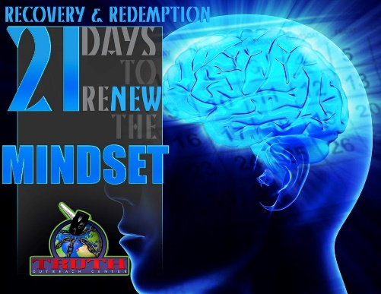

- Hornes, CJ. (2017). Don't Fit It, Don't Force It, Just Flush It. McDonough, Georgia.
- Hornes, CJ. (2017) Recovery & Redemption Workbook. 21 Days to a renewed Mindset.


Dr. CJ Hornes, published author holds a Doctorate of Divinity from CICA University and Seminary as well as the honor of Ambassador at Large and Chaplaincy. A Certified Alcohol & Drug Counselor, Certified Anger Management Facilitator trained by Anderson & Anderson Psychological Services, Dr. Hornes currently studies psychology and addiction with Purdue University Global. Unashamed to use her life experiences as a teaching mechanism, she openly shares her life with anyone that will listen. In 2011, she founded Truth Outreach Center a 501 (c) (3) non-profit organization that provides resources for homeless veterans, survivors of domestic violence and ex-offenders. A passionate goal to inspire and aspires to unlock the hidden potentials in others.
Email: hornescj@gmail.com
- Full Name: CJ Hornes
- Personal Email: hornescj@gmail.com
- Mobile Number: 678-814-33358
- Linked In: linkedin.com/in/drcjhornes
- Facebook: CJ Hornes
- Session Name/ number: Recovery & Redemption
- Category: Oral Presentation
- Date of Birth: February 9, 1973
- Postal Address: 916 Maple Leaf Dr. McDonough, Georgia 30253

Notes or Comments:

