Title of Abstract: Utilization of a Smartphone Addiction Management System for Achieving the Self-Control of Smart Devices

Ook Lee, Hanyang University Department of Information System, Korea(South)

Abstract
Statement of the Problem: Background: Smartphone addiction is a type of mental disorder that requires continuous treatment for cure and prevention. A smart phone addiction management system that is based on scientific evidence is required. This study proposes the design, development and implementation of a smart phone addiction management system for self-control of smart devices. Methods: The system architecture of the Smartphone Addiction Management System (SAMS) primarily consists of four sessions of mental monitoring: (1) Baseline settlement session; (2) Assessment session; (3) Sensing & monitoring session; and (4) Analysis and feedback session. We developed the smartphone-usage-monitoring application (app) and MindsCare personal computer (PC) app to receive and integrate usage data from smartphone users. We analyzed smartphone usage data using the Chi-square Automatic Interaction Detector. Based on the baseline settlement results, we designed a feedback service to intervene. We implemented the system using 96 participants for testing and validation. The participants were classified into two groups: the smartphone usage control group (SUC) and the smartphone usage disorder addiction group (SUD). Results: The background smartphone monitoring app of the proposed system successfully monitored the smartphone usage based on the developed algorithm. The usage minutes of the SUD were higher than the usage minutes of the SUC in 11 of the 16 categories developed in our study. Via the MindsCare PC app, the data were successfully integrated and stored, and managers can successfully analyze and diagnose based on the monitored data. Conclusion: The SAMS is a new system that is based on integrated personalized data for evidence-based smartphone addiction intervention. The SAMS is useful for managing usage data, diagnosing smartphone addiction, classifying usage patterns and predicting smartphone addiction. This system contributes to the diagnosis of a vague mental status, such as smartphone addiction, based on specific scientific indicators without reliance on consultation.

Image

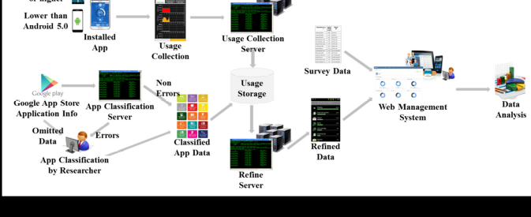

Fig. 1 System architecture of sensing and monitoring app.

Recent Publications & References

1. Chen, L.; Yan, Z.; Tang, W.J.; Yang, F.Y.; Xie, X.D.; He, J.C. Mobile phone addiction levels and negative
emotions among Chinese young adults: The mediating role of interpersonal problems. Comput. Hum. Behav.
2016, 55, 856–866. [CrossRef]
2. Chóliz, M. Mobile-phone addiction in adolescence: The test of mobile phone dependence (TMD).
Prog. Health Sci. 2012, 2, 33–44.
3. Gokcearslan, S.; Mumcu, F.K.; Haslaman, T.; Çevik, Y.D. Modelling smartphone addiction: The role
of smartphone usage, self-regulation, general self-efficacy and cyberloafing in university students.
Comput. Hum. Behav. 2016, 63, 639–649. [CrossRef]
4. Pavia, L.; Cavani, P.; Di Blasi, M.; Giordano, C. Smartphone Addiction Inventory (SPAI): Psychometric
properties and confirmatory factor analysis. Comput. Hum. Behav. 2016, 63, 170–178. [CrossRef]
5. Seo, D.G.; Park, Y.; Kim, M.K.; Park, J. Mobile phone dependency and its impacts on adolescents’ social and
academic behaviors. Comput. Hum. Behav. 2016, 63, 282–292. [CrossRef]



Biography
Ook Lee has completed his PhD at the age of 31 years from The Claremont Graduate University School of Information Systems and Technology in USA. He is the chairman and professor of Department of Information System at Hanyang University in Korea(South). He has published more than 100 papers in reputed journals and worked as a professor for the University of Queensland in Australia and North Carolina A&T State University in USA and University of Nevada at Las Vegas in USA. His research interests include information system philosophy, medical information systems, electronic democracy, and tele-psychiatry.
e-mail: ooklee@hanyang.ac.kr

Presenting Author details:
Ook Lee
+822-2220-1087
Addiction and Mental Health Track
Academic/In Person Presentation


