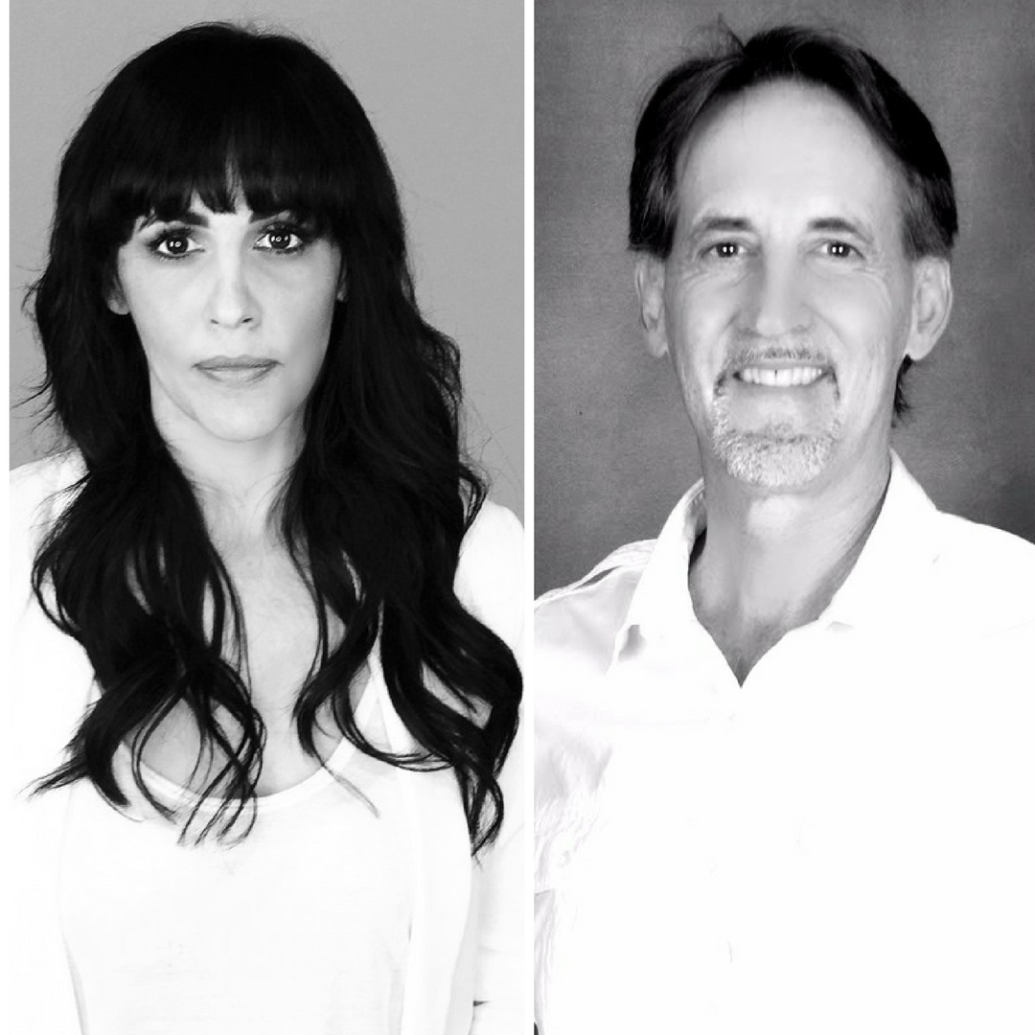
Title: RSquared - Using technology to extend your reach in the drug and alcohol recovery field
Tara Schiller, Founder of YouCoached
Paul Brethen M.A. MFT, RSquared Director and Challenge Creator

Abstract workshop description:
Learn what tools are currently available through technology that can help you reach clients and other individuals who need access to additional recovery support. We will focus on:
- What’s available now
- How to use these tools as a companion to the services you currently offer
- How to connect with individuals who were previously out of your reach
- And what you need to be prepared for in the future as a result of technology

Extended workshop description:
During our presentation we will explain the apps and technology currently available in the area of drug and alcohol recovery that can assist those working in the field. An exploration of the costs and benefits of this technology and how to work alongside it to remain effective and current in the emerging culture of man integrating with machine will then be presented.

We will also discuss how to reach individuals like teens who can’t get a ride to meetings, clients who have graduated from programs but still need support, individuals on parole, addicts in rural areas, those on a waiting list to get into treatment, and individuals who want to remain anonymous.

After discussing what’s available now, we will present what we think will emerge in the near future and what to do to prepare for and get involved with this technology.

We will finish with an open discussion about what the current frustrations in the area of recovery are, and what technology can do to fill in those gaps.

Our objective is that attendees will walk away with a toolbox of resources at their fingertips that will make them more effective, wider reaching, and informed about how to connect with those who are seeking recovery through the power of technology.

Learning Objectives:
- Increased awareness on what’s currently available for their clients via technology
- A practical understanding of how to use technology to advance their own effectiveness
- An understanding of what is being developed and will become available in the future
- An opportunity to influence what will be developed by sharing their own frustrations and concerns

Main Presenter: Tara Schiller, Founder of YouCoached and creator of the RSquared Rehab and Recovery App

BIO: Tara Schiller is the founder and creator of YouCoached, a life improvement technology company, the author of Living an Alive Life, writer for multiple online publications on the subject of personal development, and a speaker on the subjects of authenticity, personal belief, and how we can be more effective with the help of technology.

Co-Presenter: Paul Brethen M.A. MFT, co-founder of YouCoached and Director of the RSquared Rehab and Recovery App

BIO: Paul Brethen M.A. MFT
From 1986-2003 Paul worked for Matrix Institute on
Addiction in Southern California as Administrative/Clinical Director. He was a
major contributor to the development of the Matrix Treatment Model,
recognized internationally as the leading program of choice from recovery of
addictions. From 2003-2008 he traveled internationally training and consulting
professionals in the field of addiction. He is a published author and currently
working and living in Kampala, Uganda, Africa since 2008.

Mr. Brethen received a B.A. degree in theology from Azusa Pacific University in
1983, a Masters Degree in Marriage, Family, Child Therapy from Philips
Graduate Institute in 1985. He is a licensed Marriage, Family Therapist since
1992, and a Certified Addiction Specialist since 1996 from the American
Academy of Health Care Providers in the Addictive Disorders.

Presenting author details
Full name: Tara Schiller
Contact number: 760-696-2116
Session name/ number:
Category: (Oral presentation/ Poster presentation) Oral presentation or Workshop

