A Literature Review of MDMA: Its Potential Efficacy in Treating Treatment Resistant PTSD
Brandon M. Lipin
Roosevelt University

Author Note
No grant funding for this paper was provided – it was completed as part of an independent study at Roosevelt University, Psychology Course 395.

Contents
Abstract 3
A Literature Review of MDMA: Its Potential Efficacy in Treating Treatment Resistant PTSD 4
References 12
Tables 15
Figures 19

Abstract
The purpose of this paper will be to investigate empirical research on the topic of MDMA as a potential treatment for psychiatric disorders. Experimental studies, peer reviewed journals, and other works will be encompassed into the paper; with the goal being a summary of the efficacy of MDMA psychoactive-assisted therapy.
Keywords: MDMA, MAPS, PTSD, Treatment Resistant, Psycho-Therapy

A Literature Review of MDMA: Its Potential Efficacy in Treating Treatment Resistant PTSD
The purpose of this paper is multifaceted in nature; MDMA will be defined, its potential in psycho-therapy as a medication will be analyzed, and through the usage of other research a conclusion on its efficacy will be constructed. MDMA or (3,4-methylenedioxy-methamphetamine), is a drug which falls into the classes of both psychedelic and a stimulant. The molecular structure of this compound was first discovered in the early quarter of the 20th century by mistake; it was not until after the Second World War, that it became “re-discovered”. Its history of usage and the recorded subjective experiences are numerous and well documented. The specific mechanism of action which this chemical affects in the brain have made it a prime candidate to be utilized in mental health field. There are three major neurotransmitters which are affected by the ingestion of MDMA, and several areas of the brain which are important to its therapeutic power. Serotonin, neuroephinephrine, and dopamine are the three neurotransmitters mentioned; these are essential to a person’s motivational drive, memory formulation, and emotional regulation. MDMA acts as an agonist for those specific receptor sites, and substantially increases the amount of serotonin in the brain; researchers believe that this mechanism is responsible for its abilities to increase empathic capabilities in people, as well as alleviate many negative symptoms.
There have been 6 major side effects which are mainly recognized by clinicians and researchers in the field; outlined by Jerrold Meyer – University of Massachusetts.
The six principal components of the ecstasy experience identified by Sumnall et al, along with the question that loaded most strongly on that component are as follows: 1) perceptual alterations (“Everything I look at seems to vibrate or pulse when I am on ecstasy”); 2) entactogenesis (“On ecstasy I can deliberately generate insights concerning myself, my personality, and my relationships with other people”); 3) prosocial effects (“When I am on ecstasy I have strong feelings of caring or compassion for people I am with”); 4) aesthetic and mood effects (“On ecstasy it is pleasurable to move and dance”); 5) negative intoxication effects (“When I am on ecstasy I find that I have problems remembering things”); and 6) sexual effects (“Sexual orgasm has new qualities when on ecstasy”).

Along with chemical changes, MDMA has shown to lower activity in the amygdala, which is the area of our brains which controls lower level processing and importantly fear, anger and aggression. By allowing this area of the brain to calm down, therapists are able to make progress with patients that have previously been diagnosed with treatment resistant post-traumatic stress disorder. Unlike current medications that are on the market today to treat anxiety and depression, MDMA clinical trials are able to be done on a less frequent basis and show promising results in symptom remission in several follow up studies which have ranged from several months, post-treatment to several years.
Merch Pharmaceuticals was the first to synthesize MDMA in the year 1912. Their chemist that created the molecular structure did so completely by mistake. (The origin of MDMA (“Ecstasy”) – separating the facts from the myth). The chemist was working on a project to find a new medication to treat certain types of abdominal pain, accidentally MDMA was created and not utilized in any significant manner for several decades thereafter. In the late 1950s-1970s, American scientists began to synthesize the drug and test it for its potential in psychotherapy, military potential, and as a recreational drug. After gaining much popularity in the 1970s, the drug became a problem for the US government, which responded with an emergency scheduling order that would classify MDMA as a schedule 1 substance; meaning that it has a high potential for abuse, can cause danger to the body, and has no accepted medical treatment/potential. Despite the ban of the drug and its movement into the realm of illegal substances, researchers have been granted controlled access to the chemical in hopes of finding its medicinal benefits. Currently, there are many studies which have concluded with follow up data and ongoing pilot programs, which are demonstrating the efficacy of this drug in treating treatment-resistant, post-traumatic stress disorder.
The Multidisciplinary Association for Psychedelic Studies, also known as MAPS, has been a major leader in research and funding for many research based trials in this area. They have created a model for experimentation that involves a randomized, double-blind research method with a control group. This control group has differed study to study, in that some controls were defined as having been given a small dosage of MDMA, where other groups were given a placebo. Their research has been at the forefront of modern psychiatric medicine, and has helped tremendously in getting this work into the mainstream public and medical journals. Figures 4-9, visually demonstrate a summarized conclusion of the many studies that this foundation has conducted over the years, in conjunction with other health agencies or educational institutions. The fault found with MAPS, is that they are so heavily invested in this work, and have been involved in so many cases, that some may argue that the research being published in partnership with the organization may be biased to have a favorable outcome.
In 2011 a pilot program study in the United States was conducted through the University of South Carolina – Medical Center, and an organization called, Clinical Research for Multidisciplinary Association for Psychedelic Studies or (MAPS). This study was conducted with a sampling size of 20 participants who met criteria for treatment resistant PTSD using the Clinically Significant PTSD Scale or CAPS. Prior to undergoing treatment, the mean score for the sampling size was 45.4 with a standard deviation of 17.3, completing treatment the mean score was 24.6 with a SD of 18.6, and in the follow up which occurred between 17 and 74 months after the trials concluded, the mean score was 23.7 with a SD of 22.8. This data demonstrated that the effects of the MDMA assisted psychotherapy reduced symptoms reported dramatically and that the effects were still noticeable after a year or more had passed. Several participants were excluded from the follow up study or did not wish to complete it: refer to figure 1 below for a graphic depicting the reasoning. For the actual trials, the experimenters took a very controlled approach and gave 12 of the patients an active dose of MDMA, while 8 received a placebo. The participants were given 8 hours of intensive talk therapy within a hospital setting after the dosage was administered. The doctors involved noticed immediate improvement in the ability of the participants to articulate their symptoms and the reasoning behind their negative emotional states. They hypnotized that, “MDMA may enhance the therapeutic alliance by increasing the likelihood of detecting positive expressions and finding them rewarding, while at the same time reducing the chance of excessive reactivity to fleeting or unintended expressions of anger or disapproval” (Mithoefer et al. 2011). The initial studies data was collected from the CAPS scores belonging to the 12 members of the experimental group. After the 5-week program had concluded the 8 members of the placebo group were invited to also participate in an assisted therapy session, 7 of the 8 accepted the offer. Table 1, organizes the information gathered from this study, including the long term follow up information. This study was important because it was one of the first that analyzed the long term effects to the MDMA treatment being offered; previous studies did so but not to the same length of time. From the data which was demonstrated in this controlled condition, MDMA was shown to be a clinically beneficial treatment protocol to assist therapy sessions with individuals with severe PTSD. There improvements were dramatic in nature, and they were not required to have repeated dosage sessions at the conclusion of the experiment, yet the effects seemed to be lasting.
Brown University also reported data on a randomized, double-blind, experimental study that had taken place in 2013. For their experiment, participants were given a variety of different dosages and were assessed for their self-report inventory and CAPS. “In a randomized, double-blind, active-placebo controlled trial researchers enrolled 12 patients for MDMA treatment with either a low-dose (25 mg, plus 12.5 mg supplemental dose) or a full-dose MDMA (125 mg, plus 62.5 mg supplemental dose).” This study found that after an immediate follow up, the individual CAPS score did not experience a statistically significant change; however this did occur during the follow up study that occurred one year later. In addition, all participants noted an improvement in their individual self-reported survey both after the dosages that were administered and during the one year follow up on the participants.
The safety profile of MDMA and its potential to treat PTSD have been known to for a considerable period of time in the post prohibition era. In the 2002 Journal of Psychoactive Drugs, Volume 34, the Federal Food and Drug Administration worked with a team of Spanish doctors to conclude that, “the risk/benefit ratio is favorable under certain circumstances”. The findings of the collaborative efforts between the governments of the United States and the Spanish Health Ministry, helped to propel many piloting studies into the topic of MDMA assisted psycho-therapy. The journal goes on to explain that the MDMA is an essentially different psychedelic than many other previously tested for the same purpose;
On the one hand, the psychological safety profile of MDMA is superior to all other psychedelics. MDMA is relatively short acting, with primary effects lasting about 4 hours and a gradual return to baseline after about two hours or so. MDMA rarely interferes with cognitive functioning or perception and usually produces a warm, emotionally grounded feeling with a sense of self-acceptance, and a reduction of fear and defensiveness. (2002 Journal of Psychoactive Drugs, 186).

The statements and findings produced in this journal, concluded that MDMA was a vastly superior drug than other psychoactive substances; both prescription or illicit. It had the potential to keep the participant engaged in the activity and allowed for therapy to break down the emotional shields that had guarded the victims of treatment resistant PTSD. The other main goal of this specific journal volume, was to explain how the collaboration between the Spanish and US, had developed a treatment plan for how to administer MDMA in a clinical setting. The findings of several doctors discovered that MDMA had a relatively low chance of causing long-term damage to serotogenic receptor sites. The relative harm that does come from MDMA usage, is mostly caused by dehydration and increased body temperature; both of which can be controlled within a clinical setting for administration. The final suggestions by this earlier journal, recommended that MDMA be used as a treatment option because of its possibility to be administered safely, and cost effectively for the patient; as there is not a need for many treatment sessions to be given. The journal estimated at the time, that nearly 200,000 people in the United States suffered from PTSD annually. MDMA has the ability to allow these people to actively engage their specific problems and work towards a solution with a trained practitioner; as to help them not forget the past but also not be burdened by it in the future.
As far as dosing is concerned, MDMA is also considered to be a safe alternative treatment due to the low amounts needed for the assisted-psychotherapy. In between 2002-2003, several doctors began a study to determine if low-dosage MDMA treatment could help women who had been a victim of sexual assault and due to this event, developed treatment resistant PTSD. The study was supposed to be conducted with 29 female subjects; due to overwhelming pressures from political groups, the experiment was cut short and only saw the treatment of six participants. Although the doctors were not able to complete the research goals which were originally set, the six individuals that did participate were noted to have improvement to the medication provided. The profiles of the women selected and the specific dosages, and CAP scores are reported below in tables 3 and 4. This specific study was published later on in 2008, with its significance being that dosages ranging from 50-75 mg of pure MDMA were effective in trial. The dosage of MDMA has been a subject of dispute both for the ability to successfully run a double blind experiment with a placebo, and because of the safety issues which arise with higher dosages. Because of this study, future researchers were able to have an estimated starting point that would allow them to provide care to patients that were in desperate need. Not much information was able to be collected to support the notion that MDMA could be a beneficial treatment plan over previously accepted medication approaches; but the dosage information has been interesting in contributing to the overall research in the topic area.
As for the future of MDMA and its role in treating patients under clinical supervision, there is much more research and legislation to be worked out. Before any true progress in the field may be considered promising, a rescheduling of MDMA by the US Government, FDA, and DEA would be needed; the current level of access is too limiting for most researchers to be given access to the chemical substance. This problem may no longer be an issue in the future, as the United Nations is expected to hold a special meeting on global drug policy reform in April of 2016; many believe that the committee will vote on global decriminalization for most substances in an effort to tackle ever growing prison populations, the health epidemic of substance abuse, and so that previously illicit substances may be utilized in appropriate medical settings. This paper has been able to incorporate many sources to explain how and why MDMA would be suitable alternative treatment plan for many people who suffer from PTSD. The safety profile of the drug, history, mechanisms of action, and overall efficacy warrant a very close examination into future usage for patients. The other major advantage to MDMA as a treatment protocol would have to be its relative safety both to society and the individual. Through the collection of data of self-report surveys, state health centers, and law enforcement, Professor David Nutt Ph.D., was able to construct a table which compared various psychoactive substances and their relative dangers. MDMA scored very low in comparison to many substances; many that are not scheduled and easily obtainable in a majority of countries.

References
Carhart-Harris, R. L., Wall, M. B., Erritzoe, D., Kaelen, M., Ferguson, B., Meer, I. D., . . . Nutt, D. J. (2013). The effect of acutely administered MDMA on subjective and BOLD-fMRI responses to favourite and worst autobiographical memories. The International Journal of Neuropsychopharmacology Int. J. Neuropsychopharm., 17(04), 527-540. Retrieved March 1, 2016.
Doblin, R. (2002). A Clinical Plan for MDMA (Ecstasy) in the Treatment of Posttraumatic Stress Disorder (PTSD): Partnering with the FDA. Journal of Psychoactive Drugs, 34(2), 185-194.
Freudenmann RW, Spitzer M (2004) The neuropsychopharmacology and
toxicology of 3,4-methylenedioxy-N-ethyl-amphetamine (MDEA). CNS
Drug Reviews 10: 89–116.
Freudenmann RW (2005) “Ecstasy”, die Droge der Techno-Generation:
klinische Aspekte [“Ecstasy”, the drug of the techno generation: clinical
aspects]. Nervenheilkunde 24: 557–572.
Holland J (2001) Ecstasy. The complete guide. A comprehensive look at
risks and benefits of MDMA. Vermont.
Landry, M. J. (2002). MDMA: A Review of Epidemiological Data. Journal of Psychoactive Drugs, 34(2), 163-169.
MAPS - MDMA-Assisted Psychotherapy. (n.d.). Retrieved March 21, 2016, from http://www.maps.org/research/mdma
Marijuana Legalization: As The UN Prepares To Tackle The World Drug Problem Again, Will Cannabis Laws Change Global Policy? (2016). Retrieved March 23, 2016, from http://www.ibtimes.com/marijuana-legalization-un-prepares-tackle-world-drug-problem-again-will-cannabis-laws-2334526
Mithoefer, M. C., Wagner, M. T., Mithoefer, A. T., Jerome, L., Martin, S. F., Yazar-Klosinski, B., . . . Doblin, R. (2012). Durability of improvement in post-traumatic stress disorder symptoms and absence of harmful effects or drug dependency after 3,4-methylenedioxymethamphetamine-assisted psychotherapy: A prospective long-term follow-up study. Journal of Psychopharmacology, 27(1), 28-39.
Meyer, J. S. (2013). 3,4-methylenedioxymethamphetamine (MDMA): current perspectives. Substance Abuse and Rehabilitation, 4, 83–99. http://doi.org/10.2147/SAR.S37258
Oehen, P., Traber, R., Widmer, V., & Schnyder, U. (2012). A randomized, controlled pilot study of MDMA ( 3,4-Methylenedioxymethamphetamine)-assisted psychotherapy for treatment of resistant, chronic Post-Traumatic Stress Disorder (PTSD). Journal of Psychopharmacology, 27(1), 40-52.
Reverse Pharmacology. (n.d.). Encyclopedia of Molecular Pharmacology, 1079-1079.

Shulgin AT (1990) History of MDMA. In: Perouktka SL (ed.) Ecstasy: the
clinical, pharmacological and neurotoxicological effects of the drug
MDMA. Boston, pp. 1–20.
Shulgin AT (1986) The background and chemistry of MDMA. J Psychoactive Drugs 18: 291–304.
Shulgin AT, Nichols DE (1978) Characterization of three new psychotomimetics. The psychopharmacology of the hallucinogens, New York,
pp. 74–83.
Visual Overview. (n.d.). Retrieved March 15, 2016, from http://www.mdmaptsd.org/infographic.html

Tables

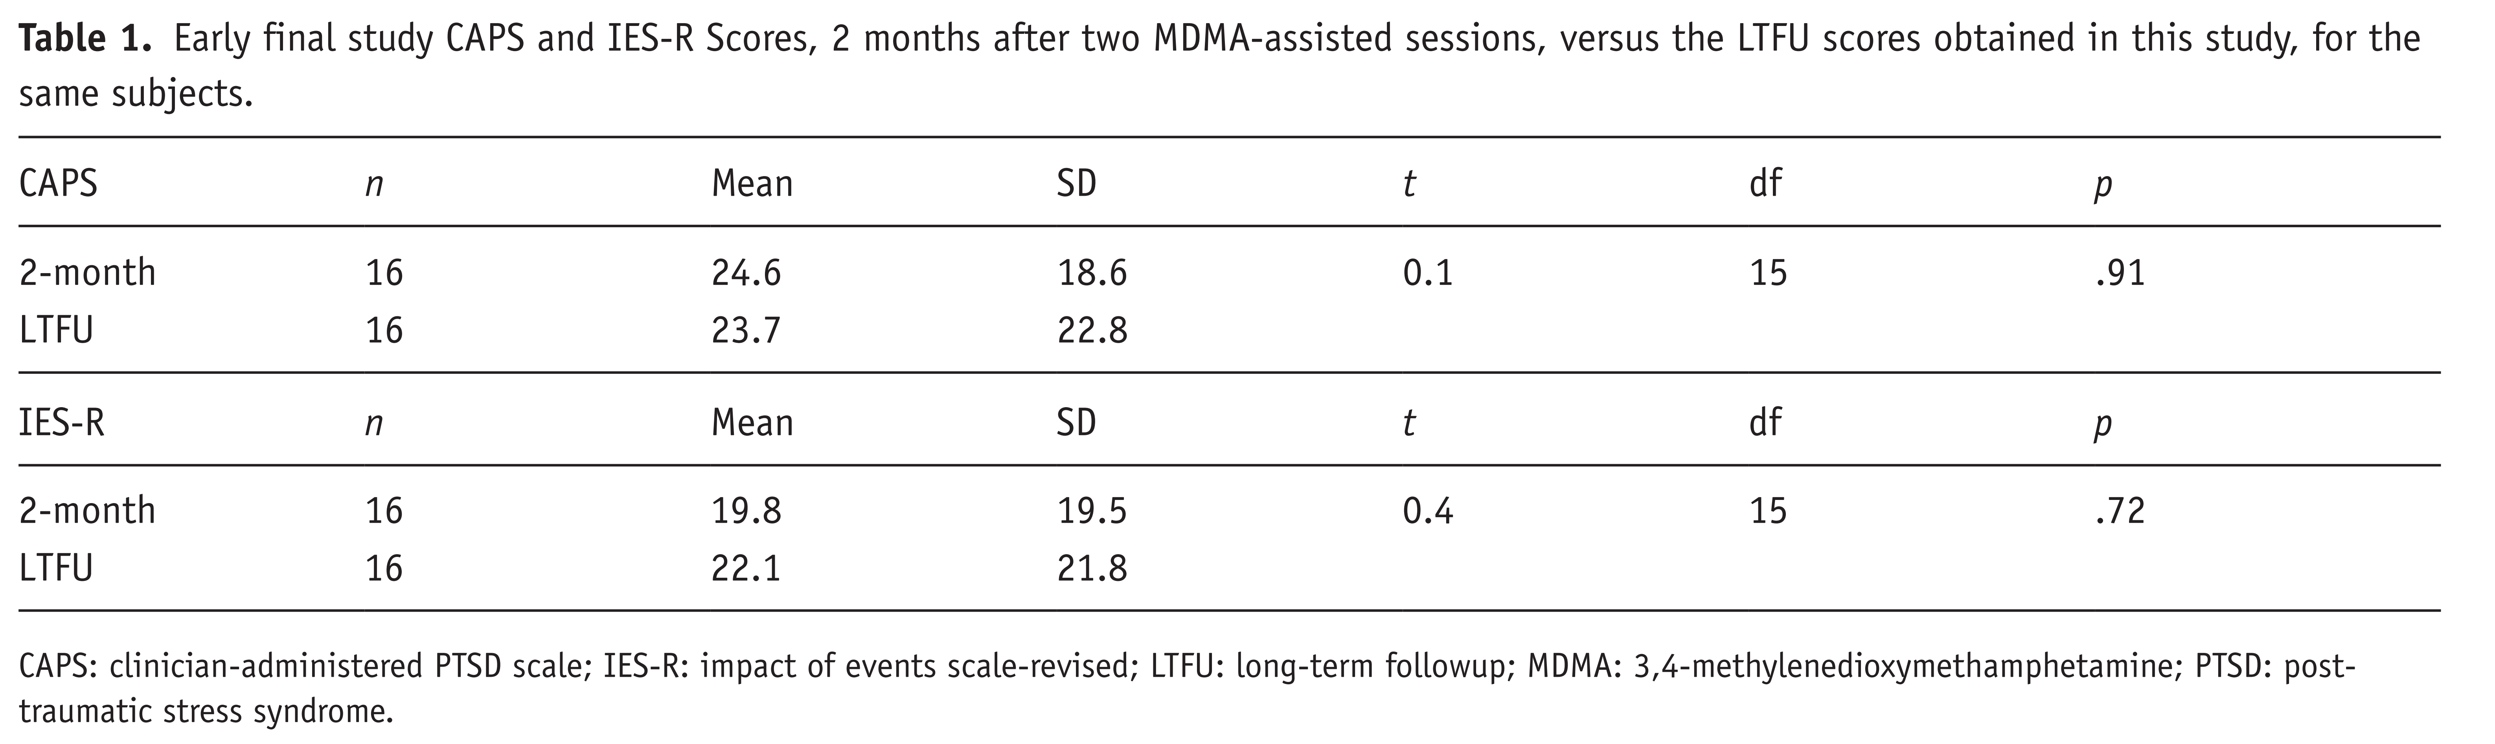
Table 1: 2011 Study with the University of South Carolina and MAPS – Follow Up Data

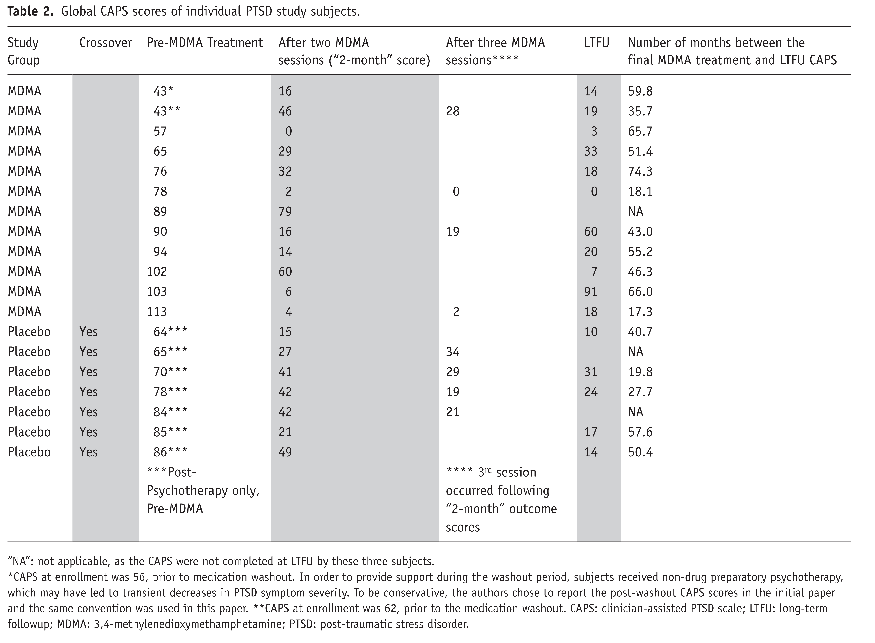

Table 3: Subject Profiles from Small Sample Group of Women

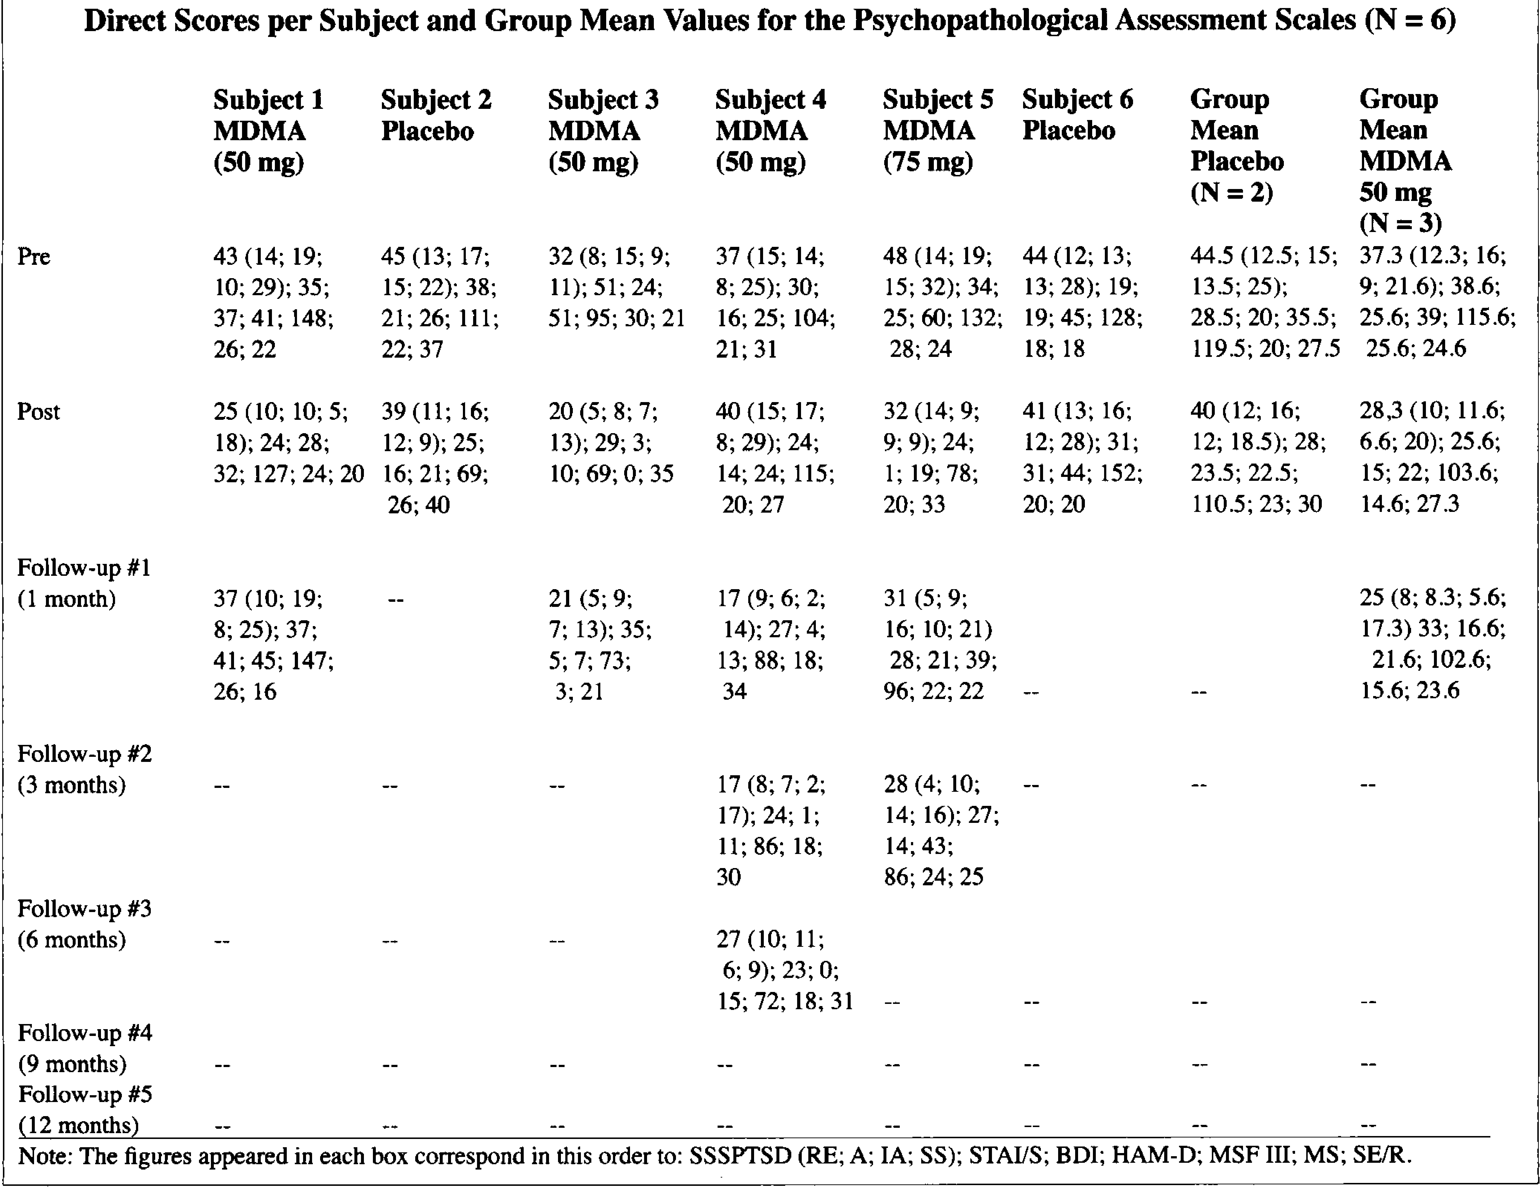
Table 4: Dosage information for participants

Figures
Figure 1: Study design with number of participants – journal of pharmacology 27 (1)

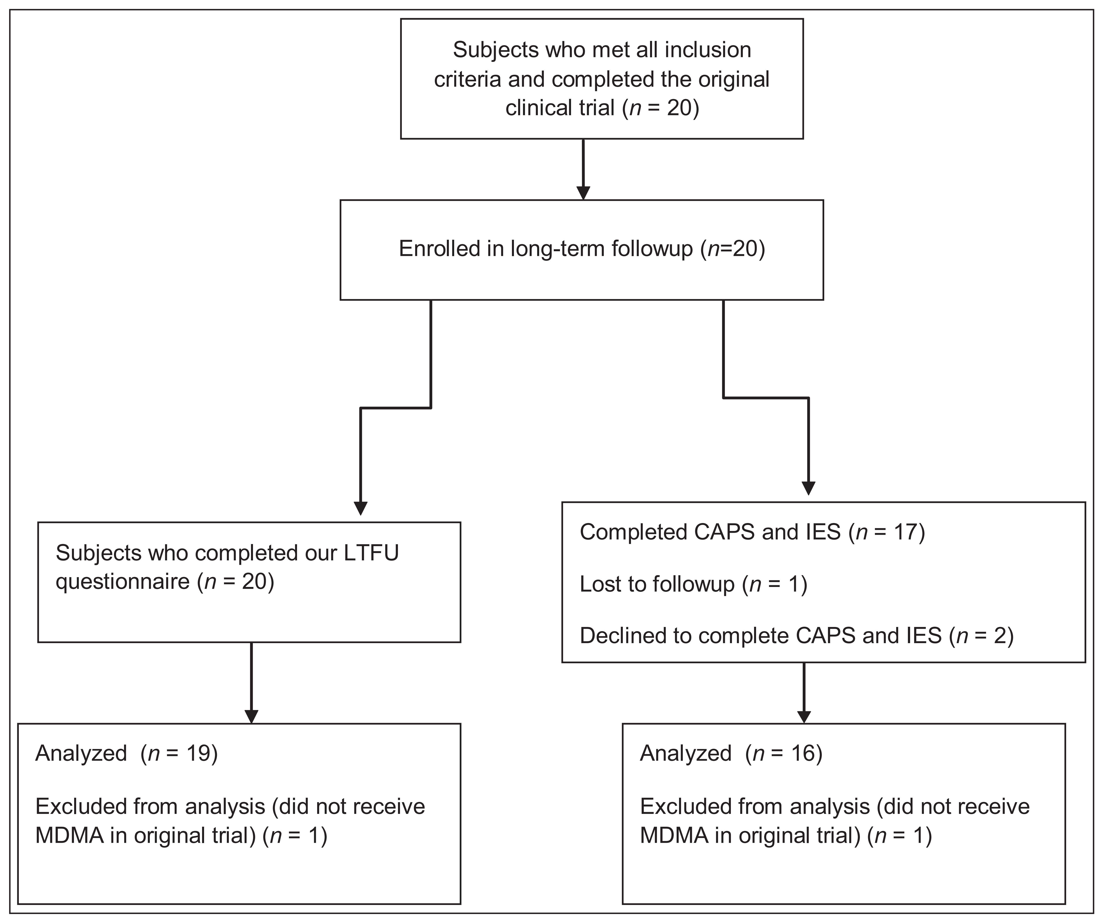

Figure 2: Graphical Demonstration of Specific Drug Use & Harm
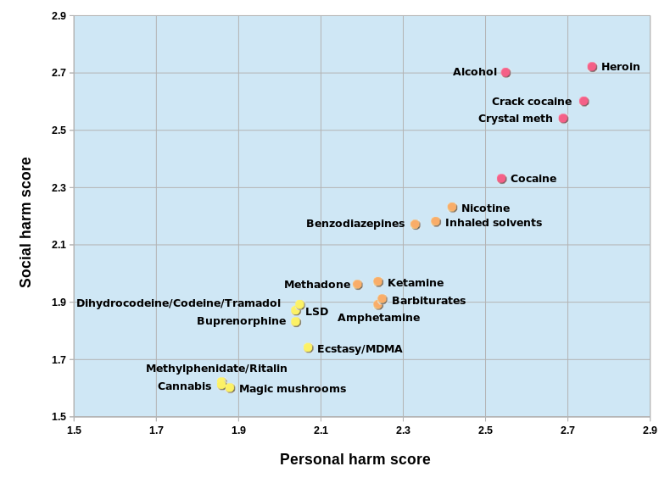

Figure 3: Defining Treatment Resistant PTSD
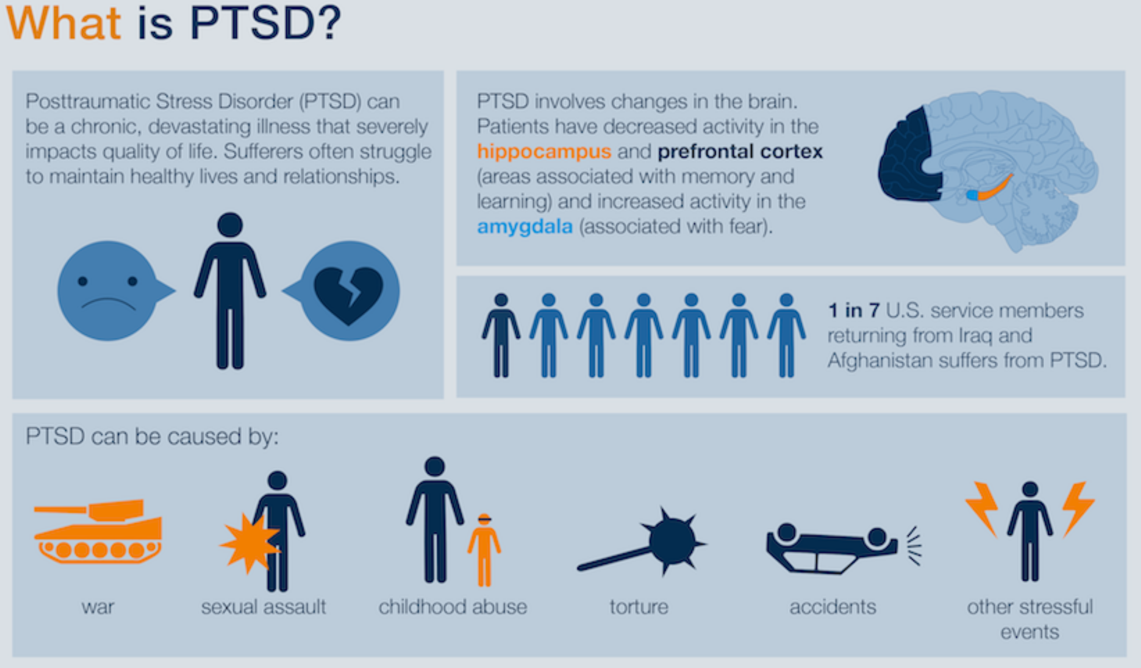

Figure 4: Defining MDMA – Assisted Psychotherapy
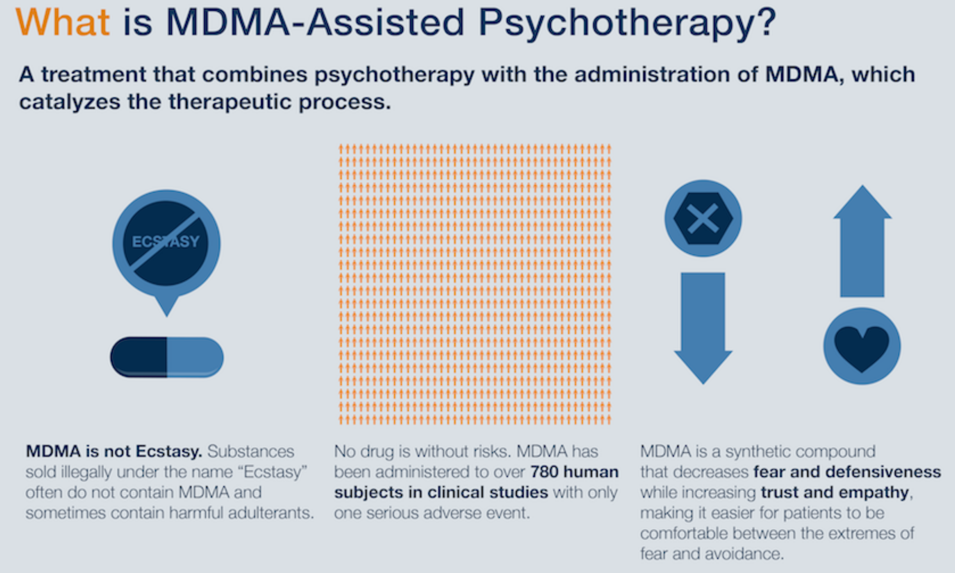

Figure 5: How MDMA is beneficial to participants
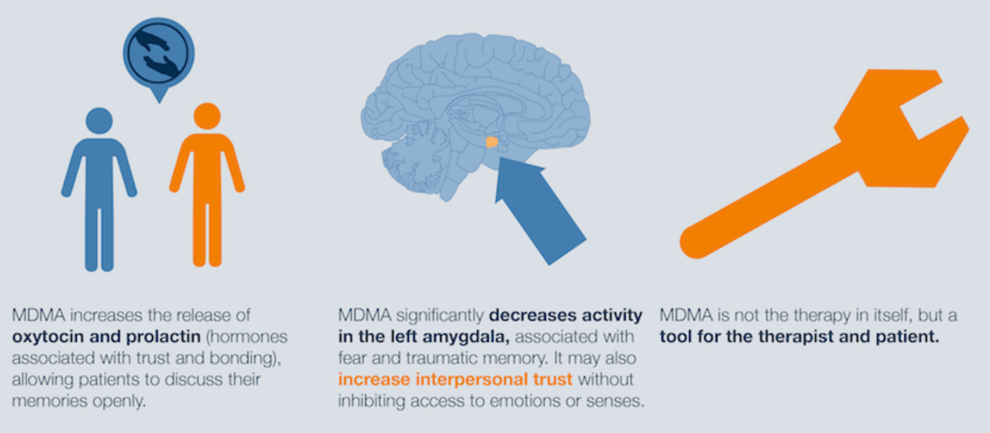

Figure 6: What is the procedure for therapy
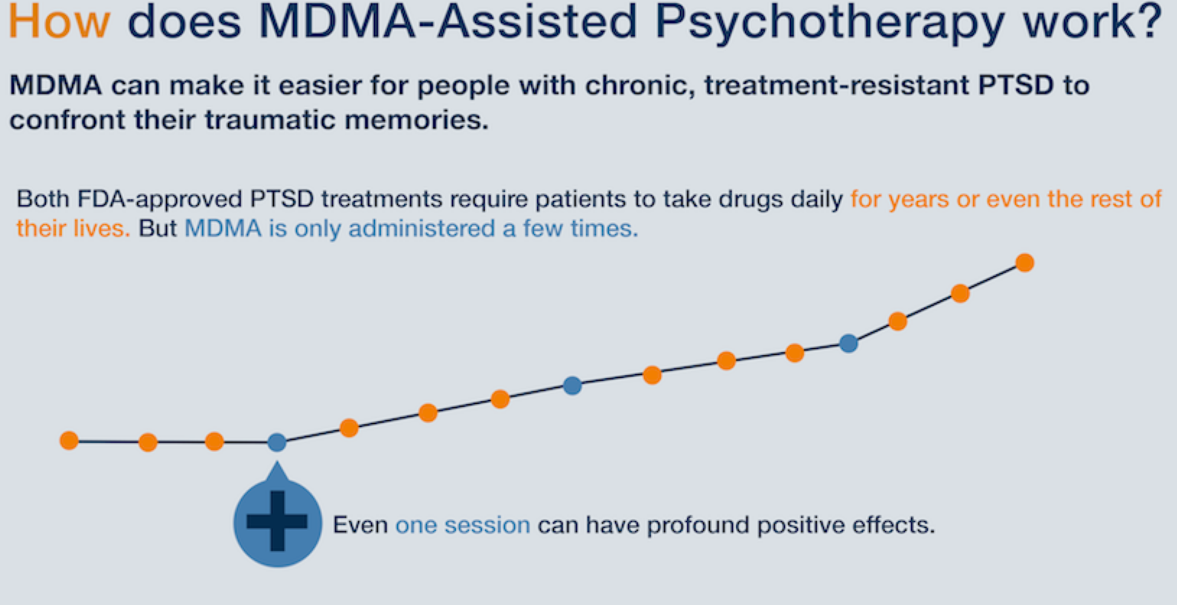

Figure 7: Efficacy of MDMA treatment
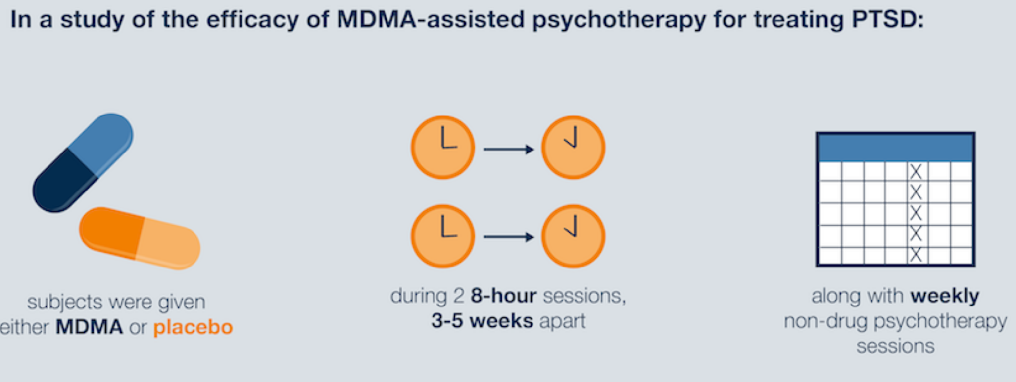

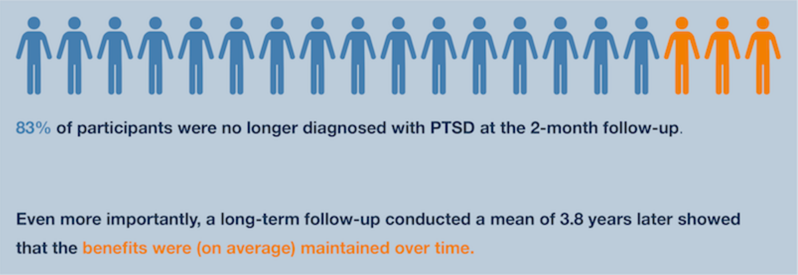

Figure 8: Outcomes of treatment
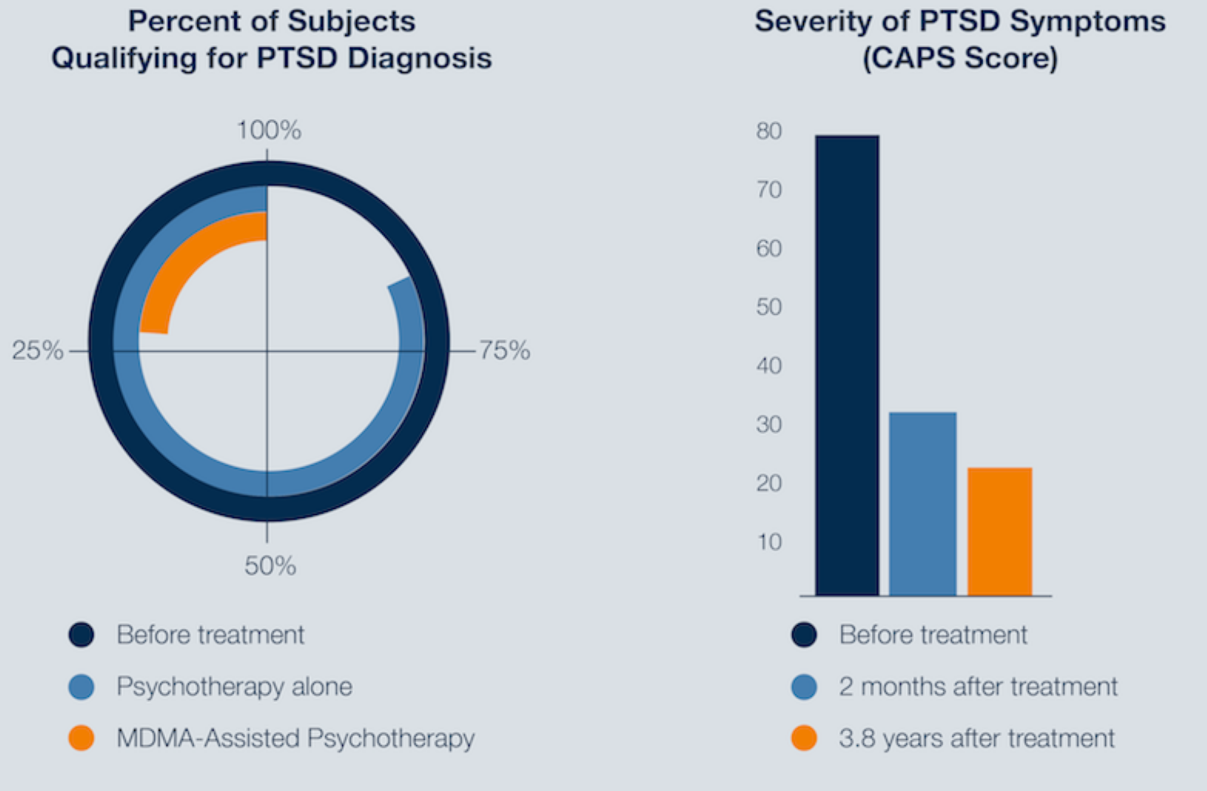

Figure 9: Last positive results
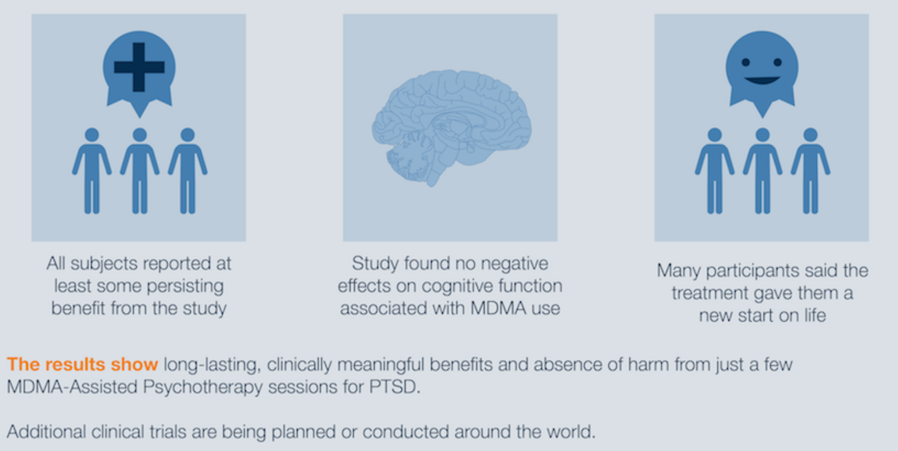

Shulgin AT (1986) The background and chemistry of MDMA. J Psychoactive Drugs 18: 291–304.
Holland J (2001) Ecstasy. The complete guide. A comprehensive look at risks and benefits of MDMA.
The origin of MDMA (“Ecstasy”) – separating the facts from the myth
3,4-methylenedioxymethamphe (MDMA): current perspectives
Shulgin AT (1986) The background and chemistry of MDMA. J Psychoactive Drugs 18: 291–304.
http://www.maps.org/research/mdma
Durability of improvement in post-traumatic stress disorder symptoms and absence of harmful effects or drug dependency after 3,4-methylenedioxymethamphetamineassisted psychotherapy: a prospective longterm follow-up study
The Brown University Psychopharmacology Review April 2013
Journal of Psychoactive Drugs, Volume 34 187-192
Marijuana Legalization: As The UN Prepares To Tackle The World Drug Problem Again, Will Cannabis Laws Change Global Policy
Shulgin AT (1990) History of MDMA. In: Perouktka SL (ed.) Ecstasy: the clinical, pharmacological and neurotoxicological effects of the drug MDMA. Boston, pp. 1–20.
Shulgin AT (1986) The background and chemistry of MDMA. J Psychoactive Drugs 18: 291–304.
Figure 2: Graphical Demonstration of Specific Drug Use & Harm
Freudenmann RW, Spitzer M (2004) The neuropsychopharmacology and toxicology of 3,4- ethylenedioxy-N-ethyl-amphetamine (MDEA). CNS Drug Reviews 10: 89–116.

