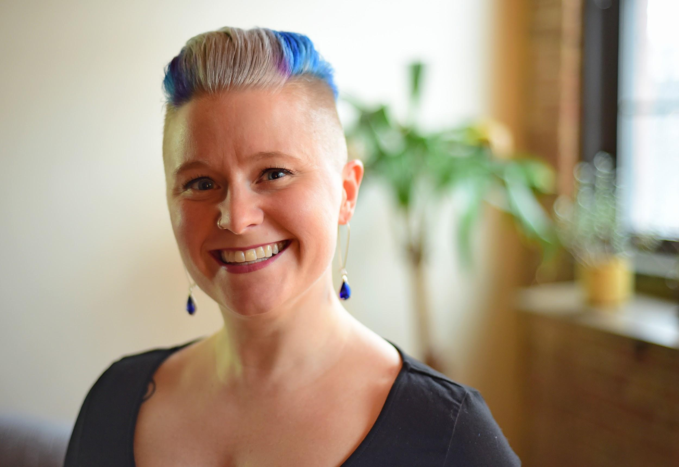
Title: Self-Compassion in Psychotherapy with Addictive Disorders
Name: Sarah Buino, LCSW, CADC, CDWF
Organizations: Head/Heart Therapy, Inc., Chicago, IL - USA
Loyola University, Chicago, IL - USA

Addiction is a disease that induces shame and strips a person of their self-worth. Self-compassion (or self-empathy) is a crucial, but often overlooked component of healing from addictive disorders. Many of our clients are able to extend compassion to others, but neglect themselves, which creates barriers to recovery.

Kristin Neff and Tim Desmond are leaders in the field of self-compassion research. Their methods for increasing self-compassion will be introduced and explored in terms of client and self. This workshop will discuss components and functions of self-compassion from a scientific and philosophical framework and provide resources for specific tools for utilizing self-compassion in the therapy room.

Biography

Sarah Buino is the founder of Head/Heart Therapy, Inc. in Chicago, IL - USA. She is a licensed clinical social worker, certified addictions counselor, Certified Daring WayTM facilitator, and adjunct faculty member at Loyola University in Chicago.

Sarah integrates her knowledge of complementary healing modalities such as music, yoga, reiki, and the chakra system into her clinical practice to help clients enhance their authenticity. She’s also the host of a podcast Conversations With a Wounded Healer which examines the role of one’s own healing while being a care-giving professional.

Presenting author details
Full name: Sarah Buino
Contact number: 1-773-351-7101
Twitter account: @HeadHeart_Chi
Linked In account: https://www.linkedin.com/in/sarahbuino/
Session name/ number:
Category: Oral presentation/workshop

