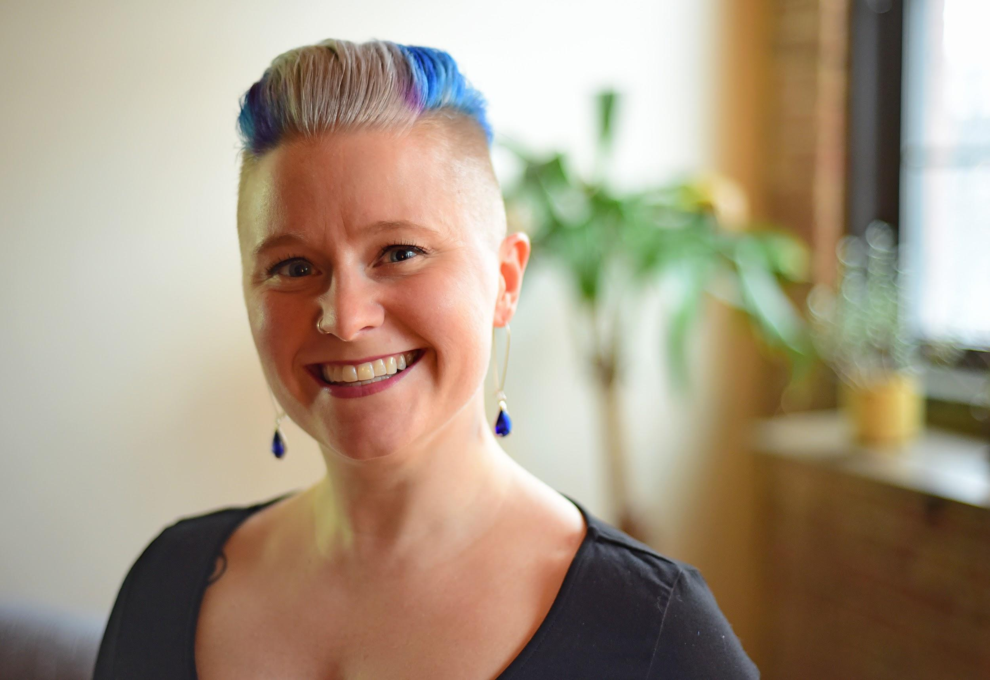
Title: Addiction, Shame, and Trauma: Starting from the Bottom Up
Name: Sarah Buino, LCSW, CADC, CDWF
Organizations: Head/Heart Therapy, Inc., Chicago, IL - USA
Loyola University, Chicago, IL - USA

As professionals who work with clients struggling with substance use disorders, we know that shame, addiction, and trauma often come as a package deal. Treating these issues with talk therapy isn’t always effective in attending to the deep roots of the problem. In order to properly address addiction (and underlying trauma) we need to engage the limbic system utilizing somatic and experiential interventions.

This seminar is designed to view addiction, shame, and trauma from an attachment trauma perspective and utilize somatic and experiential tools to provide symptom relief to patients. Participants will learn to provide an experience rather than an explanation and take away interventions they can perform with clients in a variety of settings.

Biography

Sarah Buino is the founder of Head/Heart Therapy, Inc. in Chicago, IL - USA. She is a licensed clinical social worker, certified addictions counselor, Certified Daring WayTM facilitator, and adjunct faculty member at Loyola University in Chicago.

Sarah integrates her knowledge of complementary healing modalities such as music, yoga, reiki, and the chakra system into her clinical practice to help clients enhance their authenticity. She’s also the host of a podcast Conversations With a Wounded Healer which examines the role of one’s own healing while being a care-giving professional.

Presenting author details
Full name: Sarah Buino
Contact number: 1-773-351-7101
Twitter account: @HeadHeart_Chi
Linked In account: https://www.linkedin.com/in/sarahbuino/
Session name/ number:
Category: Oral presentation/workshop

