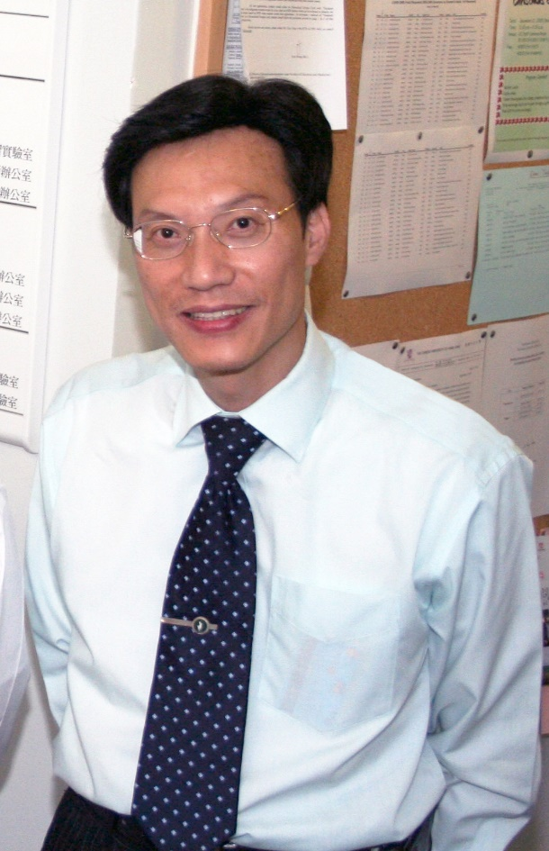

Title: Relationships between drug use history, virtuous orientation, and the realization of drug harm among at-risk youth

Name: Steven Sek-yum Ngai, Department of Social Work, The Chinese University of Hong Kong, New Territories, Hong Kong

Abstract

Illicit drug use by youth has been a major concern in many societies because of its great health and social risks. As such, identification of key factors that enhance young people's realization of drug harm represents an important research direction for developing innovative and effective measures to reduce adolescent drug use. Given this consideration, the present study seeks to investigate the role of drug use history in moderating the effect of virtuous orientation on the realization of drug harm among youth. Available literature has indicated that strengthening virtuous orientation, including morally good traits that are learnable, will likely enhance young people's realization of drug harm. Moreover, previous research has shown that drug use history may trigger a cascading effect from cognitive impairment, decreased virtuous orientation to reduced realization of drug harm. This study recruited 169 at-risk youths who were drug users through two youth service agencies in Hong Kong, with a two-wave panel survey. The time interval between an initial and a follow-up survey was 6.6 months. Results show that Wave 2 virtuous orientation fostered Wave 2 realization of drug harm, controlling for Wave 1 realization of drug harm and demographic characteristics. Additionally, drug use history moderated the effect of virtuous orientation on realization of drug harm. For the youth with shorter drug use history, virtuous orientation significantly increased realization of drug harm. However, for those with longer drug use history, this positive effect was non-significant. These results encourage strengthening virtuous orientation to increase young people's realization of drug harm, particularly among those with shorter drug use history.

Biography

Dr. Steven Sek-yum Ngai is a Professor at the Department of Social Work, The Chinese University of Hong Kong (CUHK). His current research interests are in the areas of social exclusion and youth citizenship, mutual aid and youth empowerment, and service-learning and leadership development. In total, he has published over 140 articles on these areas. Since 2000, he has conducted 29 research projects funded by the Hong Kong Research Grants Council as well as government bureaus and NGOs in Hong Kong or Macau. Dr. Ngai received CUHK Research Excellence Award in 2011 and CUHK University Education Award in 2014.

Presenting author details

Full name: Dr. Steven Sek-yum Ngai
Contact number: (852) 39437512
Email: syngai@cuhk.edu.hk
Session name: Child and adolescent substance abuse
Category: Oral presentation

