Title: Improving Addiction Treatment Outcomes through Intervention, Case Management and Family Involvement
Karen Franklin, CIP, CAI, MCLC
Certified Intervention Professional
Certified Arise interventionist
Masters Life Coach

Family Intervention & Recovery Services, LLC
Abstract
Statement of the Problem:
Studies have confirmed the central role of family in addiction treatment positively impacts outcomes. Addiction recovery may appear to be a personal journey; however, it often actually ends up being a group effort. Family members have a role to play in every phase of addressing addiction – from the earliest stages of encouraging them to seek treatment on through the maintenance of ongoing recovery.
Intervention helps to change perspectives for many families giving them the first exposure to addiction as a disorder affecting the brain of the person struggling. The family is educated on how their own denial and how enabling of the problem plays into the cycle that is addiction. When the family stops contributing to the problem, there is the beginning of change to break the cycle. Without education, the family continues in the cycle of dysfunction, chaos and distress.
A study at a treatment facility in India examined whether family members involvement in intervention and relapse prevention would improve the individual’s success in remaining sober. The study was conducted by Prasanthi Nattala, Kit Sang Leung, Nagarajaiah and Pratima Muthy. The intervention group participants consistently showed better results than those in the non-intervention group on all of the outcomes, such as reduction in quantity of alcohol, drinking days, and number of days with dysfunction in family, occupational and financial dimensions. The study’s findings show the important of family “buy-in” when an individual enters treatment for alcohol use disorder. The involvement of a family member helps ensure that an individual will be successful in avoiding relapse.
On-going involvement in case management, family recovery coaching and after care planning by an intervention professional, helps the family to begin their own journey of recovery which in turn helps them to become stronger and more supportive in healthy behaviors.
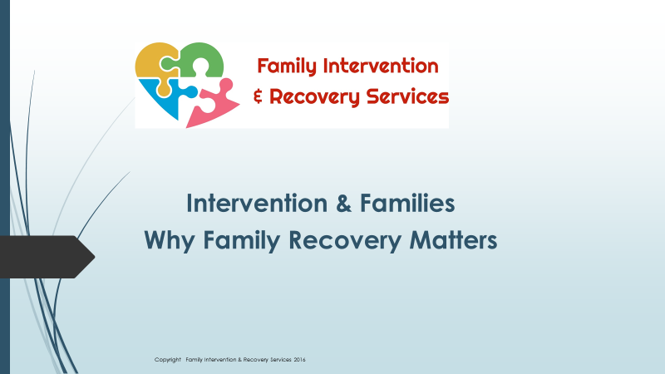
Recent Publications (minimum 5)
- Seal Press, (2009) Addicted Like Me, A Mother-Daughter Story of Substance Abuse and Recovery
- Drugfree.org (2009) Denial: The First Deadly Sin of Parenting
- Drugfree.org (2009) Enabling: The Second Deadly Sin of Parenting
- Together AZ Newspaper (2010), ADDICTED LIKE ME – The Mother-Daughter Journey Continues
- Together AZ Newspaper (2011), Confronting your Substance Abusing Teenager
- Together AZ Newspaper (2011), Coping with an Adult Child’s Addiction


Biography
Karen is a certified intervention professional, public speaker and the co-author of the acclaimed book Addicted Like Me, A Mother-Daughter Story of Substance Abuse and Recovery as featured on ABC World News Tonight with Diane Sawyer. In Addicted Like Me, Karen and her daughter share their personal story of the tragic effects of multi-generational addiction to provide inspiration and insight into the hope and healing that is possible when the cycle of addiction is broken through intervention and family recovery. Karen excels in working with Codependency & Family Systems affected by Addiction. Her own personal experience combined with her professional training and credentialing in the field, gives her a unique perspective in educating and guiding families through one of the most difficult challenges a family can experience. Karen is a "road warrior" often traveling nationwide and internationally to where the need is to help families break the cycle of addiction.

Presenting author details
Full name: Karen Franklin
Email: karen@familyrecoveryservices.com
Contact number:602-690-8440
Research Interest: Addiction in Family Systems
Twitter account:
Linked In account: https://www.linkedin.com/in/karen-franklin-cip-cai-mclc-5b96683/
Category: Oral presentation

Notes/Comments:

