Title: Adopting a Holistic Approach to Overcoming Alcoholism
Ram Dubey, MBA (Distinctions), M Soc Sci (Professional Counselling)

Abstract
Statement of the Problem: There is a lack of awareness about dangers of problem drinking as well as what to do if somebody has become addicted to it. Social acceptance, associated glamour, career and potential life success benefits often encourage indulgence. When the drinking goes overboard the reverse happens. By this time addiction may have set in and people, family and friends are at a loss what to do.
Methodology & Theoretical Orientation: Review of Books and Research shows that adhoc attempts to resolve the problem, by adopting a piece meal approach of seeking either medical, support group or counselling help often meets with limited recovery.
Findings: One needs to get sober and approach impacts of alcohol on them with honesty, openness, positivity and endurance. They need to take a holistic approach to recovery.
Conclusion & Significance: The S.P.E.R.M. model to overcoming alcoholism and leading fulfilling lives encourages people to get a new life away from alcohol. The acronym is to remind people that the new life should go beyond just seeking medical and counselling help and also include rebuilding Spiritual, Physical, Emotional, Relational and Mental health. The model has been put together from the reading of various books and research done in the addiction and alcoholism area. This is not a research book or paper. It is just an effort to demystify the help available for alcohol addiction and an attempt to motivate and encourage people to seek help and take a simple approach to remember and work on all aspects of their recovery.
Image (Optional)
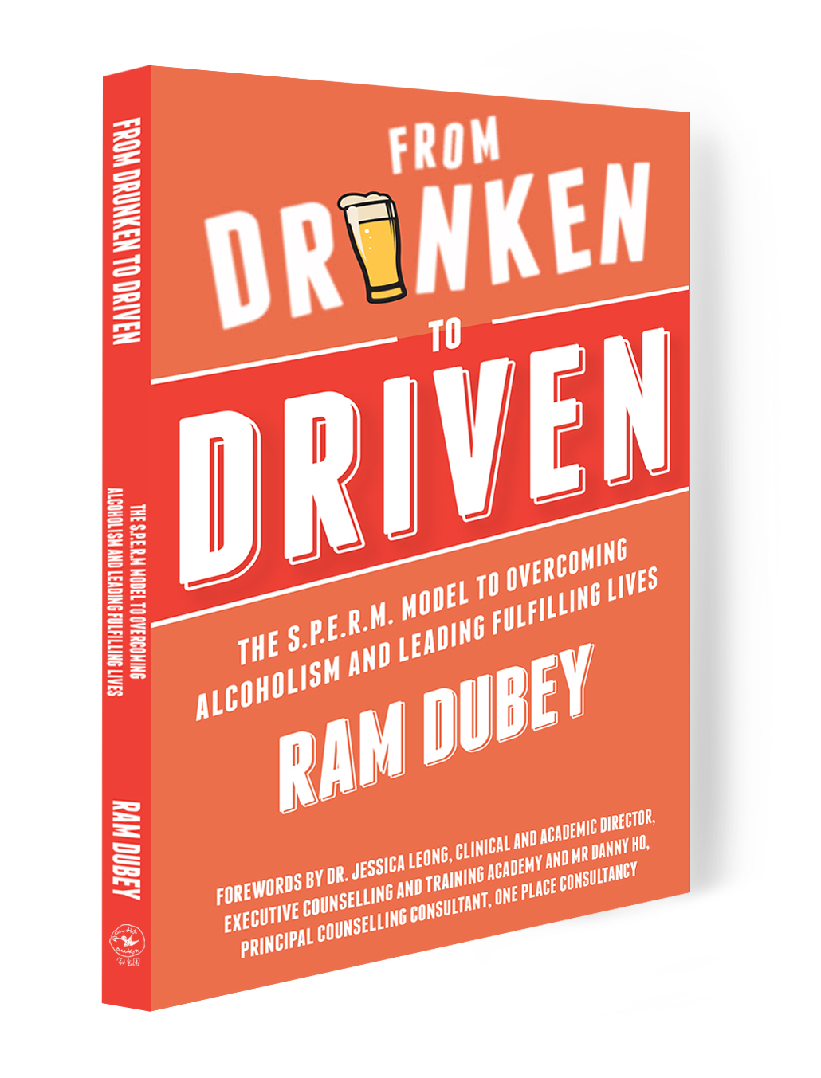
Recent Publications ((Optional)
Dubey, R. N. (2017). From drunken to driven: the S.P.E.R.M. model to overcoming alcoholism and leading fulfilling lives. Singapore: Candid Creation Publishing LLP.
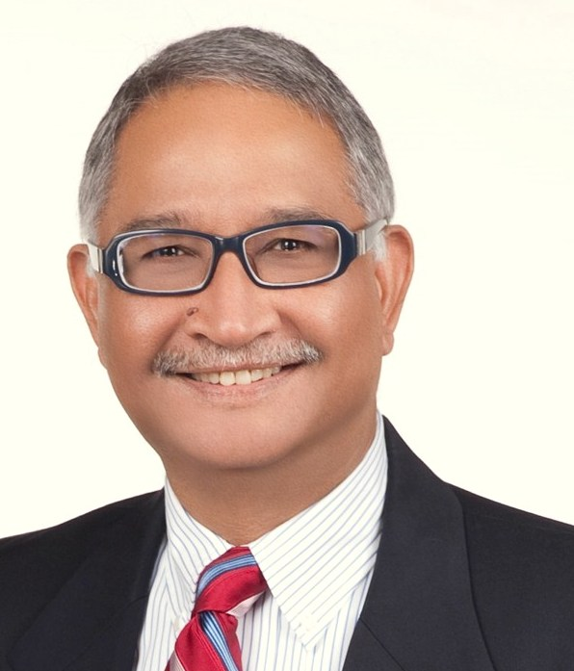

Biography (150-word limit)
Ram Dubey is a Registered Clinical Counsellor, Accredited Mediator and Author of the book ‘From Drunken to Driven’. He provides individual and group counselling as well as mediation and training in private and institutional settings. A former Regional Director in a Banking Software House he now engages in building social awareness about ‘Alcoholism’ and the harm it brings to people, families and communities. His aim is to encourage people to seek help early and get on the path to recovery. His book has been featured in local press, TV and Radio. He has also been awarded the Abdeali Tayebali Family Trust Gold Medal by the Muslim Kidney Action Association in recognition of his social work and publication of his book to help the community.
Presenting author details
Full name: Ram Narain Dubey
Email: dubeyram@singnet.com.sg
Contact number: (65)97703121
Research Interest:
Current designation: Registered Clinical Counsellor
Twitter account:
Facebook account: https://www.facebook.com/ramdubeyram?ref=bookmarks
LinkedIn account: https://www.linkedin.com/in/dubeyram/
Category: (Oral presentation/ Poster presentation/ Workshop)
Short oral presentation to share the S.P.E.R.M. Model

Notes/Comments:

