Title: What is the nature of the bond between psychoactive substance use and artistic creation?

Fruzsina Iszáj, PhD, ELTE University, Faculty of Education and Psychology, Department of Clinical Psychology and Addiction, Budapest, Hungary
Mark Griffiths, PhD, Psychology Department, Nottingham Trent University, Nottingham, UK
Zsolt Demetrovics, PhD, ELTE University, Faculty of Education and Psychology, Department of Clinical Psychology and Addiction, Budapest, Hungary

Abstract (300 word limits)
Statement of the problem: The connection between the use of psychoactive substances and the artistic creation and creativity is a long-standing topic. This bound is often marked as mysterious and is popularized a lot by the media. However, science does not state a clear viewpoint in the topic. Based on this, a systematic review about the relationship between psychoactive substances and the artistic creation and creativity was conducted. Methodology: In this presentation, the summary of this review is introduced which means a total of 19 studies. These include all the empirical publications and case reports that had been published in English in peer-reviewed journals or scientific books. Findings: The general results suggest that there is an association between creativity and substance use. However, because of the diversity of the studies, it is still not clear whether substance use directly facilitates creativity or the artistic creative process. Conclusion: It is concluded that specific skills might be changed as a consequence of substance use, and therefore might have an effect on the style of creation.

Keywords: artistic creative process, creativity, psychoactive substance use, drugs, systematic review

Recent Publications (minimum 5)
1. Iszáj F., Kapitány-Fövény M., Farkas J., Kökönyei Gy., Urbán R., Mark D. Griffiths M.D, Demetrovics Zs. (2017). Substance Use and Psychological Disorders Among Art and Non-art University Students: an Empirical Self-Report Survey. Int J Ment Health Addiction. DOI 10.1007/s11469-017-9812-5 [IF: 1.179] (scientific paper)

2. Iszáj F., Griffiths M. D., Demetrovics Zs. (2016). Creativity and Psychoactive Substance Use: A Systematic Review. International Journal of Mental Health and Addiction. [IF: 1.018] (scientific paper)
3. Iszáj F., Ehmann B., Demetrovics Zs. (2012). The effects of psychedelic substances on artistic creation. In: Marije Wouters, Jane Fountain, Dirk J Korf (eds.) The Meaning of High: Variations according to drug, set, setting and time. Lengerich: Pabst Science Publishers, 2012. pp. 40-53. (book chapter)

4. Iszáj, F., Demetrovics, Zs. (2011). Balancing between sensitization and repression: the role of opium in the life and art of Edgar Allan Poe and Samuel Taylor Coleridge. SUBSTANCE USE AND MISUSE 46:(13) pp. 1613-1618. (scientific paper) [IF: 1.104]

5. Iszáj, F., Demetrovics, Zs. (2011). "Unborn selves"--literature as self-therapy in Virginia Woolf's work. PSYCHIATRIA HUNGARICA 26: (1) pp. 26-35.(scientific paper).

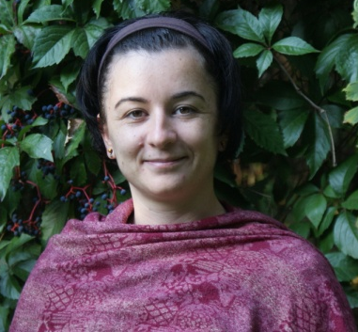

Biography (150 word limit)
Dr. Iszáj is currently working as a postdoctoral fellow at University of Mysore, India. Her project includes the understanding of human consciousness, through studying yoga and cognitive skills. She owns a PhD in psychology, she conducted her research at the Department of Clinical Psychology and Addiction, Eotvos Lorand University, Budapest, Hungary. Her doctoral dissertation was about the relationship between the artistic creative process and psychoactive substance use. She is specifically interested in conscious vs. unconscious processes, various altered states of consciousness, yoga, mental health and psychoses.

Presenting author details
Full name: Dr. Fruzsina Iszáj
Email: ifruzsi@gmail.com
Contact number: +3620/8249537
Research Interest: consciousness studies, addictions, psychoactive substance use, higher order thoughts, yoga, mental health
Resarchgate account: https://www.researchgate.net/profile/Fruzsina_Iszaj
Linked In account: https://www.linkedin.com/in/fruzsina-isz%C3%A1j-b4672360/
Category: (Oral presentation/ Poster presentation / Workshop)

Notes/Comments:

