Title: Using the example of military veterans in Community Outreach for the LGBT Community for Drug Addiction Treatment
Schulte,Paul. Paths to Recovery for Gay & Bisexual Drug Addicts.Rowman & Littlefield, 2015.
Statement of Problem: Many in the LGBT community seek drug-taking activity, particularly meth, in part because they have PTSD due to bullying, sexual abuse, rape, assault or homelessness. As with veterans, the problem is too big for a stretched mental health community. The LGBT community could use models that veterans employ to take care of their own who have PTSD. The absence of treatment of underlying issues like widespread PTSD makes continuous sobriety problematic.
Methodology & Theoretical Orientation: In my book “Paths to Recovery for Gay and Bisexual Drug Addicts”, I examined methods used by the military veterans to help their brothers and sisters returning from battle to cope with PTSD.
Findings: Military programs for soldiers with PTSD can be easily modified for the LGBT community. These include celebrations of life (with symbols & plays) as well as programs which offer mentors, leaders, values, and moral compasses for the LGBT community.
Conclusion & Significance: The mental health crisis in the LGBT community in Asian cities is deepening and needs urgent attention.

Image
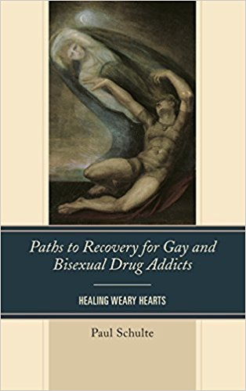
Recent Publications (minimum 5)
- Schulte, Paul. (2015). Paths to Recovery for Gay and Bisexual Drug Addicts: Healing Weary Hearts. (Rowman and Littlefield). 178 pages.
- Schulte, Paul. (2015). Cravings for Deliverance: How William James, Father of American Psychology, Influenced Alcoholics Anonymous. (Lantern Press). 167 pages.

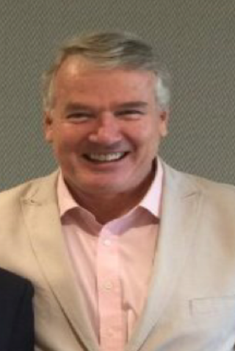
Biography (150 word limit)
Paul Schulte has a BA and MA from The Catholic University of America (Washington DC) in Philosophy. He has a MA from Tufts University in international economics. He has a degree in Alcohol and Drug Counseling from Loyola Marymount University in LA and he did his internship at the UCLA School of Medicine. He has been active in LGBT drug addiction for 15 years and has established counseling groups for, among others, victims of sexual abuse and crystal meth users. He is Founder and Editor of Schulte Research. He is retired from banking.

Presenting author details
Full name: Paul Schulte
Email: paul@schulte-research.com
Contact number: 852 9705 0777
Research Interest: LGBT drug addiction treatment.
Current designation: Visiting Fellow at HK University of Science and Technology, Visiting Fellow at Singapore University of Social Sciences, Senior Fellow at The Fletcher School of Law and Diplomacy, Tufts University.
Twitter account: NA
LinkedIn account: Paul Schulte, Founder, Schulte Research, Hong Kong
Category: (Oral presentation/ Workshop)

Notes/Comments:

