Mitigating risks of students use of study drugs through understanding motivations for use and applying harm reduction theory: a literature review
Dor D Abelman, HBHSc(C), Western University School of Health Studies, Canada

Abstract (300 word limits)
Statement of the Problem: As postsecondary students’ use of “study drugs” becomes more popular with increasingly reported negative effects on health and academic performance, failing prohibitionist policies to reduce consumption, and ambiguity in literature towards best practices to address this population, we present a literature review that seeks effective solutions educational institutions can apply to improve outcomes for students who use drugs. Methodology & Theoretical Orientation: Motivations for use, effects of the substances, an analysis of efforts to control use from educational institutions, and suggestions on promoting most effective outcomes based on harm reduction, are described. Theory, quantitative, and qualitative works from systematic reviews, cohort studies, and epidemiological assessments are examined on the “study drugs” methylphenidate, dextroamphetamine, and amphetamine, also known as Adderall, Ritalin, Focalin, and Concerta. There is a focus on postsecondary students ages 18–25 in North America. Findings: Results show important risk factors for drug use including low perceived self-efficacy or enjoyment in courses, poor accommodation of special needs, reliance on external validation, having a low GPA, and experiencing a mental health issue. There is much misconception on the health and academic effects of these drugs in literature, among students, and on online knowledge sources. Conclusion & Significance: We suggest these drugs do not improve GPA and learning, while they might temporarily increase memory, but with detrimental negative health effects. Campaigns that address underlying factors of use can be most successful in mitigating harms.
Image
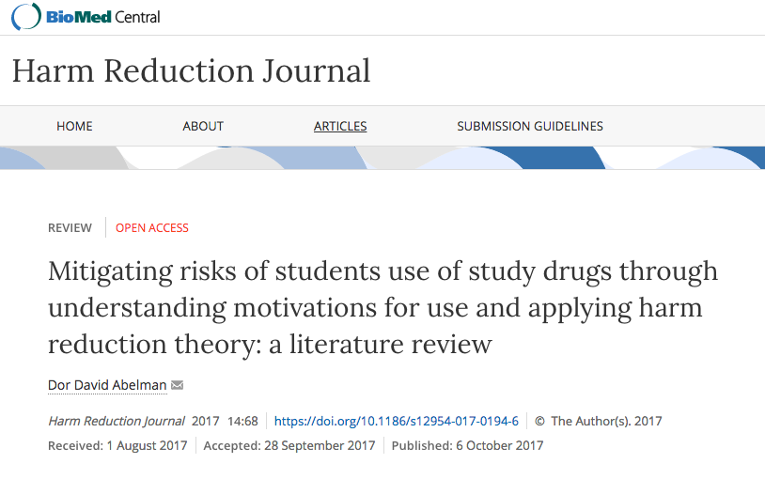
Recent Publications (minimum 5)
- Abelman, D. D. (2017). Mitigating risks of students use of study drugs through understanding motivations for use and applying harm reduction theory: a literature review. Harm Reduct. J. 14, 68.
- Abelman, Dor D. & Hannah, Andrew D. (in press). Applying health promotion theories to improve depressive symptoms through exercise. University of Western Ontario Medical Journal, 86(2).
- Zecevic, A., Tran, V., & Abelman, D. (2017). Aging globally: lessons from Scandinavia: student survey 2017. Internal Documents. School of Health Studies, Faculty of Health Sciences, Western University, London, Canada.
- Swarbrick, Dana & Abelman, Dor. (2017). Letter from the editor. RehabINK Peer-Reviewed Academic Magazine, 3:1. https://rehabinkmag.com/2017/06/19/letter-from-the-editor-2/
- Abelman, Dor D. (2017) Equity and education as means of cancer risk reduction: A focus on average Canadians and vulnerable populations. Abstract. Oral Abstract Program of Public Health 2017, 24-25. http://www.cpha.ca/uploads/confs/2017/oral-abstract-program.pdf
- Abelman, Dor D. (2016). Staying Current in Your Field of Interest: Tips for Aspiring Students as Researchers. Health Studies Publications, 83. http://ir.lib.uwo.ca/healthstudiespub/83

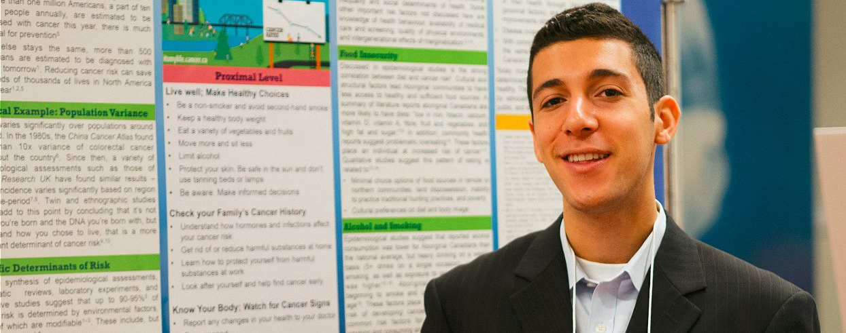
Biography (150 word limit)
Dory is a student and research assistant at Western University Canada, School of Health Studies. He holds publications related to Harm Reduction, Health Promotion, and the Social Determinants of Health, and has presentation experience in national and international conferences. He has previously acted on the editorial board of RehabINK, a UofT-run peer-reviewed publication, and held cross affiliation with the University of Toronto Department of Medical Biophysics. He has contributed to various works as an editor, reviewer, laboratory assistant, and in the capacity of providing statistical services. He hopes to combine his interests in public health with biostatistics to bring promising new reviews that help bring people healthier and more meaningful lives. See more of his work on LinkedIn or ResearchGate at Dor David Abelman, or on twitter @DoryAbelman
Presenting author details
Full name: Dor David Abelman
Email: dabelman@uwo.ca
Contact number: (416)-824-9555
Research Interest: Health Promotion, Harm Reduction, and Public Health
Twitter account: @DoryAbelman
Linked In account: https://www.linkedin.com/in/dory-abelman/
Category: (Oral presentation/ Poster presentation / Workshop): Oral Presentation

