Morphine–Induced Conditioned Place Preference Increases Dendritic Spine Densities and Enhances Emotional Memory Formation

Mina Sadighi Alvandi^{1,2}, Yaghoub Fathollahi ¹, Judith Homberg²
¹ Department of Physiology, School of Medical Sciences, Tarbiat Modares University, Tehran, Iran.
² Donders Institute for Brain, Cognition and Behaviour, Radboud University Medical Centre, Nijmegen, the Netherlands

Drug of abuse has the potential to produce addiction associated with structural and functional changes in brain that are necessary for memory formation. Dendritic spines have been considered as essential components for neuronal connectivity and synaptic plasticity, neurochemical mechanisms for learning and memory. The overall aim of this study was to evaluate the effect of morphine-induced conditioned place preference (CPP) on the dendritic spine density as an important parameter in synaptic plasticity and memory formation. Male Sprague Dawley rats (320-400 g) were subjected to the morphine-induced CPP test during 10 days, consisting of a pre-test, 8 conditioning trials and a post-test. During conditioning days, rats were received 10 mg/kg morphine. After the post-test, rats were anesthetized and brains were removed. The brains were subjected to Golgi staining to evaluate changes in spine density. The results showed that rats that received morphine exhibited more place conditioning as compared to saline treated rats and rats that were exposed to the CPP paradigm without any injections. Locomotor activity did not change significantly in these groups. The morphine-CPP group displayed a significant increase in spine density as compared to the saline-CPP and CPP without injection groups in the dentate gyrus and CA1 area of the ventral hippocampus. In conclusion, morphine elicits structural alterations in hippocampal synapses as up-regulation of spine density, which may take part in memory formation.
Key words- Addiction, hippocampus, memory, spine density.

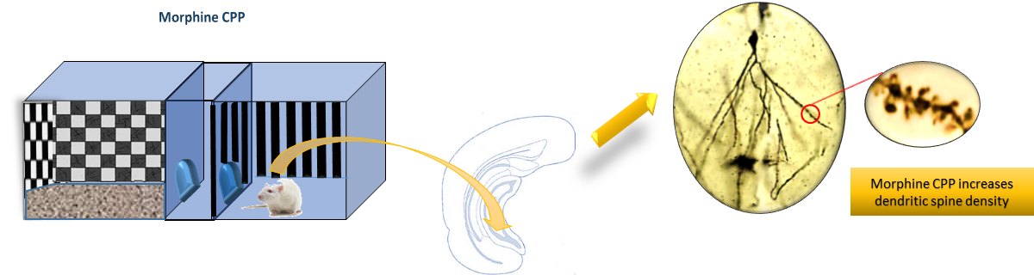

Presenting author details
Full name: Mina Sadighi Alvandi
Email: mina_sadighi@yahoo.com
Contact number: 0098 9142353771
Research Interest: Drug addiction
Category: poster presentation

