Mindfulness based yoga in recovery
Anouk Prop, MSc Psychology Maastricht University, Yoga Teacher, Trauma Therapist

Abstract
Nowadays there are many programs available to treat addiction and substance abuse. An increasing number is focusing on a more holistic approach, encompassing a variety of methods and tools to help achieve, maintain, and enhance recovery. Yoga as a complementary health practice is increasingly being used in substance abuse treatment programs and throughout recovery to help prevent relapse, reduce withdrawal symptoms and cravings, and provide a healthy outlet to cope with potential triggers and daily life stressors. Yoga has been used for thousands of years as a means of promoting physical, mental and spiritual health and is seen as a very beneficial coping tool in recovery. The physical benefits support increasing strength, flexibility and dealing with withdrawal pains. Breathing exercises, gentle motions and a mindfulness-based approach reduces stress, cravings and treats any psychological distress or trauma. The improved circulation lowers blood pressure and increases oxygen flow to the brain that has a mood altering effect on the accompanying depression in recovery. Self-awareness and self-discipline is enhanced through the practice of yoga and its full on exposure therapy nature. Moreover, the origins of yoga are believed to have existed before many other belief systems were born, which provides a solid foundation for a connection with a higher power that has proven to be the crucial step in 12 step recovery programs. In addition, mindfulness based yoga focuses on the principles of acceptance and compassion that are key principles in recovery. In this session, best practices methods of mindfulness-based yoga as a tool in recovery are demonstrated in combination with an overview of its benefits and implications for practice.
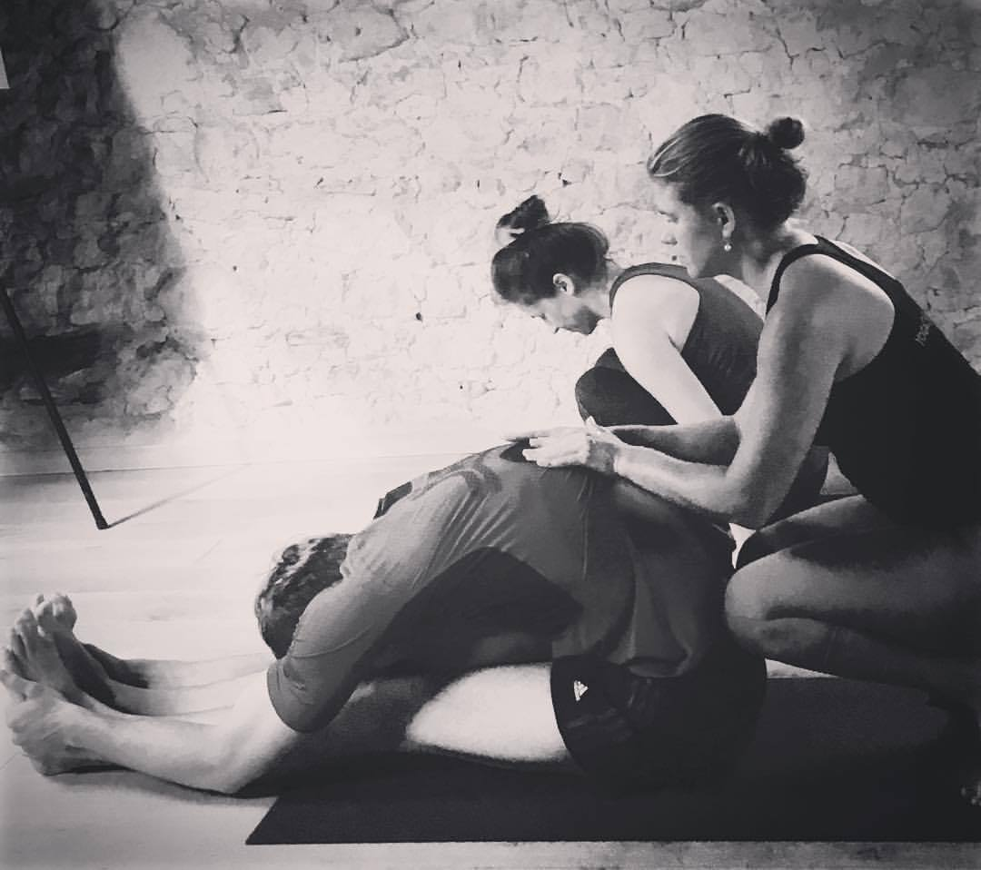

Biography
Anouk Prop is a psychologist and registered Yoga Alliance (500RYT) yoga teacher and trauma therapist, originally from the Netherlands. With additional postgraduate education in trauma healing, she’s an expert in addressing the roots of addiction, which are often nurtured by psychological stress, unresolved trauma and deep lack of self-love. She combines psychology, trauma healing and yoga through their very compatible aspects and stresses on the non-medical methods in healing and offers a holistic approach as such. Anouk has a broad range of experience in the field, in clinical and rehabilitation settings in several countries, varying from working with children and adults with a history of abuse, addiction, anxiety disorders, depression, but also car-accidents and other traumatic events like war or natural disasters. She encounters people with deeply rooted tension, trauma or blockages on a level which goes beyond cognition and shows that addictive behavior can be replaced by more healthy habits to overcome obstacles in life. Her mindful approach is focused on empowerment and guiding people towards their own unique essence by gently inviting them to look in the beautiful, though sometimes confronting mirror life provides, taken by her hand of compassion, positivity and enthusiasm.

Presenting author details
Full name: Anouk Prop
Email: anoukprop@hotmail.com
Contact number: +66 629497995
Research Interest: psychology, mindfulness, recovery, yoga
Current designation: Psychologist; yoga therapist; trauma therapist
LinkedIn account: Anouk Prop
Category: Best practice

Notes/Comments:
As agreed this will be a presentation of a best practice, in the conference hall, for one hour.

