Using Improvisational Theater and Psychodrama to Treat and Prevent Adolescent Substance Abuse: Drug Story Theater Where the Treatment of One Becomes the Prevention of Many
Joseph Shrand, MD, Drug Story Theater, Marshfield, MA; Carol M. Shrand, BA; Kenneth Texeira, PhD

Proceedings Abstract:
Objectives: The goal of this session is to present the use of treatment of teenagers in recovery to help reduce and prevent substance abuse in middle- and high-school students. Methods: Drug Story Theater (DST) takes teenagers in the early stages of recovery and teaches them improvisational theater and psychodrama with which they craft their own shows about the seduction of, addiction to, and recovery from drugs and alcohol. They perform these shows for middle schools and high schools so the treatment of one becomes the prevention of many. In between each scene, the teenagers step out of character and create a PowerPoint presentation on the adolescent brain. The audience takes a pre- and postshow survey, which is then collated and analyzed. Five teenagers and three parents created and performed a play called “The Price You Pay.” Results: Students (N = 1,303) were surveyed, and 1,099 answered whether marijuana was addictive or not. Students (43 percent) thought marijuana was addictive before seeing the show, and 60 percent thought that it was addictive after the show (grade 6: 146/26 pre and 175/13 post; grade 9: 164/125 pre and 232/80 post; grade 10: 156/177 pre and 199/134 post; grade 11: 88/106 pre and 112/75 post; and grade 12: 65/146 pre and 111/93 post). Perception shifted in high-school students from 31 percent who thought marijuana was addictive before the show to 54 percent who perceived marijuana as addictive after the show (P < 0.05). Sixth-grade students (71 percent of 212) thought that marijuana was addictive before viewing the show, and 87.3 percent thought that marijuana was addictive after seeing the show. Sixth graders (17 of 31) who did not think marijuana was addictive before they saw the show changed their minds (54 percent; P < 0.01). Students (43.4 percent) in grades 9–12 knew the function of the prefrontal cortex; after the show, 69 percent answered correctly. Students in grades 9–12 (36 percent) knew the function of oxytocin; after the show, 78.3 percent answered correctly. In one school, there was a 3–5 percent reduction in substance use 30 days after seeing The Price You Pay. Conclusions: The perception that marijuana is addictive declined from grades 6 to 12. This perception can be influenced by seeing teenagers in recovery performing a play and teaching about the brain, facilitating prevention of substance use. This model can be replicated in a culture-specific way, creating DST Troupes wherever teenagers are exposed to drugs and alcohol. More research is needed to assess whether the decrease of substance use is sustainable.
Title:
Using Improvisational Theater and Psychodrama to Treat and Prevent Adolescent Substance Abuse: Drug Story Theater Where the Treatment of One Becomes the Prevention of Many
Submitter's E-mail Address:
JShrand@aol.com

Learning Objectives:
- Educate middle school and high school audiences about basic brain anatomy, function, and neurotransmitters involved in addiction.
- Focus on the function and different maturity of the limbic system compared to the pre-frontal cortex and how this creates a risk for addiction in the teenage brain
- Educate about dopamine, oxytocin, and the interaction of these neurotransmitters in addiction
- Teach students that no one will scare them out of using drugs and alcohol but that they have a choice: they can get high but the price they pay is trust
- Influence audience members to reconsider their perception of marijuana as an addictive substance.
- Reduce current substance use in teenagers who have watched a DST production.
- Educate the educators about the neuro-science of teenager addiction and basic brain development so they can design effective brain-based lesson plans.

- Professional Practice Gap Identification
Adolescent substance abuse is America’s number one health problem. If a person starts using drugs or alcohol after the age of 21, one out of twenty-five are at risk for lifelong addiction. If a person starts using before the age of 18, that number goes from 1:25 to 1:4. One out of every four teenagers who use drugs or alcohol before the age of 18 are at risk for lifelong addiction simply because of the way the brain is developing. In 2009, 21.8 million Americans age twelve and older had used illicit drugs. 10.4 million Americans aged twelve to twenty, more than 25% of this age group, use alcohol on a consistent basis. 10.0% of the American adolescent population (ages twelve to seventeen) currently use marijuana, hashish, cocaine, heroin, hallucinogens, inhalants, or prescription medications nonmedically. Marijuana is the most prevalent drug of abuse, with usage rates of 6.3% in adolescents ages fourteen to fifteen and 14.0% among adolescents ages sixteen to seventeen¹.

It is estimated that only 10% of people challenged with addiction actually obtain treatment. In part this is due to the stigma surrounding addiction, and the veil of secrecy that dominates communities and schools. However, with the recent increase in overdose deaths from heroin, substance use is being viewed as a public health crisis rather than a crisis of morality. DST, Inc. is poised and ready to capitalize on this more appropriate understanding of addiction, bringing awareness of the dangers of drugs and alcohol to school age children by having their peers deliver the message based on their own experience.

Various treatment approaches have been initiated to decrease substance abuse in teens, but none have had overwhelming success.,,,,,Analysis of these valiant attempts reveal that some try to scare people out of using drugs or alcohol, some entail adults telling their stories to middle and high school students, and others have adults act in theatrical performances to middle schools and high schools . None of these efforts take into account the development of the adolescent brain, nor access other adolescents in their own treatment to help prevent the potential drug and alcohol use of their peers.

Unfortunately, professional productions of “anti-drug dramas” have been shown to be relatively ineffective in promoting adolescent drug abstinence. Sadly, there are very few treatment modalities with robust positive outcomes for adolescents struggling with addictions and drug abuse^{3,4,5}. Teaching at teens does not seem to be effective, and may even turn an adolescent off to learning about the effects of drugs and alcohol. Professionally-written and performed “life story” and “anti-drug” plays are not truly directed to the adolescents at risk of addiction, nor do they appear to include them in the design of the theatrical experience. Traditional models of drug education appear to be insufficient.
A large clinical review of 5071 papers written between January 1, 1984, and March 15, 2015 focused on Universal school-based drug prevention curricula available for dissemination in the United States that reported alcohol, tobacco, marijuana, or other drug use outcomes. 13 articles met final inclusion criteria. Of the 13 articles, 6 RCTs of 4 distinct school-based curricula were identified for inclusion. Of 42 single-drug measures just 3 presented statistically significant (P < .05) differences between the intervention group and the control group. Only one program revealed statistically significant positive effects at final follow-up (Lions-Quest Skills for Adolescence). The authors concluded: The results of our review demonstrate the dearth of independent research that appropriately evaluates the effectiveness of universal, middle school-based drug prevention curricula. Independent evaluations show little evidence of effectiveness for widely used programs. New methods may be necessary to approach school-based adolescent drug prevention.”
There is compelling evidence that adolescents who are engaged in treatment have higher rates of successful recovery than those who are not actively involved. Drug Story Theater is designed to directly engage adolescents in their education, treatment, and evolution of their own arc of sobriety. However, Drug Story Theater goes even further by taking the treatment of those in recovery to serve as a prevention intervention for other teens. The Treatment of One Becomes the Prevention of Many.

DST capitalizes on the adolescent’s predilection to take risks, seek pleasure, and be social. Prevention efficacy is currently being measured using pre-and post- program written evaluations.

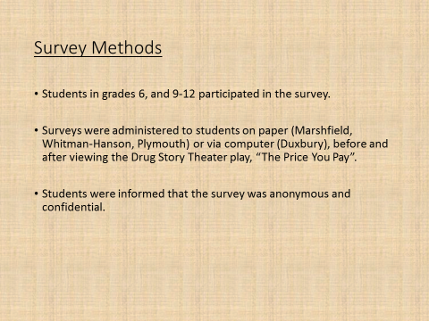
- Results
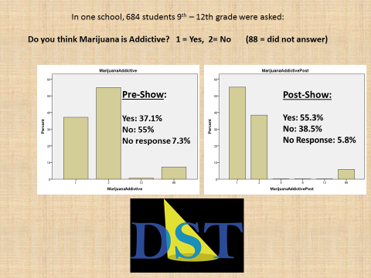
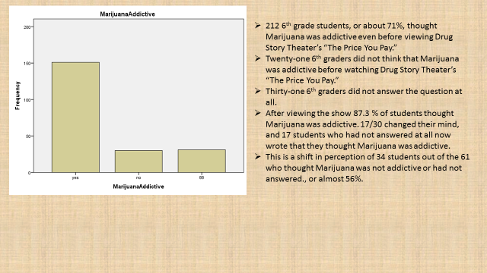
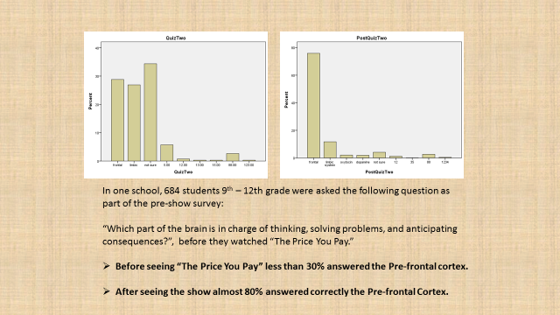
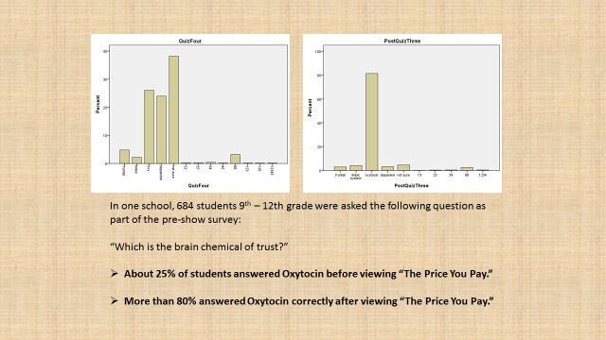

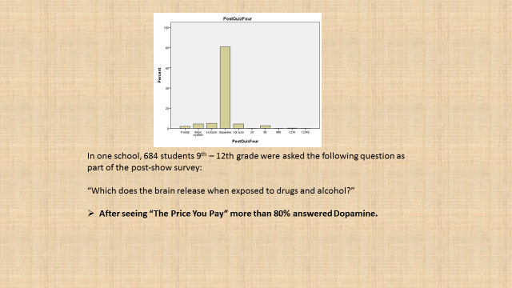
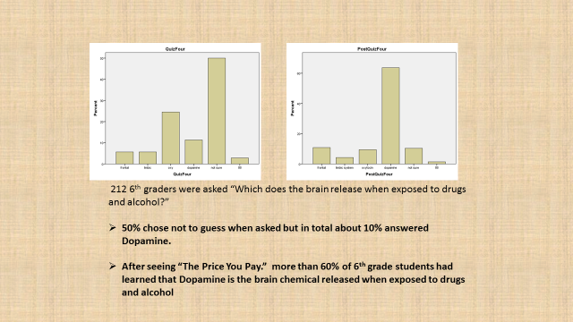

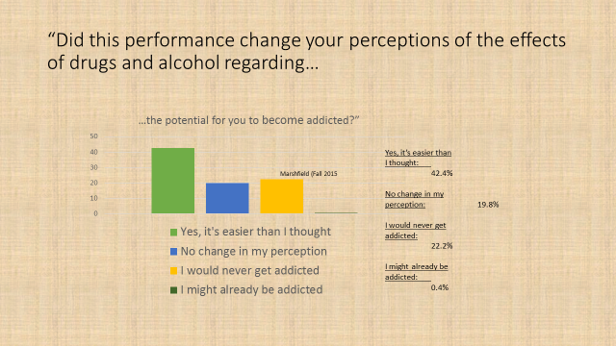
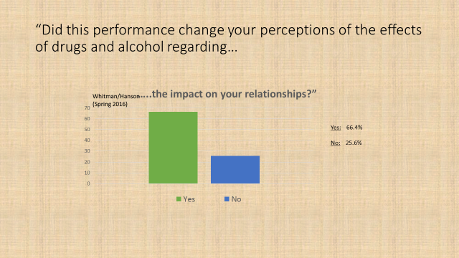
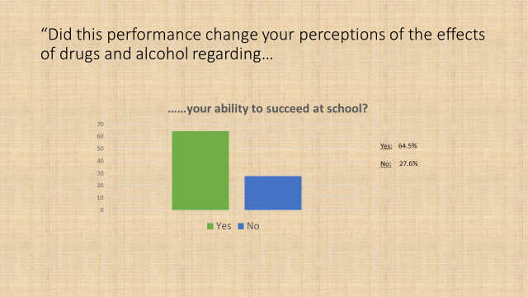

- Conclusions
Teenagers in recovery can change the perception of others teens to facilitate prevention of substance use.

http://www.casacolumbia.org/newsroom/press-releases/national-study-reveals-teen-substance-use-americas-1-public-health-problem
Kelly JF, Myers MG, Rodolico J. “What do adolescents exposed to Alcoholics Anonymous think about 12-step groups?” Substance Abuse. 2008; 29(2): 53-62.
Spear SF, Ciesla JR, Skala SY. “Relapse patterns among adolescents treated for chemical dependency.” Substance Use and Misuse. 1999 Nov; 34(13): 1795-81
Clayton RR, Cattarello AM, Johnstone BM. “The effectiveness of Drug Abuse Resistance Education (project DARE): 5-year follow-up results.” Preventive Medicine. 1996 May-Jun; 25(3): 307-18.
Sloboda Z, Stephens RC, Stephens PC, Grey SF, Teasdale B, Hawthorne RD, Williams J, Marquette JF. “The Adolescent Substance Abuse Prevention Study: A randomized field trial of a universal substance abuse prevention program.” Drug and Alcohol Dependence. 2009 Jun 1; 102(1-3): 1-10. Epub 2009 Mar 29.
Klimas J, Tobin H, Field CA, O'Gorman CS, Glynn LG, Keenan E, Saunders J, Bury G, Dunne C, Cullen W. Psychosocial interventions to reduce alcohol consumption in concurrent problem alcohol and illicit drug users. Cochrane Database Syst Rev. 2014 Dec 3;12: CD0092
Faggiano F, Minozzi S, Versino E, Buscemi D. Universal school-based prevention for illicit drug use. Cochrane Database Syst Rev. 2014;12:CD003020.
Guttman N, Gesser-Edelsburg A, Israelashvili M. “The paradox of realism and ‘authenticity’ in entertainment-education: a study of adolescents' views about anti-drug abuse dramas.” Health Communication. 2008 Mar-Apr; 23(2): 128-41.
McWhirter PT. “Enhancing adolescent substance abuse treatment engagement.” Journal of Psychoactive Drugs. 2008 Jun; 40(2): 173-82.
Flynn AB, Falco M, Hocini S. JAMA Pediatr. 2015 Nov;169(11):1046-52. Independent Evaluation of Middle School-Based Drug Prevention Curricula: A Systematic Review.
Stephens-Hernandez AB, Livingston JN, Dacons-Brock K, Craft HL, Cameron A, Franklin SO, Howlett AC. “Drama-based education to motivate participation in substance abuse prevention.” Subst Abuse Treatment, Prevention and Policy. 2007 Apr 5; 2:11.

