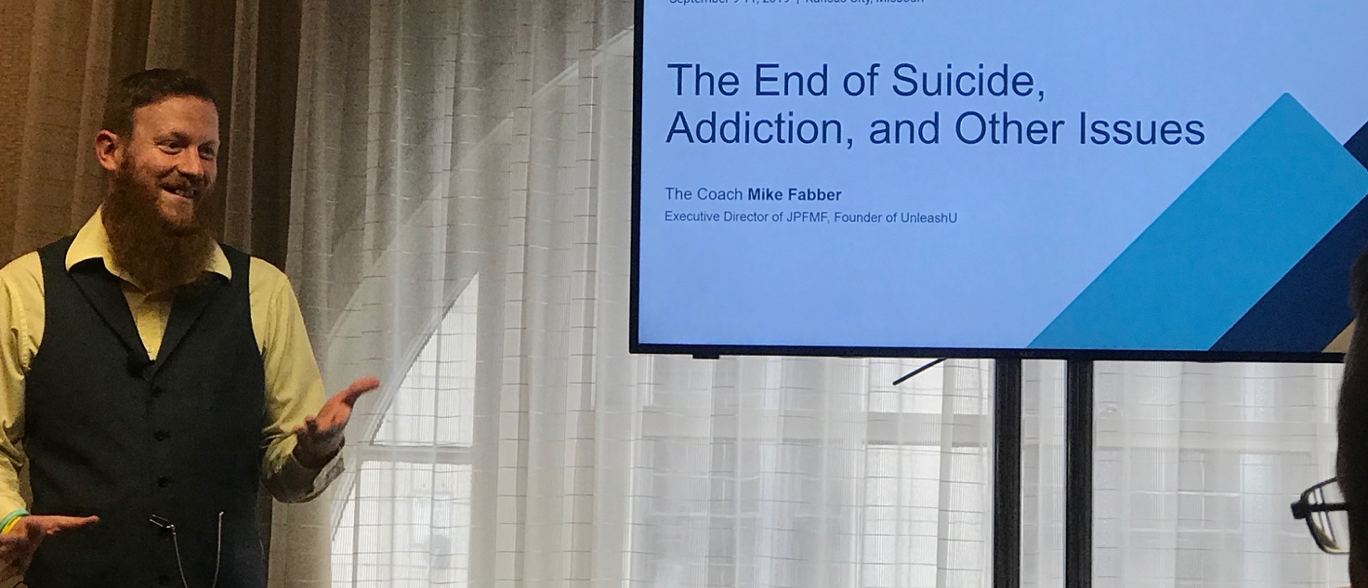
Title: Impact Theory
Name: The Coach Mike Fabber
Exectuive Director of Joseph Patrick Fabber Memorial Foundation, Founder of UnleashU
Agenda
- Suicide Rate/ Facts
- Addiction Rate/ Facts
- Connection- What Do we need to fill?
- Exercises/Tools
- Conclusion
This session will give you the tools and ability to measure one’s impact based on connection and vulnerbility. Discuss how to measure ones impact in their own life as well as others. The learning objective is for everyone to see their own significance; identify challenges and concerns of being “stuck” and to tap into their full potential greatness that in return impacts others.

Biography
The Executive Director of Joseph Patrick Fabber Memorial Foundation, with the mission to prevent suicide, anti-drugs, and anti-bullying. He is a High-Performance Success Coach, author, entrepreneur, speaker, and owner of several businesses. The Coach Mike Fabber is the founder of UNLEASHU.

Presenting author details
Full name: Michael Fabber
Contact number: (302)682-7566
Twitter account: https://twitter.com/thecoachmikef
Category: Oral

