Substance use disorder and associated factors among prisoners in a correctional institution in Jimma, Southwest Ethiopia: A cross-sectional study
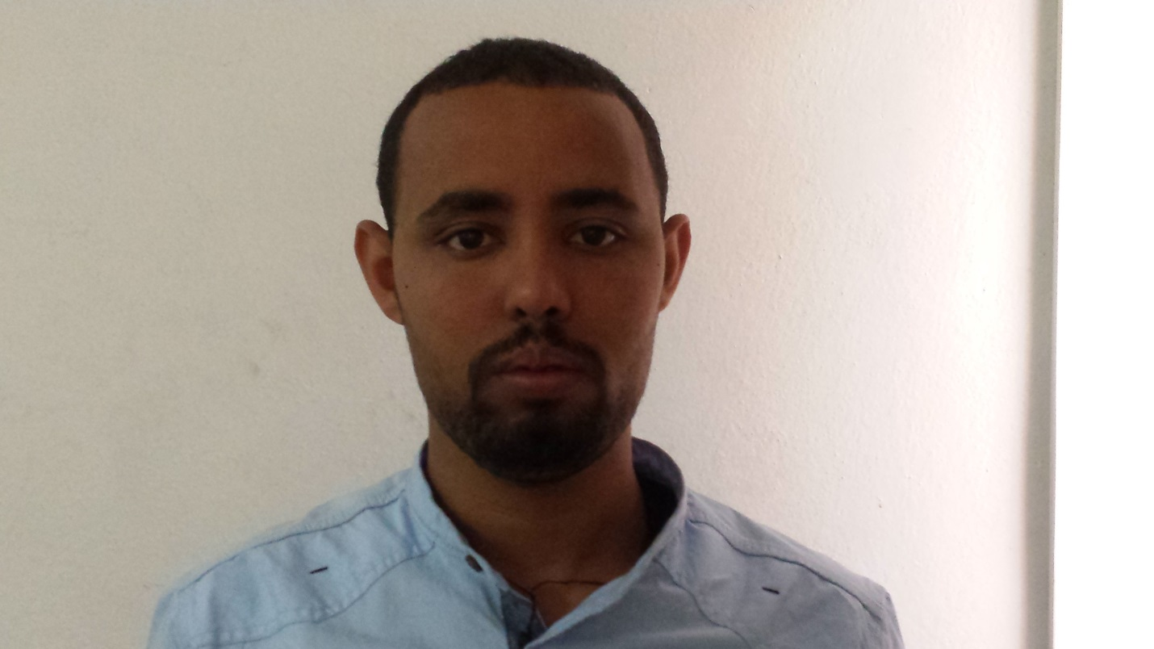
Name: Yimenu Yitayih
Jimma University, Department of psychiatry
Abstract
Background: Substance use disorder is an important public health problem and one of the major causes of disability worldwide. Substance use and criminal behavior are closely related, and a large proportion of substance users commit crimes. However, little is known about substance use disorders among prisoners in Ethiopia. Therefore, we investigated substance use disorder and associated factors in inmates of a correctional institution in Jimma, Southwest Ethiopia.
Methods: We used a cross-sectional study design to collect data from 336 prisoners from June 5 to July 5, 2017. Study participants were selected by a systematic random sampling technique. Among 1460 prisoners eligible for the study 336 prisoners were selected from registration book by using the sampling interval of 1460/336. Alcohol use disorder, nicotine dependence, khat abuse, cannabis use disorder, Psychopathy, adverse traumatic life events and social support were assessed. Data were entered into EpiData version 3.1 and analyzed in bivariate and multivariable logistic regression models with the Statistical Package for Social Science version 21. Variables with a P value < 0.05 in the final fitting model were declared to be associated with the outcome variable.
Results: The overall prevalence of substance use disorder was 55.9%. The prevalence of khat abuse was 41.9%; of alcohol use disorder, 36.2%; of nicotine dependence, 19.8%; and of cannabis use disorder, 3.6%. Poor social support, living in urban areas, psychopathy, and a family history of substance use were positively associated with substance use disorder. Conclusions: Substance use disorder is prevalent among prisoners. The increased morbidity and unpleasant psychosocial consequences associated with substance use disorders, together with our finding that 66.3% of prisoners with substance use disorders were interested in obtaining treatment suggest a need to establish prison-based treatment in this correctional institution in Jimma.
Biography
Yimenu Yitayih has completed his MSC in psychiatry at the age of 26 years from Jimma universty. Curently I am lecturer at Jimma Universty at psychiatry department . I has published 1 paper and 4 papers under review in reputed journals and has been serving also as clincian in treating mental and substance use disorder patients.
Presenting author details
Full name: Yimenu Yitayih Abyu
Contact number: +251921130353
Email account: yemenu2007@gmail.com
Category: Poster presentation

