Psychopathy and khat abuse among prisoners in Jimma correctional institution: Cross sectional study.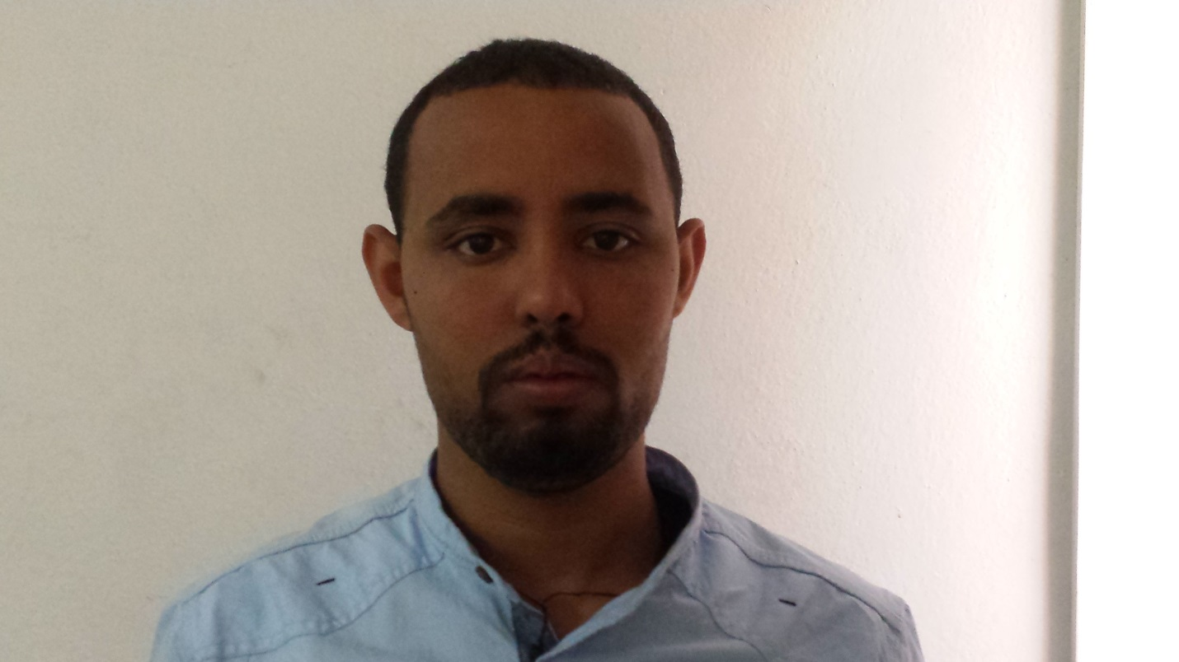
Name: Yimenu Yitayih
Jimma University, Department of psychiatry
Abstract
Background: Khat abuse and psychopathy are two situations strongly related to criminal activity. Psychopathic features lead to increases in substance use because of facets of personality linked to features of psychopathy. However, little is known about the association between psychopathy and khat abuse among prisoners in Ethiopia. Therefore, we examined the relationship between psychopathy and khat abuse among prisoners in Jimma correctional institution, Southwest Ethiopia.
Materials and methods: We employed a cross-sectional study design to collect data from 336 prisoners from June 5 to July 5, 2017. Study participants were selected by a systematic random sampling technique. Khat abuse was assessed using the drug abuse screening tool and psychopathy was assessed by Psychopathy Checklist Screening Version. We also assessed nicotine dependence, alcohol use disorder, adverse traumatic life events and Social Support Scale. Data were entered into EpiData version 3.1 and analyzed in bivariate and multivariable logistic regression models. Variables with a P value < 0.05 in the final fitted model were declared to be significantly associated with the outcome variable.
Results: The overall prevalence of lifetime khat use was 59.9%, and the prevalence of khat abuse among psychopathy prisoners was 78%. The result showed that, participants with psychopathy had 3 times increased odds of having khat abuse compared to their counterparts (AOR= 3.00 (1.17- 7.67)). Among the confounders, those who had family history of use substance, poor support, alcohol use disorder and suicidal ideation and attempt were also positively associated with khat abuse.
Conclusions: The prevalence of khat abuse was high among prisoners with psychopathy. Also, this study indicates that prisoners with psychopathy are at higher risk for khat abuse than those with no psychopathy.
Biography
Yimenu Yitayih has completed his MSC in psychiatry at the age of 26 years from Jimma universty. Curently I am lecturer at Jimma Universty at psychiatry department . I has published 1 paper and 4 papers under review in reputed journals and has been serving also as clincian in treating mental and substance use disorder patients.
Presenting author details
Full name: Yimenu Yitayih Abyu
Contact number: +251921130353
Email account: yemenu2007@gmail.com
Category: Poster presentation

