Trauma exposure and alcohol use disorder among prisoners in Jimma Zone correctional institution, Southwest Ethiopia: A cross-sectional study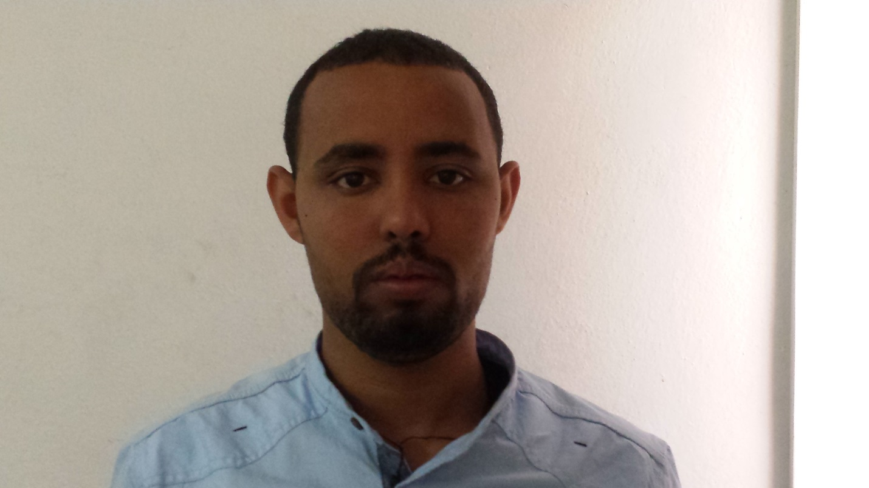
Name: Yimenu Yitayih
Jimma University, Department of psychiatry
Abstract
Background: Alcohol use disorder is one of important public health problem. Trauma exposure and alcohol use are closely related, and a large proportion of trauma-exposed individuals use alcohol. However, little is known about the association between trauma exposure and alcohol use disorder among prisoners in Ethiopia. Therefore, we examined alcohol use disorder in inmates of Jimma Zone correctional institution, Southwest Ethiopia, who had traumatic life experiences.
Materials and methods: We employed a cross-sectional study design to collect data from 336 prisoners from June 5 to July 5, 2017. Study participants were selected by a systematic random sampling technique. Alcohol use disorder was assessed using the Alcohol Use Disorders Identification Test and adverse traumatic life events were recorded with the Life Events Checklist. We also assessed nicotine dependence, khat abuse, psychopathy and social support. Data were entered into EpiData version 3.1 and analyzed in bivariate and multivariable logistic regression models. Variables with a P value < 0.05 in the final fitted model were declared to be significantly associated with the outcome variable.
Results: The overall prevalence of lifetime alcohol use was 40.1%, and the prevalence of alcohol use disorder among prisoners with lifetime trauma exposure was 44.0%. The result showed that, participants with multiple trauma exposures had 2.5 times increased odds of having alcohol use disorder compared to their counterparts (AOR=2.47 (1.23-4.94)). Among the confounders, those living in urban areas, presence of psychopathy, khat abuse, and nicotine dependence were also positively associated with alcohol use disorder.
Conclusions: The prevalence of alcohol use disorder was high among prisoners with lifetime exposure to traumatic life experience. Also, this study indicates that prisoners with multiple trauma exposures are at higher risk for alcohol use disorder than those with no trauma exposure. A public health intervention targeting survivors of traumatic experience has to be designed and implemented to decrease risk of alcohol use disorder.
Biography
Yimenu Yitayih has completed his MSC in psychiatry at the age of 26 years from Jimma universty. Curently I am lecturer at Jimma Universty at psychiatry department . I has published 1 paper and 4 papers under review in reputed journals and has been serving also as clincian in treating mental and substance use disorder patients.
Presenting author details
Full name: Yimenu Yitayih Abyu
Contact number: +251921130353
Email account: yemenu2007@gmail.com
Category: Poster presentation

