Title: From “Mother-Son” to “Parents-Children”: The Fallacy of Traditional Chinese Medicine
Name: Eric M. Hao
Acupuncture Centre for Intractable Pain (ACIP)
Taipei, Taiwan, ROC

Abstract

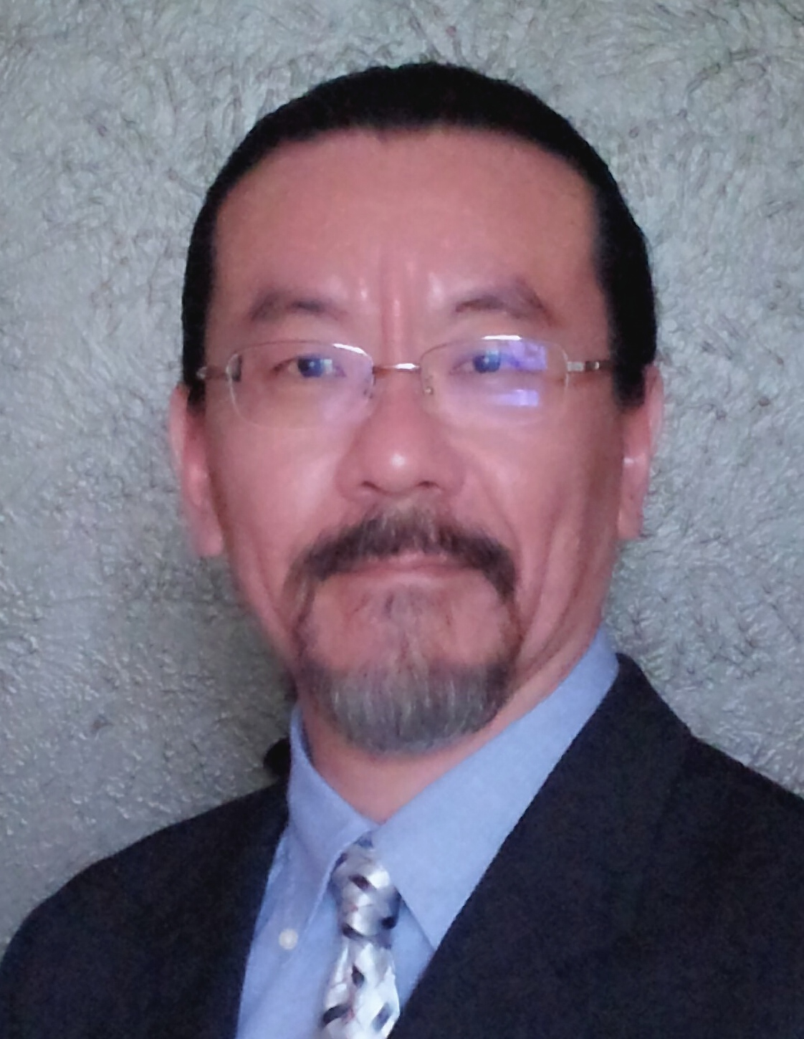
One of the fallacies in Traditional Chinese Medicine (TCM) theory is the "One mother generate a son" concept which unmatches the natural fact that, in most cases, requires both genders to reproduce next generations. If TCM with a fundamental fragility is gaining global attention and achievements, it is difficult to measure the positive impact on academic and clinical advancements when a "father" is incorporated and formed the new "Parents-Children" relationship. By applying new theory and the treatment modalities derived from it, TCM practitioners and acupuncturist will be able to manage challenging cases such as numbness, neuropathy, intractable painful and functional disorders with immediate and consistent success.

Keywords: Acupuncture, TCM, numbness, intractable pain

Biography

Mr. Eric Hao is a licensed acupuncturist in the State of Texas, USA with a master’s degree in acupuncture and oriental medicine and NCCAOM certification. He was a dentist in Taiwan from 1990-2012. Mr. Hao has been learning and practicing acupuncture for 21 years (1997-2018) and studied Power Of Nature Acupuncture Medical System (PONAMS) in 2006. He is currently an international speaker of PONAMS and hosting PONAMS teaching and training programs worldwide upon request.
Presenting author details
Full name: Eric Mengchen Hao
Contact number: +1-214-609-3421
Twitter account: N/A
Linked In account: N/A
Session name/ number: N/A
Category: (Oral presentation/ Poster presentation): Oral presentation or Workshop, whichever is available.

