The effect of acupuncture and carboxytherapy on pain relief in patients with trigeminal neuralgia
Cristine Keller Cota
Specialist in Physical Therapy and Acupuncture
RJ, Brazil

Abstract
Trigeminal Neuralgia (TN) is a chronic painful condition usually caused by the focal compression of the trigeminal nerve, characterized by attacks of intensive pain on the face. In many cases, conventional treatments (medication or surgery) do not provide an effective pain relief, some patients seek acupuncture.: To report the immediate result of acupuncture associated with carboxytherapy (a technique where carbon dioxide is injected into the subcutaneous tissue to improve circulation and oxygenation, usually for aesthetic purposes).: Patient, female, 38 years old, diagnosed with TN for 3 months, treated without success with carbamazepine 200mg / day, complained of excruciating pain in the maxillary region and with palpation sensitivity, especially at the E6 acupuncture point (JIACHE) , in the right side. According to the principles of Traditional Chinese Medicine (TCM), after the diagnosis the treatment started with points IG4, F3 and YinTang where the needles were inserted and retained for 20 minutes and CO2 was injected locally at point E6 on the right side for 10 seconds, with a flow of 60 mg. The intensity of the pain was assessed using a numerical rating scales (NRS), where the patient classify his pain according to the intensity of the sensation, ranging from zero (no pain) to 10 (the worst possible pain). Prior to treatment, the patient reported NRS pain 10. However 12 hours after treatment EVN pain was zero. Acupuncture associated with carboxytherapy was shown to be effective in relieving immediate TN pain.

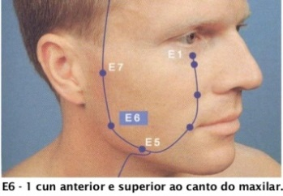 | 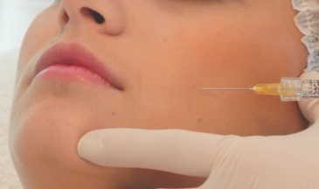
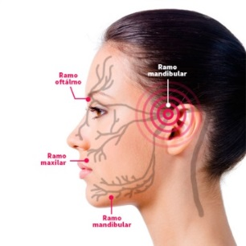 | 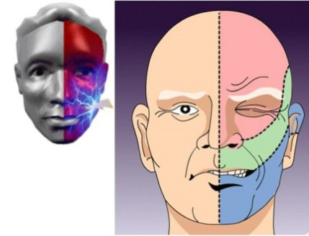

Biography 

Cristine has experience developing studies in her clinical practice for pain relief in patients with acute and chronic complaints. Her study is based on the use of an apparatus generally used for aesthetics and associated with acupuncture points promoting pain relief with delayed response only to treatment with acupuncture. This is a new technique that can offer relief from many pains for well-beijng and the best quality of life of the patient.

