The 101 of Yin Yoga

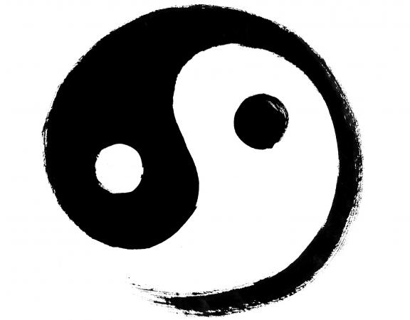

We will explore the key elements of this slower style practice & how it can benefit you & patients.

Your presenter Rachel Smiljanic is international yoga teacher, yoga therapist, meditation teacher & holistic body worker. She’s an Aussie that currently lives in the Boston, MA with her husband & pup Theodore.

Her passion is helping people to slow down, heal themselves from the inside out, return to their true authentic self through the magic of yoga.

Rachel suffered from anxiety & depression in her younger years from burning the candle at both ends for way to long. She restored & healed her body through a combination TCM, acupuncture & yoga.

