Kelly Samuels, LMT
Nature’s Purpose Massage Therapy

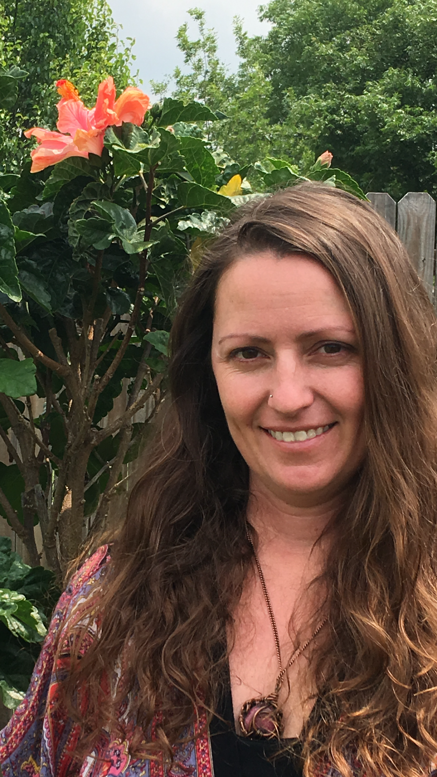

Kelly Samuels graduated Cum Laude from Navarro College and went on to achieve her certification in massage through Universal Body Wellness. She is a licensed massage therapist and wellness coach, that has run a holistic practice in Anna,Texas since 2008. Although raised holistically, in her mid twenties she began to battle illness and dis-ease. Through those struggles she discovered true wellness in the return to a natural lifestyle, and her calling to help others achieve wellness was unveiled. She incorporates craniosacral therapy, myofascial release, neurostim, reflexology, sound therapy, emotional release, energy work, and healing touch in her practice. She uses her studies and experience to mold a unique style of services that allow her clients to achieve a reduction in pain while bringing about relaxation, peace, and an overall sense of well being. Her passion for her work and true desire to help others is evident throughout her practice and can be seen through the success of Nature’s Purpose.

