The effcects of Hominis Placenta extract on Melanin synthesis of B16 melanoma cells
Hyungsik Seo, Dr PhD, Pusan National University, Republic of Korea

Abstract (300 word limit)
Objective : This research was carried out for the development of medicine for vitiligo treatment and focused on the effect of Hominis Placenta extract on Melanin synthesis of B16 melanoma cells.
Methods : Acitivity of tyrosinase playing a vital role in synthesis of Melanin and the quantity of Melanin, which is the final product in cultured B16 melanoma cells, effects of Hominis Placenta extract were measured.
Results : The results indicated that Hominis Placenta extract increased both the amount of Melanin and the activity of tyrosinase according to the concentration, and they also supported by western blot analysis.
Conclusion : The results suggests that Hominis Placenta extract has an advantageous effect on the promotion of Melanin synthesis and will contribute to the development of vitiligo treatment through further related studies.

Image
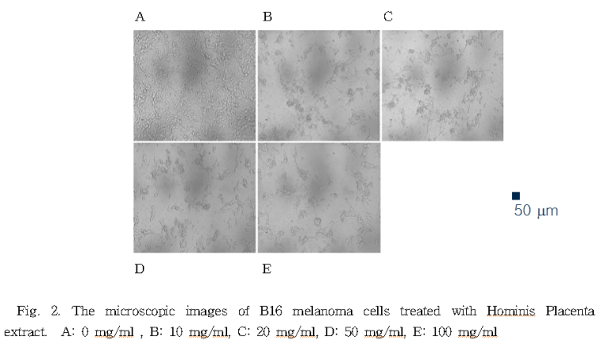
Recent Publications (minimum 5)
1. Hyungsik Seo et al (2016). Cornu Cervi Pantotrichum Pharmacopuncture Solution Facilitate Hair Growth in C57BL/6 Mice. Journal of Pharmacopuncture. 19(2):122-8.
2. Hyungsik Seo et al (2015). The Success of Thread-embedding Therapy in Generating Hair Re-growth in Mice Points to Its Possibly Having a Similar Effect in Humans. Journal of Pharmacopuncture. 18(4):20-5.
3. Hyungsik Seo et al (2015). Single-dose Intravenous Toxicology Testing of Daebohwalryeok Pharmacopuncture in Sprague-Dawley Rats. Journal of Pharmacopuncture. 18(2):42-50.
4. Hyungsik Seo et al (2015). Toxicity of Single-dose Intramuscular Injection of Samjeong Pharmacopuncture in Sprague-Dawley Rats. Journal of Pharmacopuncture. 18(2):60-6.
5. Hyungsik Seo et al (2011). Hwangryunhaedoktang in adult patients with Atopic Dermatitis: a randomised, double-blind, placebo-controlled, two-centre trial - study protocol. BMC Complementary and Alternative. 11(1).

 Biography (150 word limit)
Dr. Hyungsik Seo is a full professor, Department of Ophthalmology, Otolaryngology and Dermatosurgery, School of Korean Medicine, Pusan National University in Korea. I was selected as a excellent researcher at Sangji University. I have served as a member of the editorial board of the Society of Korean Medicine Ophthalmology, Otolaryngology and Dermatology, and the associate editor of the Korean Pharmacopuncture Institute. I am a consultant of Korea Medical Dispute Mediation and Arbitration Agency. My research fields are formulation development of Korean Medicine, cosmetic formulation and efficacy evaluation of functional cosmetics.

Email: aran99@pusan.ac.kr

Notes/Comments

