Hominis Placenta facilitates hair re-growth by upregulating cellular proliferation and expression of fibroblast growth factor-7
Hyungsik Seo, Dr PhD, Pusan National University, Republic of Korea

Abstract (300 word limit)
Background Hominis Placenta (HP) known as a restorative medicine in Traditional Korean Medicine (TKM), has been widely applied in the clinics of Korea and China as an anti-aging agent to enhance the regeneration of tissue. This study was conducted to investigate whether topical treatment of HP promotes hair regrowth in the animal model.
Methods The dorsal hairs of 8-week-old C57BL/6 mice were depilated to synchronize hair follicles to the anagen phase. HP was applied topically once a day for 15 days. Hair growth was evaluated visually and microscopically. The incorporation of bromodeoxyuridine (BrdU) and expression of proliferating cell nuclear antigen (PCNA), fibroblast growth factor-7 (FGF-7) in dorsal skin tissue was examined by immunohistochemical analysis. Reverse transcription polymerase chain reaction (RTPCR) was used to measure the mRNA expression of FGF-7.
Results HP exhibited potent hair growth-promoting activity in C57BL/6 mice. Gross examination indicated that HP markedly increased hair regrowth as well as hair density and diameter. Histologic analysis showed that HP treatment enhanced the anagen induction of hair follicles. Immunohistochemical analysis revealed that BrdU incorporation and the expressions of PCNA were increased by treatment of HP. HP treatment significantly increased the expression of FGF-7, which plays pivotal roles to maintain anagen phase both protein and mRNA levels.
Conclusions Taken together, our results indicate that HP has a potent hair growth-promoting activity; therefore, it may be a good candidate for the treatment of alopecia.

Image
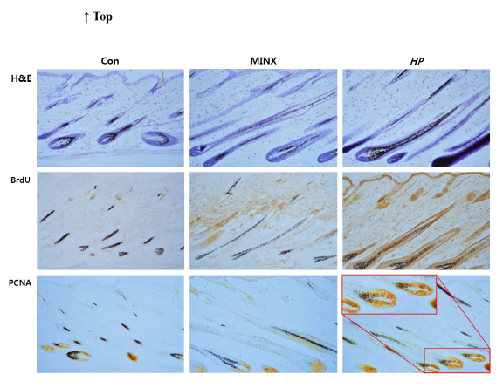
Microscopic observation of hair follicle in C57BL/6 mice.
Histologic examination reveals hair follicle development in C57BL/6 mice treated with normal saline or MINX or HP for 15 days. Dorsal skin sections were stained with hematoxylin and eosin. Immunohistochemical staining were performed to examine the expression of BrdU and PCNA. MINX: minoxidil; HP: Hominis placenta; Original magnification: X100, large box: X200.
Recent Publications (minimum 5)
1. Hyungsik Seo et al (2016). Cornu Cervi Pantotrichum Pharmacopuncture Solution Facilitate Hair Growth in C57BL/6 Mice. Journal of Pharmacopuncture. 19(2):122-8.
2. Hyungsik Seo et al (2015). The Success of Thread-embedding Therapy in Generating Hair Re-growth in Mice Points to Its Possibly Having a Similar Effect in Humans. Journal of Pharmacopuncture. 18(4):20-5.
3. Hyungsik Seo et al (2015). Single-dose Intravenous Toxicology Testing of Daebohwalryeok Pharmacopuncture in Sprague-Dawley Rats. Journal of Pharmacopuncture. 18(2):42-50.
4. Hyungsik Seo et al (2015). Toxicity of Single-dose Intramuscular Injection of Samjeong Pharmacopuncture in Sprague-Dawley Rats. Journal of Pharmacopuncture. 18(2):60-6.
5. Hyungsik Seo et al (2011). Hwangryunhaedoktang in adult patients with Atopic Dermatitis: a randomised, double-blind, placebo-controlled, two-centre trial - study protocol. BMC Complementary and Alternative. 11(1).

 Biography (150 word limit)
Dr. Hyungsik Seo is a full professor, Department of Ophthalmology, Otolaryngology and Dermatosurgery, School of Korean Medicine, Pusan National University in Korea. I was selected as a excellent researcher at Sangji University. I have served as a member of the editorial board of the Society of Korean Medicine Ophthalmology, Otolaryngology and Dermatology, and the associate editor of the Korean Pharmacopuncture Institute. I am a consultant of Korea Medical Dispute Mediation and Arbitration Agency. My research fields are formulation development of Korean Medicine, cosmetic formulation and efficacy evaluation of functional cosmetics.

Email: aran99@pusan.ac.kr

Notes/Comments

