Inhibitory effects of Solanum xanthocarpum Schrad. & Wendl. on tracheal responsiveness
and inflammatory mediators in ovalbumin-induced bronchial asthma
Poonam Arora, S.H. Ansari, A.K. Najmi, Adil Ahmad, Sayeed Ahmad
Abstract
Solanum xanthocarpum (Family Solanaceae) is a well-known anti-allergic drug in Asian system of medicines. In the present study, ethanolic fraction of S. xanthocarpum whole plant was examined for spasmogen-induced contractile responsiveness in isolated guinea pig tracheal preparations. Additionally, physiological and biochemical effects of S. xanthocarpum extract (0.6 and 1.2 mg/kg) and dexamethasone (2.5 mg/kg) treatments were investigated in ovalbumin induced model of bronchial asthma in wistar rats. Histamine content in lungs and inflammatory markers, including cell counts, IgE, cytokines such as IL-4, IL-5, IL-1β, TNF-α, LTD-4, and nitrite levels in both blood and bronchoalveolar fluid were analysed. Breathing rate and tidal volume as lung function parameters were examined by spirometer. Pre-treatment with S. xanthocarpum flower extract inhibited allergen induced tracheal response in the order of histamine>methacholine>bradykinin induced contractions. Oral treatment for 28 days with drug extract (1.2 mg/kg) significantly (p<0.01 and p<0.05) inhibited infiltration of inflammatory cytokines, IgE, nitrites and circulating cells particularly eosinophils, in blood/serum and bronchoalveolar fluid of asthmatic rats. Improvement in lung functions and histamine levels (p<0.05) support these findings. Results of the study suggest therapeutic potential of S. xanthocarpum in allergic asthma possibly related to its ability to block histamine (H1) receptors, inhibit cellular response and subsequent production of inflammatory cytokines in airways.

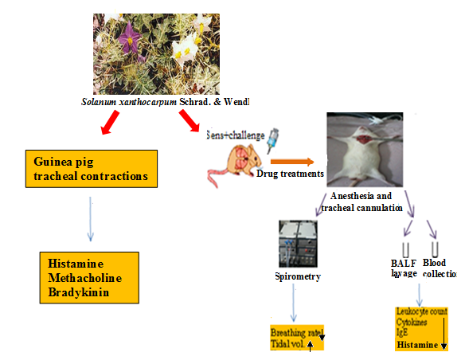
Figure: Effects of Solanum xanthocarpum on physiological and biochemical parameters in animal model of ovalbumin-induced asthma. ( , increase; , decrease; Sens, sensitization IgE, immunoglobulin)

Recent publications
- Investigation of anti-asthmatic potential of Kanakasava in ovalbumin-induced bronchial asthma and airway inflammation in rats. J Ethnopharmacology, (IF: 3.03).
- Investigation of anti-asthmatic potential of dried fruits of Vitis vinifera L. in animal model of bronchial asthma. Allergy Asthma Clin Immunol, 2016; 12: 42. (IF: 2.283).
- Antiobesity activity of Zingiber officinale. Pharmacog J. 2016; 8(5): 440-446.
- Quality Assessment of “Kanakasava”, an anti-asthmatic Ayurvedic formulation. Am J Pharm Tech Research, 2014; 4(4).
- Development of quality standards of Carica papaya Linn. Leaves. Der Pharmacia Lettre, 2013, 5 (2): 370-376.

