Crossing the Bridge, from West to East, using the knowledge of EBM (evidence based medicine) to advance your practice

Elizabeth A. Perry (Gibbs)
- 22+ years of National & International Healthcare Consulting
- Columnist and healthcare journalist: ASK LIZ, I Care Magazine, Martin County, FL
- ‘Spotlight on Health’, Radio Show with Laurie Scola, WSTU 1450
‘Providing Health Information for Today & Tomorrow’
- B.S.B.A., in Accounting, Northeastern University, Boston, MA 1996
- Masters in Management, Harvard University, Cambridge, MA 2009
- Student of Oriental Medicine, at Atlantic Institute of Oriental Medicine (A.T.O.M.) Fort Lauderdale, FL 2018

Abstract (223 words)
Why do we care about a new strategic approach in helping our patients lead longer and better quality lives? Evidence Based Medicine (EBM) shows that by incorporating Strategic Acupuncture and Oriental Medicine into the continuum of care, favorable clinical outcomes increase significantly. The top 10 Medical Schools in the United States, along with the U.S. military are crossing the bridge from West to East.
Chronic disease is growing exponentially in the United States. More patients are developing cardiovascular disease, diabetes, respiratory problems, cancer, stroke, dementia, and Parkinson’s disease than ever before. See how combining established clinical solutions with new strategic innovations will advance your practice. The Aging population is at greater risk for physical and mental health problems. Using only western medicine, the result has a significant personal, social and economic cost and the impact of all three inevitably compounds the cost. So, the question is, how do we in our individual practices cross the bridge to optimize health performance of our patients? The solution includes using established modalities, coupled with new and advanced Acupuncture Strategies to more powerfully accommodate the ever-changing healthcare market. Using evidence based medicine in our communication is essential as changes continue to shift to a more educated patient.

Image 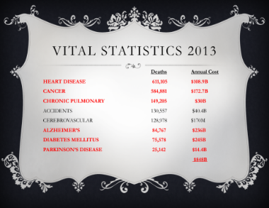

Recent Publications (minimum 5)
- Perry L. (2017) Heart Health, iCare Community Magazine 4:1:19.
- Perry L. (2017) Depression, iCare Community Magazine 4:3:21.
- Perry L. (2016) Tea Time, iCare Community Magazine 4:5:21.
- Perry L. (2016) Acupuncture, iCare Community Magazine 4:2:19.
- Perry L. (2015) Coconut Oil, iCare Community Magazine 3:5:19.

Biography (150 words)
Liz’s knowledge of healthcare leadership, big data and clinical expertise is what brings a unique value to our industry at large. Her consulting skills have taken her around the globe where she has helped build major healthcare organizations, from C-level executives and clinical leaders to the front lines with organizations throughout the continuum. Liz is an advisory source to the community providing health Information via her Radio Show, ‘Spotlight on Health’, and is a healthcare journalist for the I Care Magazine in Martin County, Florida.
Email: drlizperry@gmail.com

Notes/Comments:

