TCM Nutrition: providing a different mindset using foods for balanced health.
Dr. Yi-Chuan Liu (Candace), B.Med, MSOM, DAOM

Abstract (300 word limit)
Statement of the Problem: improper diets and the lack in correct food recommendations for balanced health.
Traditional Chinese Medicine (TCM) encompasses eight strategies: meditation, exercise (Tai Chi), diet and nutrition, astrology, Feng Shui (geomancy), body work, herbs, and acupuncture. The Chinese recognized nutrition as one of these pillars was crucial for Doctors to incorporate into their teaching and practices. Food can prevent, correct or cause disease depending of a person’s choice. Ideally, a combination of dietary therapy, acupuncture, and herbal prescriptions specifically designed for the patient’s individual needs along with lifestyle changes will heed a positive outcome.
TCM nutrition is the product of 5,000 years of China's history. TCM influenced diet therapy was first introduced in the Zhou Dynasty (1100 – 700 BC). This is when the first detailed herbal books were written. It has continued to evolve with modern Western medical standards while still keeping its roots in the Ancient’s teachings and philosophies. The word dietetics, from the Greek word “diata” means “life care” or “art of living”, illustrates the breadth and importance of using nutrition to support life.
The famous doctor Sun Si Mao accentuated the important role of nutrition by explaining, “without the knowledge or proper diet, it is hardly possible to enjoy good health”. In many cases, TCM doctors used nutrition first and foremost to treat a condition with other approaches for healing coming second. According to the ancient practices, “Doctors first have to find the cause for an illness and determine which disharmony prevails. To balance this disharmony, the first and foremost measure is appropriate diet. It is not until this measure bears no results that one should use medicines (herbs)” (Chinese Nutrition Therapy). In other words, nutrition is an important therapeutic method used in Traditional and Modern (integrative) Chinese Medicine to ensure all people achieve optimal health by becoming more resilient and resistant in their daily life.

Image

Recent Publications (minimum 5)
- Balch, P. A. (2010). Prescription for Nutritional Healing: A Practical A-to-Z Reference to Drug-Free Remedies Using Vitamins, Minerals, Herbs, & Food Supplements (5th ed.) (S. Bell, Ed.). New York, NY: Penguin Group.
- Chia, M., & Wei, W. U. (2012). Cosmic nutrition: The Taoist approach to health and longevity. Rochester, VT: Destiny Books.
- Flaws, B., & Wolfe, H. L. (1983). Prince Wen Hui's cook: Chinese dietary therapy. Brookline, MA: Paradigm Publications.
- Flaws, B. (1998). The tao of healthy eating: Dietary wisdom according to traditional Chinese medicine. Boulder, CO: Blue Poppy Press.
- Gagné, S. (2008). Food energetics: The spiritual, emotional, and nutritional power of what we eat. Rochester, VT: Healing Arts Press.
- Kastner, J. (2004). Chinese nutrition therapy: Dietetics in traditional Chinese medicine (TCM). Stuttgart: Thieme.
- Leggett, D. (1999). Recipes for Self-Healing. Totnes, England: Meridian Press.
- Leggett, D. (1994). Helping Ourselves: A Guide to Traditional Chinese Food Energetics. Totnes England: Meridian Press.
- Maciocia, G. (2004). Diagnosis in Chinese Medicine: A Comprehensive Guide. Edinburgh: Elsevier Churchill Livingstone.
- Maciocia, G. (2005). The Foundation of Chinese Medicine: A Comprehensive Text for
- Acupuncturists and Herbalists (2nd ed.). Elsevier Churchill Livingstone.
- Pitchford, P. (1993). Healing with Whole Foods: Oriental Traditions and Modern Nutrition.
- Berkeley, CA: North Atlantic Books.
- Wang, Y., Sheir, W., & Ono, M. (2010). Ancient wisdom, modern kitchen: Recipes from the East for health, healing, and long life. Cambridge, MA: Da Capo Lifelong.
- Zhang, Y., & Yao, Y. (2012). Your guide to health with food and herbs: Using the wisdom of traditional Chinese medicine. New York: Better Link Press.

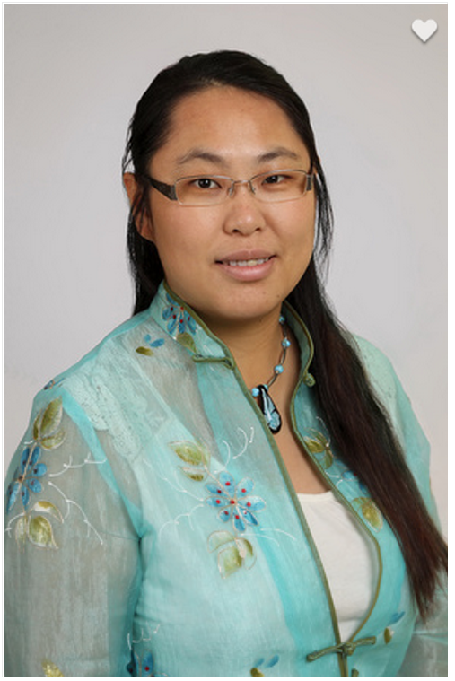Biography (150 word limit)
Yichuan (Candace) Liu earned her Bachelor of Medicine degree from the Nanjing University of Chinese Medicine, Master and Doctoral degree from Midwest College of Oriental Medicine. She is a professor at the Midwest College of Oriental Medicine where she teaches TCM nutrition, and herbs. She is also a supervisor of student interns in the College’s clinic. Dr. Liu brings classical TCM as well as any new herbal research in the field into the classroom and clinic setting. Her teaching and clinical style is traditional because it encompasses a Mind / Body / Spirit approach that exemplifies the same attitudes of the famous Chinese Doctors of old. It also aims to fully merge the practices of east and west by taking the best of the old and combines it with modern scientific advances in medicine to provide an integrative approach to patient center care.
Email: candace969@gmail.com

Notes/Comments:

