The Association of Cannabis Use and Cigarette Smoking with Psychological Distress Among Adults in California
Nan Wang, MA MS, University of California, Davis, USA

Abstract (300 word limit)
In November 2016, California voters passed the Adult Use of Marijuana Act making recreational cannabis sales legal to adults aged 21and older starting January 1st, 2018. This study aims to understand the relationship of cannabis use and cigarette smoking with serious psychological distress (SPD) in California in light of the legalization of recreational cannabis sales. This cross-sectional study included 42,313 adult participants from the 2017 to 2018 California Health Interview Surveys. We used the Kessler-6 (K6) scale to measure psychological distress in the past 30 days. Multiple logistic regression models were used to examine the association between cannabis/cigarette use and SPD. Cannabis use was positively associated with SPD (AOR = 2.48, 95% CI = 1.57, 3.91), but this association was not significantly different before and after recreational cannabis sales legalization in California (AOR = 0.82, 95% CI = 0.72, 2.05). Cigarette smoking was also positively associated with SPD (AOR = 2.76, 95% CI = 2.05, 3.71). Compared to those who used neither cannabis nor cigarettes, sole cannabis users (AOR = 2.51, 95% CI = 1.75, 3.60), sole cigarette smokers (AOR = 3.23, 95% CI = 2.28, 4.60), and dual users of cannabis and cigarettes (AOR = 5.65, 95% CI = 4.04, 7.89) were more likely to report SPD. Dual users were also more likely to report SPD than sole cannabis users (AOR = 2.25; 95% CI = 1.48, 3.43) and sole cigarette smokers (AOR = 1.75; 95% CI = 1.18, 2.59). These findings provide evidence for the need to develop effective cessation intervention strategies targeting individuals with SPD to reduce their cannabis use and dual-use of cannabis and cigarettes.

Table

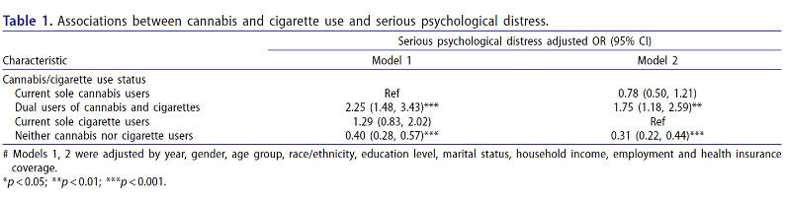

Recent Publications (minimum 5)
- SZ Yang, D Wu, N Wang, T Hesketh, KS Sun, L Li, X Zhou (2019) Workplace violence and its aftermath in China’s health sector: implications from a cross-sectional survey across three tiers of the health system BMJ open 9 (9),
- N Wang, D Wu, C Sun, L Li, X Zhou (2018) Workplace violence in County hospitals in eastern China: risk factors and hospital attitudes Journal of interpersonal violence 36 (9-10), 4916-4926
- N Wang, S Yang, X Zhou, T Hesketh (2017) Workplace violence and its aftermath among health workers in Zhejiang province: a cross-sectional study The Lancet 390, S81
- N Wang, T Yao, HY Sung, W Max (2021) The Association of Cannabis Use and Cigarette Smoking with Psychological Distress Among Adults in California Substance use & misuse, 1-9
- D Wu, Y Wang, SZ Yang, N Wang, KS Sun, TP Lam, XD Zhou(2020) A Socio-ecological Framework for Understanding Workplace Violence in China’s Health Sector: A Qualitative Analysis of Health Workers' Responses to an Open-ended Survey Question Journal of interpersonal violence 40 (9-10). 7658-7665

 Biography (150 word limit)
Paste your Logo here
Nan Wang has her expertise in tobacco control, substance use, and mental health. Her current studies include estimating the impact of COVID-19 on the association between e-cigarettes and mental health among college students in the United States. Her previous research includes estimating the impact of recreational cannabis legalization on the association between cannabis and psychological distress in California and Violence against health workers in China.
Email: naawang@ucdavis.edu

Notes/Comments:

Presenting author details
Full name: Nan Wang
Contact number: (+1) 6504211576
Twitter account: @NanWang0801
Linked In account:
Session name/ number:
Category: Oral presentation

