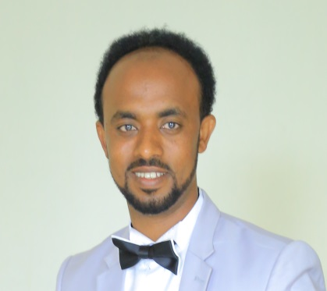
ECG Interpretations Competency of Medical Interns: Experience from two Ethiopian Medical Schools
Melaku Getachew¹, Temesgen Beyene¹, Sofia Kebede¹
¹Addis Ababa University, Ethiopia
Presenter: melakug02@gmail.com, +251953137119
Abstract
Electrocardiography (ECG) is the graphical display of electrical potential differences of an electric field originating in the heart. Interpretation of ECG is an essential skill in emergency medicine. Only a few studies have been performed to evaluate the ECG interpretation skills of general practitioners worldwide. There is no study published until now in Ethiopia on the competence of ECG interpretation among graduating medical students. The aim of this study was to assess competency of ECG interpretation among 2018 graduating Class medical students in Addis Ababa University and Haramaya University. A cross-sectional study was conducted on graduating medical students at Addis Ababa and Haramaya University. Data had collected from October 01, 2018, to October 30, 2018, by using structured questionnaires. Data were analyzed by using SPSS version 25.0 statistical software. Descriptive statistics, Chi-square, Mann-Whitney U test, and Binary logistic regression were utilized.
Two hundred two graduating medical students were involved on this study, out of this 61.3% (95% CI 56.3 – 66.3%) and 32.75% (95% CI 28.25-37.25) were able to correctly interpret the primary ECG parameters and the arrest rhythm of ECG abnormalities, respectively. The ability to detect from common emergency ECG abnormalities were Anterio septal ST segment elevation myocardial infraction, atrial fibrillation and first-degree atrioventricular block were 42.6%, 39.1% and 32.1% respectively. This study showed graduating medical students had low competency in ECG interpretations.

Biography
My name is Melaku Getachew. I graduated from Haramaya university, Ethiopia in 2106 with Degree of doctor of medicine. I worked as lecturer in school of medicine in Haramaya University. I have started post graduate studies in Emergency and Critical Care medicine at Addis Ababa University. I am a senior chief academic resident of Emergency and Critical Care medicine in Addis Ababa University, Ethiopia.
Presenting author details
Melaku Getachew Gebregiorgis
Mobile No. +251953137119
Email: melakug02@gmail.com
Category: Oral presentation

