Tox Oriented ACLS “An evidence based approach”

Bhat Shamim Ahmad MD, King Saud Medical City Riyadh, KSA

Rashid Shireen MD, Al Kabeer Center Srinagar, India

Abstract (300 word limit)
Statement of the Problem: Toxicology is one of the subspecialty which has grown leaps and bounds in the recent years worldwide. Intoxication constitutes a global burden and most of the emergency physicians are worldwide facing difficult cases of intoxication more over arrival of a intoxicated unresponsive patient makes it more difficult for the treating physicians to approach their management Researchers have reported diverse different approaches for managing such cases and international bodies are framing day in and day out the updated guidelines for such cases.
The purpose of this literature review is to identify the recent Tux oriented ACLS guidelines and compare them with the recent evidence.
. Methodology & Theoretical Orientation: After looking through the recent 2015 (latest) ACLS guidelines in relation to TOX afflicted patients presenting with cardiac arrest or instability in terms of neuro and hemodynamics, a through literature review was done for the most commonly poisoning patients and the guidelines were compared to the recent standard evidence available related to various poisoning cases. Following this the level of evidence and recommendations made were also evaluated. This all was done to have a evidence based approach for the commest poisoning induced instability and cardiac arrests and incorporate it for the board residency residents of emergency medicine. In addition it was anticipated to form a general consensus for treating such cases in future and clear off some of the myths related to treatment involved for such cases.
Findings: The comparison of the recent guidelines from ACLS and the evidence in its support proved most of the treatment has weak evidence as to the disbelief of most of the treating physician.
Some of the antidotes used in current practice are at the edge of being disrepute and are no more recommended to be standard of care eg Flumazenil in BZD poisoning.
. Conclusion & Significance:. This literature review made it clearer that we need to review the standard guidelines every now and then in terms of the supporting evidence against or in favor of it particularly if it is a sub specialty like Tox

Image

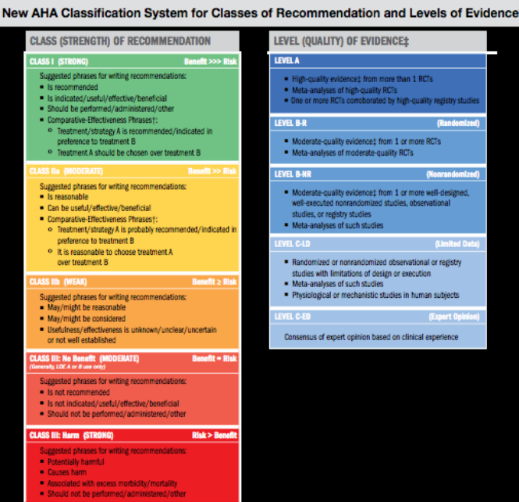
Recent Publications (minimum 5)

1) Mixed species malaria infection – A Case report from Kashmir region…National Journal of Emergency Medicine Nov 2013.
- “Sheehan syndrome presenting .as major depressive disorders --- A case report ….National Journal Of Emergency Medicine May 2013
- Abstract “Role of Barbiturate Coma In Severe Head Injury Patient” published in International Journal of Emergency Medicine. 2008
- Abstract “Role of Thoracic Ultrasound in detecting Pneumothorax in polytrauma patients” published in Indian Journal Of Medicine 2009
- “Awareness of Basic Life Support among the alternative medicine doctors” published in Indian Journal of Anesthesia 2009.



Biography (150 word limit)

Presently working in King Saud Medical City, Riyadh KSA as Acting Consultant Emergency Medicine: Since Oct 2011 till date. (7 Years plus post board experience).
Deputy Program Director Saudi Diploma of Emergency Medicine KSA
Academic Co coordinator Dept. of Emergency Medicine King Saud Medical City Riyadh KSA.
Approved from Saudi Council as Evaluator for Saudi Board of Emergency Medicine.
International Faculty for various Emergency medicine summits in Asia.
- MD in Accident & Emergency Medicine.
- ACLS Instructor – AHA Certified
- ATLS Instructor – ACS certified
- Trained Emergency Sonologist.
- Trained Emergency Echocardiographist.
- Gold medalist for Academic Excellence & Clinical Research work During M.D programme.
- Merit in Otorhinolaryngology in Medical School.
- Ex Incharge Organ harvesting and transplantation programme of Vinayaka Mission Hospital.
- Life Member ISTAC.( Indian Society for Trauma & Acute Care).
- Golden Course Instructor approved by Saudi Commission for health specialties Riyadh KSA.

shamimahmeed8@gmail.com
shbhat@ksmc.med.sa

Notes/Comments:

Interested in research and academic interactions.
Sub specialty Fellow Clinical Toxicology

Pursuing MBA Hospital Administration and management through Bits Pilani India

