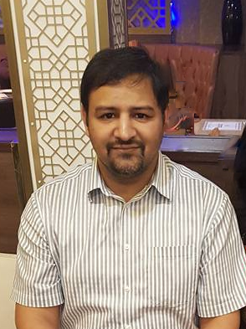

Title: When the going gets tough!
Name: Dr Immad Qureshi

Emergency Physicians are uniquely placed in that they care for patients at their most vulnerable time, and often have to make quick decisions about management. A common dilemma they face is about end of life decisions, particularly related to DNA CPR.
I will use this opportunity to discuss the three situations where end of life discussions may need to be taken:
- Withdrawal of care
- Ceiling of care
- Palliation/palliative care
I will also discuss how the DNA CPR decisions in each of these situations is different and may have an element of medical decision, as well as patient wishes taken in to account.
I will also discuss my opinions on how in most of these cases, it is not a discussion that should be initiated or had by the emergency team with family, rather should be primary speciality or intensive care, but will arm audience with the tools to have the discussions themselves as we often need to have these discussions ourselves as patients end up waiting in emergency departments for primary team.
This will take about 25-30 minutes allowing for Q & A.

Biography

Dr Immad Qureshi has completed his MBBS from Army Medical College in Pakistan in 2005 and MSc in Critical Care from Cardiff University in 2015. He has a Diploma in Football Medicine from FIFA in 2018 and he completed his Fellowship of the Royal College of Emergency Medicine of UK in 2018 as well.
He currently works at University Hospitals Birmingham and is also the FASSGEM Representative for the West Midlands RCEM regional board. He also holds memberships of the American College of Emergency Medicine, the Pakistan Society of Emergency Medicine and the Saudi Society of Emergency Medicine

