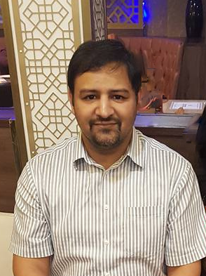

Title: The digital doctor
Name: Dr Immad Qureshi

Technology today has made a doctor's life easy as well as difficult. We are all aware of the patient that presents after having consulted "Dr Google", but how often do we ourselves turn to the internet when presented with a clinical problem. In this talk, I will introduce some of the medical and trauma applications that I believe every doctor should consider having on their phone, and talk about how they can improve patient care and safety. I will talk about the apps in the following groups: * educational *guidelines and clinical calculators *appraisals, logbooks and CPD logging. I will also discuss briefly about the ethics of consulting your phone in front of the patient. I will finish off with an introduction to what I believe is the greatest asset of the modern day doctor, the ultrasound probe and the many uses I have found for it in everyday practice. I shall include links to all applications at the end of my presentation and invite questions. This should take about 15 minutes in total including questions.

Biography

Dr Immad Qureshi has completed his MBBS from Army Medical College in Pakistan in 2005 and MSc in Critical Care from Cardiff University in 2015. He has a Diploma in Football Medicine from FIFA in 2018 and he completed his Fellowship of the Royal College of Emergency Medicine of UK in 2018 as well.
He currently works at University Hospitals Birmingham and is also the FASSGEM Representative for the West Midlands RCEM regional board. He also holds memberships of the American College of Emergency Medicine, the Pakistan Society of Emergency Medicine and the Saudi Society of Emergency Medicine

