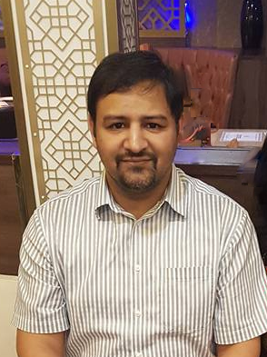

Title: Elderly Trauma: Beyond ATLS
Name: Dr Immad Qureshi

Although this talk could be presented in track 1, elderly trauma has its own significance and is better presented in geriatric emergency medicine.
In this presentation, I will introduce the audience to the concepts of Elderly Trauma that has been taught in UK under the HECTOR course that include a difference in what significant mechanism of injury can be for the elderly population, why they should be considered to be a different and special group of injured patients, introduce the concept of a silver survey past primary and secondary survey.
The oral talk requires about 15-20 minutes and can run longer if time for questions is included.

Biography

Dr Immad Qureshi has completed his MBBS from Army Medical College in Pakistan in 2005 and MSc in Critical Care from Cardiff University in 2015. He has a Diploma in Football Medicine from FIFA in 2018 and he completed his Fellowship of the Royal College of Emergency Medicine of UK in 2018 as well.
He currently works at University Hospitals Birmingham and is also the FASSGEM Representative for the West Midlands RCEM regional board. He also holds memberships of the American College of Emergency Medicine, the Pakistan Society of Emergency Medicine and the Saudi Society of Emergency Medicine

