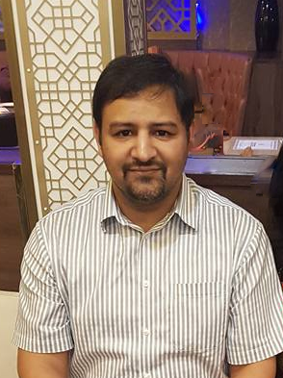

Title: Alcohol withdrawal syndrome: Are we under-treating our patients?
Name: Dr Immad Qureshi

Alcohol dependence and alcohol related emergency department (ED) attendances make up a significant proportion of the patients attending ED. These patients are at risk of developing alcohol withdrawal syndromes (AWS) and need to be identified and risk stratified.
My presentation will cover simple epidemiology of AWS, including prevalence and incidence in the ED. It will briefly touch upon the pathophysiology of AWS, including the 4 stages (mild, moderate, severe, and delirium tremens). This will include signs and symptoms and likely timeframes for developing each stage.
I will talk about the risk of thiamine deficiency and developing Wernicke’s encephalopathy that starts within just 14 days of regular alcohol misuse. Tools used to screen alcohol misuse, including CAGE, FAST, AUDIT to identify patients will be introduced. Scoring tools to identify presence of AWS will be introduced including the commonly used CIWA-Ar score and the GAWS score used in my hospital.
Treatment options for AWS will be discussed including baseline dosing or fixed schedule reducing doses of benzodiazepines. Alternative drugs to chlordiazepoxide will be discussed and the dose of thiamine replacement for these patients.
In hospital and community detox will be touched upon and mention of alcohol liaison team/nurse role in the management of these patients while in hospital and to facilitate discharge.
All these managements are guided by NICE guidance on Acute alcohol withdrawal and links to NICE guidelines will be presented.
This whole presentation will take 12-13 minutes leaving 2 minutes for questions.

Biography

Dr Immad Qureshi has completed his MBBS from Army Medical College in Pakistan in 2005 and MSc in Critical Care from Cardiff University in 2015. He has a Diploma in Football Medicine from FIFA in 2018 and he completed his Fellowship of the Royal College of Emergency Medicine of UK in 2018 as well.
He currently works at University Hospitals Birmingham and is also the FASSGEM Representative for the West Midlands RCEM regional board. He also holds memberships of the American College of Emergency Medicine, the Pakistan Society of Emergency Medicine and the Saudi Society of Emergency Medicine

