Long non-coding RNA growth arrest specific-5 (GAS5)：a potential biomarker for early diagnosis of severe asthma
Qian Zhang PhD, Affiliated Changzhou No. 2 People’s Hospital, Nanjing Medical University, China
Di Wu MS, Affiliated Changzhou No. 2 People’s Hospital, Nanjing Medical University, China

Abstract
Object: To explore the possibility of GAS5 acting as a biomarker for early diagnosis of severe asthma.
Methods: Peripheral blood was obtained from healthy volunteers, patients with steroid-sensitive asthma and severe asthma and peripheral blood mononuclear cell (PBMC) were separated. Western blotting was used to detect GR^{Ser226} of three groups after dexamethasone treatment, and qPCR was used to detect GAS5 level of three groups before and after dexamethasone treatment in vitro. BALB/c mice (n＝24, aged 6 weeks) were randomly and averagely divided into 3 groups: control group, asthma group and dexamethasone group. The mice were sensitized and challenged with ovalbumin (OVA) and lipopolysaccharide (LPS) to produce a steroid-resistant murine model of asthma. qRT-PCR was used to detect the expression of GAS5 in lung tissue of mice. HBECs (Human bronchial epithelial cells) were cultured, transfected with miR-9 mimics, JNK1 inhibitor and interfered with IL-2+IL-4 and dexamethasone. Western blotting was used to detect the expression of GR^{Ser226} and qPCR was used to detect the level of GAS5 in HBECs.
Results: The steroid-sensitive asthma group had an over 20 times higher GAS5 level in PBMC (P<0.001), but severe asthma group was over 15 times lower (P<0.001) after dexamethasone treatment. The expression of GR^{Ser226} of severe asthma group was significantly higher than that of control group and steroid-sensitive asthma(P<0.001). In lung tissue of mice, the GAS5 level of dexamethasone group was lower than asthma group (P<0.001) and control group (P<0.05). Interference with IL-2 and IL-4 or transfection of miR-9 mimics could both evaluate the expression of GR^{Ser226} in HBECs (P<0.001). The GAS5 level in HBECs after IL-2+IL-4+dexamethasone interference was lower than HBECs only treated with IL-2+IL-4 (P<0.001). HBECs transfected with miR-9 mimics expressed a higher level of GAS5 than that after dexamethasone treatment (P<0.05). However, transfecting with JNK1 inhibitor could reverse the expression of GAS5 in HBECs transfected with miR-9 mimics and interfered with dexamethasone, making it much higher than that of HBECs only transfected with miR-9 mimics and interfered with dexamethasone but similar with HBECs interfered with dexamethasone solely. But the level of GAS5 in HBECs interfered with IL-2+IL-4 and dexamethasone was not affected by JNK1 inhibitor.
Conclusion: GAS5 has the possibility of acting as a biomarker for early diagnosis of severe asthma by comparing GAS5 level of PBMCs of patients with severe asthma before and after glucocorticoids treatment. And the expression difference of GAS5 is due to GR^{Ser226} phosphorylation.

Image
Figure 1. The RNA expression of GAS5 in PBMCs from severe and mild asthma and the role of dexamethasone.
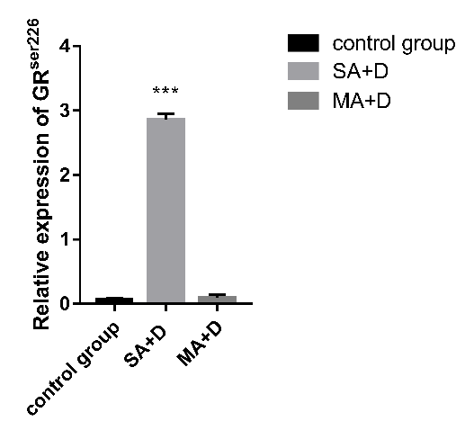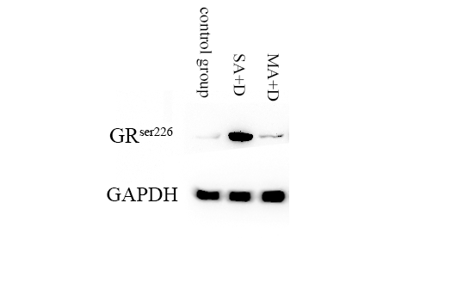

Figure 2. The protein expression of GR^{Ser226} in PBMCs from severe and mild asthma stimulated by dexamethasone in vitro.
Recent Publications
- Chen Y, Mao ZD, Shi YJ, Qian Y, Liu ZG, Yin XW, Zhang Q. Comprehensive analysis of miRNA-mRNA-lncRNA networks in severe asthma. Epigenomics. 2019; 11(2): 115-131. (Corresponding author)
- Qian Y, Mao ZD, Shi YJ, Liu ZG, Cao Q, Zhang Q. Comprehensive analysis of miRNA-mRNA-lncRNA networks in non-smoking and smoking patients with chronic obstructive pulmonary disease. Cell Physiol Biochem. 2018; 50(3): 1140-1153. (Corresponding author)
- Shi Y, Fu X, Cao Q, Mao Z, Chen Y, Sun Y, Liu Z, Zhang Q. Overexpression of miR-155-5p inhibits the proliferation and migration of IL-13-induced human bronchial smooth muscle cells by suppressing TGF-beta activated kinase 1/MAP3K7 binding protein 2. Allergy Asthma Immunol Res. 2018; 10(3): 260-267. (Corresponding author)

Mao Z, Shi Y, Cao Q, Chen Y, Sun Y, Liu Z, Zhang Q，Huang M. Transcriptional regulation on the gene expression signature in combined allergic rhinitis and asthma syndrome. Epigenomics. 2018; 10(2): 119-131. (Corresponding author)

Gu X, Zhang Q, Du Q, Shen H, Zhu Z. Pinocembrin attenuates allergic airway inflammation via inhibition of NF-κB pathway in mice. Int Immunopharmacol. 2017; 53: 90-95.


Qian Zhang received his Ph.D. degree in Pulmonary Medicine from Nanjing Medical University, Nanjing, Jiangsu Province, P.R. China. In 2010, he worked as a visiting scholar in the department of internal medicine at Far Eastern Memorial Hospital, Taiwan. From 2011 to 2016, he worked as a postdoctor in Nanjing General Hospital of Nanjing Military Command, Nanjing, Jiangsu Province, P.R. China. Currently, he is working as chief physician, associate professor and director in the department of respiratory medicine at Changzhou No.2 People’s Hospital affiliated to Nanjing Medical University. He is interested in pulmonary medicine, critical care medicine, molecular biology, allergy and immunology.
Email: kezhang0601@163.com

