Comprehensive analysis of miRNA-mRNA-lncRNA networks in severe asthma
Qian Zhang PhD, Affiliated Changzhou No. 2 People’s Hospital, Nanjing Medical University, China

Abstract (300 word limit)
Background: Severe asthma is a subset of difficult-to-treat asthma, that
requires treatment with high dose inhaled corticosteroids plus a second controller and/or systemic corticosteroids to prevent it from becoming ‘uncontrolled’ or that ‘uncontrolled’ despite this therapy. However, the pathology of severe asthma remains elusive. It is urgent to explore the pathology and develop biomarkers for severe asthma.
Methods: The shared and divergent differentially expressed mRNAs (DEmRNAs), miRNAs (DEmiRNAs) and lncRNAs (DElncRNAs) in asthma and severe asthma were identified by RNA-sequencing. Severe asthma specific and shared DEmiRNA-DEmRNA-DElncRNA interaction networks were performed.
Results: Compared with normal control, 1328 DEmRNAs, 608 DElncRNAs and 63 DEmiRNAs were identified in severe asthma. Compared with asthma, 95 DEmRNAs, 143 DElncRNAs and 96 DEmiRNAs were identified in severe asthma. MiR-133a-3p-EFHD2/CNN2-AC144831.1 interactions and miR-3613-3p-CD44/BCL11B-LINC00158/CTA-217C2.1/AC010976.2/RP11-641A6.2 interactions were speculated to involve with the development of severe asthma. The results of GSE69683 validation were generally consistent with our RNA sequencing results.
Conclusion: This study provides clues for understanding the mechanism of severe asthma.

Keywords: asthma, comprehensive analysis, DEmiRNA-DEmRNA-DElncRNA interaction networks, lncRNA, miR-133A-3P, miR-3613-3p, miRNA, mRNA, RNA-sequencing, severe asthma

Image 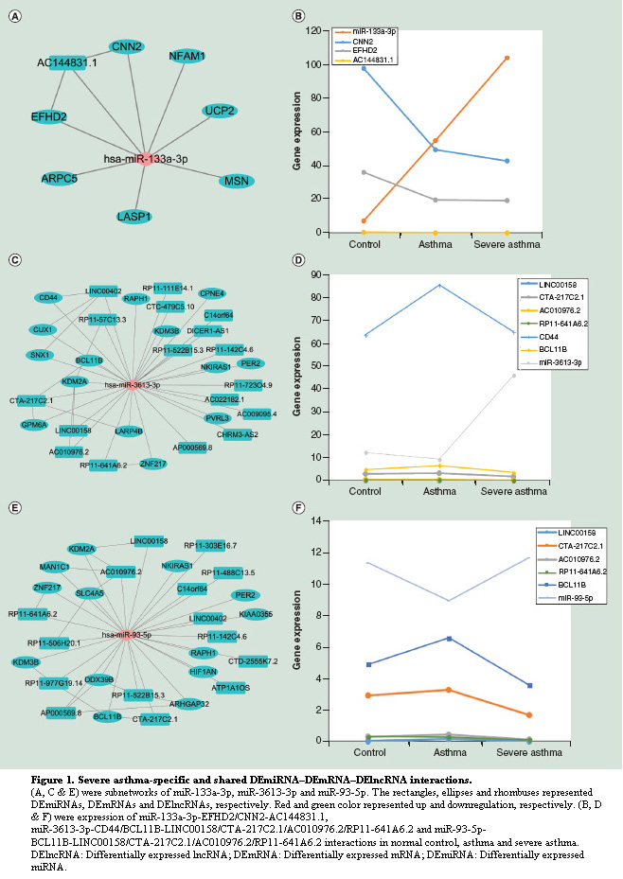

Recent Publications (minimum 5)
- Chen Y, Mao ZD, Shi YJ, Qian Y, Liu ZG, Yin XW, Zhang Q. Comprehensive analysis of miRNA-mRNA-lncRNA networks in severe asthma. Epigenomics. 2018 Nov 14. doi: 10.2217/epi-2018-0132. [Epub ahead of print] (Corresponding author)
- Qian Y, Mao ZD, Shi YJ, Liu ZG, Cao Q, Zhang Q. Comprehensive analysis of miRNA-mRNA-lncRNA networks in non-smoking and smoking patients with chronic obstructive pulmonary disease. Cell Physiol Biochem. 2018; 50(3): 1140-1153. (Corresponding author)
- Shi Y, Fu X, Cao Q, Mao Z, Chen Y, Sun Y, Liu Z, Zhang Q. Overexpression of miR-155-5p inhibits the proliferation and migration of IL-13-induced human bronchial smooth muscle cells by suppressing TGF-beta activated kinase 1/MAP3K7 binding protein 2. Allergy Asthma Immunol Res. 2018; 10(3): 260-267. (Corresponding author)

Mao Z, Shi Y, Cao Q, Chen Y, Sun Y, Liu Z, Zhang Q，Huang M. Transcriptional regulation on the gene expression signature in combined allergic rhinitis and asthma syndrome. Epigenomics. 2018; 10(2): 119-131. (Corresponding author)

Gu X, Zhang Q, Du Q, Shen H, Zhu Z. Pinocembrin attenuates allergic airway inflammation via inhibition of NF-κB pathway in mice. Int Immunopharmacol. 2017; 53: 90-95.

Biography (150 word limit)
Qian Zhang received his Ph.D. degree in Pulmonary Medicine from Nanjing Medical University, Nanjing, Jiangsu Province, P.R. China. In 2010, he worked as a visiting scholar in the department of internal medicine at Far Eastern Memorial Hospital, Taiwan. From 2011 to 2016, he worked as a postdoctor in Nanjing General Hospital of Nanjing Military Command, Nanjing, Jiangsu Province, P.R. China. Currently, he is working as chief physician, associate professor and director in the department of respiratory medicine at Changzhou No.2 People’s Hospital affiliated to Nanjing Medical University. He is interested in pulmonary medicine, critical care medicine, molecular biology, allergy and immunology.

Email: kezhang0601@163.com
Notes/Comments

