Several drugs induce mast cell degranulation and pseudo-allergic reactions via MRGPRX2
Jue Wang, Student, School of Pharmacy,
Xi’an Jiaotong University, Xi’an 710061, China

Abstract (300 word limit)
Mast cells are unique immunocytes that function as sentinel cells in host defense reactions such as immediate hypersensitivity responses and anaphylactic responses. The mast cell specific receptor MRGPRX2 (Mas-related G protein-coupled receptor X2) triggers mast cell degranulation-a key process in anaphylactic reactions. In 2014, McNeil et al. reported that MRGPRX2 was crucial for drug-induced pseudoallergic reactions. It is widely observed that antimicrobials, opioid receptor and muscle relaxant agonists can induce pseudo-allergic reactions (i.e. IgE-independent mechanism) with symptoms ranging from skin inflammation to life-threatening systemic anaphylaxis. But the allergy effect of these drugs and the possible mechanisms underlying anaphylactoid reactions have not been demonstrated.
Several drugs were screened by Ca2+ imaging using MRGPRX2 overexpressing HEK293 cells. MRGPRX2 related anaphylactoid reactions induced by these components were investigated by body temperature drop and mast cell degranulation assays. We showed that MRGPRX2 is involved in allergic-like reactions to three types of antimicrobials（antifungal agents, aminoglycosides, and sulfonamides）and muscle relaxant agonists（Mivacurium and Cisatracurium）
These results should alarm many clinicians that such drugs might induce anaphylactoid reactions and provide guidance on safe dosage of these drugs.

Image
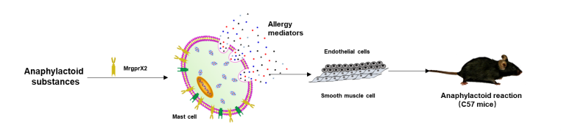

Figure 1. Several drugs induce mast cell degranulation and pseudo-allergic reactions via MRGPRX2
Recent Publications (minimum 5)
[1] Delu Che, Jue Wang, Tao Zhang* etc. Mivacurium induce mast cell activation and pseudo-allergic reactions via MAS-related G protein coupled receptor-X2. Cellular immunology.2018.
[2] Rui Liu, Jue Wang, Nan Wang* etc. Relationship between MRGPRX2 and pethidine hydrochloride- or fentanyl citrate-induced LAD2 cell degranulation. The Journal of pharmacy and pharmacology. 2018.
[3] Delu Che, Rui Liu, Jiao Cao, Jue Wang, Tao Zhang* etc. Cisatracurium induces mast cell activation and pseudo-allergic reactions via MRGPRX2. International Immunopharmacology. 2018.
[4] Delu Che, Jiao Cao, Rui Liu, Jue Wang, Tao Zhang* etc. Harpagoside-induced anaphylactic reaction in an ige-independent manner both in vitro and in vivo. Immunopharmacology & Immunotoxicology. 2018.
[5] Rui Liu, Tinging Zhao, Delu Che, Jiao Cao, Jue Wang, Nan Wang* etc. The anti-anaphylactoid effects of hydroxysafflor yellow A on the suppression of mast cell Ca2+ influx and degranulation. Phytomedicine. 2018.

Biography (150 word limit)

Jue Wang has her expertise in pseudo-allergic reactions and the possible mechanisms underlying anaphylactoid reactions. She currently focused on allergic asthma and mast cell related diseases.
Email:wj18992175699@stu.xjtu.edu.cn

Notes/Comments:

